Transmission Timings Report Week - 6
3/02/2025 - 9/02/2025

SBR2 Cloud Production2 - Single Requests (SRP)

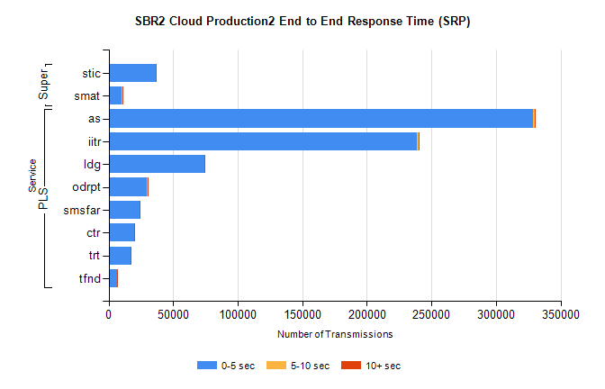
Stream | Service | 0-5 sec | 5-10 sec | >10 sec | Total | % within 5 sec timing target
PLS | as | 328738 | 1100 | 195 | 330035 | 99.6%
PLS | iitr | 238600 | 1308 | 211 | 240138 | 99.4%
PLS | ldg | 74090 | 131 | 28 | 74252 | 99.8%
PLS | odrpt | 29705 | 772 | 190 | 30667 | 96.9%
PLS | smsfar | 23926 | 50 | 17 | 23993 | 99.7%
PLS | ctr | 19489 | 52 | 13 | 19554 | 99.7%
PLS | trt | 17334 | 42 | 4 | 17381 | 99.7%
PLS | tfnd | 6557 | 17 | 2 | 6576 | 99.7%
Super | stic | 36256 | 144 | 46 | 36446 | 99.5%
Super | smat | 10362 | 102 | 26 | 10490 | 98.8%

SBR2 Cloud Production2 - Bulk or Batch Requests (BBRP)

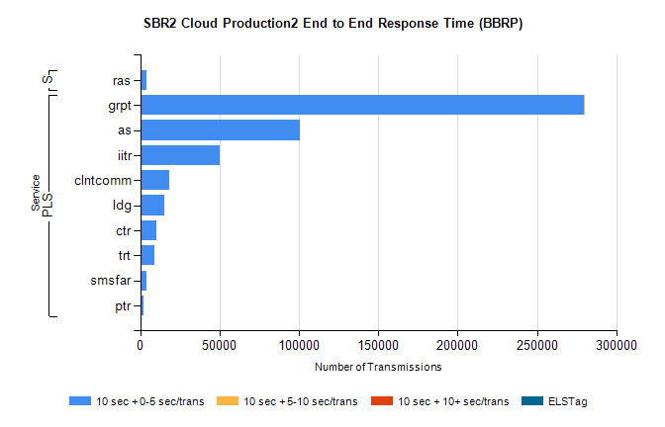
Stream | Service | 10 sec + 0-5 sec /trans | 10 sec + 5-10 sec /trans | 10 sec + >10 sec /trans | Processing Incomplete | ELStag | Total
PLS | grpt | 279795 | 93 | 0 | 0 | 0 | 279954
PLS | as | 100528 | 0 | 0 | 0 | 0 | 100528
PLS | iitr | 50231 | 0 | 0 | 0 | 0 | 50231
PLS | clntcomm | 18356 | 0 | 0 | 0 | 0 | 18356
PLS | ldg | 14951 | 0 | 0 | 0 | 0 | 14951
PLS | ctr | 10131 | 0 | 0 | 0 | 0 | 10131
PLS | trt | 9009 | 0 | 0 | 0 | 0 | 9009
PLS | smsfar | 4081 | 0 | 0 | 0 | 0 | 4081
PLS | ptr | 1790 | 0 | 0 | 0 | 0 | 1790
Super | ras | 3638 | 0 | 0 | 0 | 0 | 3638

SBR2 Cloud Production2 - ...

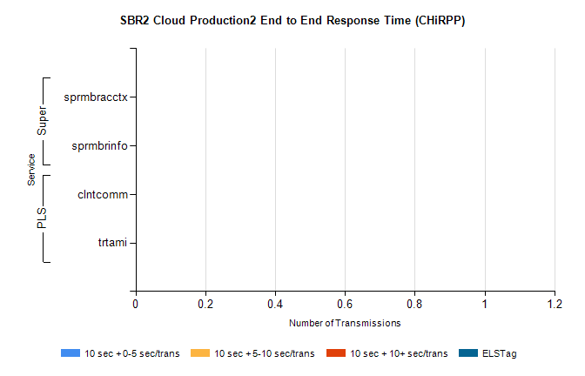
Stream | Service | 10 sec + 0-5 sec /trans | 10 sec + 5-10 sec /trans | 10 sec + >10 sec /trans | Total | % within 5 sec timing target
PLS | clntcomm | 0 | 0 | 0 | 25315 | 0.0%
PLS | trtami | 0 | 0 | 0 | 18 | 0.0%
Super | sprmbracctx | 0 | 0 | 0 | 3369 | 0.0%
Super | sprmbrinfo | 0 | 0 | 0 | 2759 | 0.0%

SBR1 Production Transactions

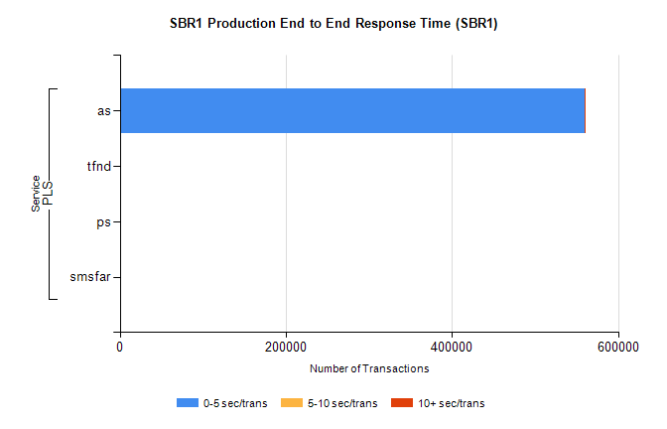
Stream | Service | 0-5 sec/trans | 5-10 sec/trans | 10+ sec/trans | Total | % within 5 sec timing target
PLS | as | 559181 | 186 | 936 | 560303 | 99.8%
PLS | tfnd | 193 | 45 | 4 | 242 | 79.8%
PLS | ps | 36 | 33 | 88 | 157 | 22.9%
PLS | smsfar | 1 | 8 | 1 | 10 | 10.0%

