Transmission Timings Report Week - 7
10/02/2025 - 16/02/2025

SBR2 External Vendor Testing Environment (EVTE3)

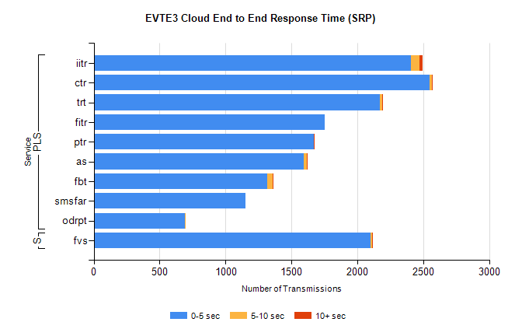
Stream | Service | 0-5 sec | 5-10 sec | >10 sec | Total | % within 5 sec timing target
PLS | iitr | 2406 | 66 | 20 | 2685 | 89.6%
PLS | ctr | 2550 | 18 | 6 | 2662 | 95.8%
PLS | trt | 2172 | 18 | 3 | 2242 | 96.9%
PLS | fitr | 1753 | 0 | 0 | 1806 | 97.1%
PLS | ptr | 1668 | 3 | 1 | 1738 | 96.0%
PLS | as | 1594 | 22 | 7 | 1718 | 92.8%
PLS | fbt | 1319 | 38 | 1 | 1458 | 90.5%
PLS | smsfar | 1154 | 0 | 0 | 1154 | 100.0%
PLS | odrpt | 689 | 1 | 0 | 690 | 99.9%
Super | fvs | 2103 | 8 | 1 | 2112 | 99.6%

SBR2 External Vendor Testing Environment (EVTE3)

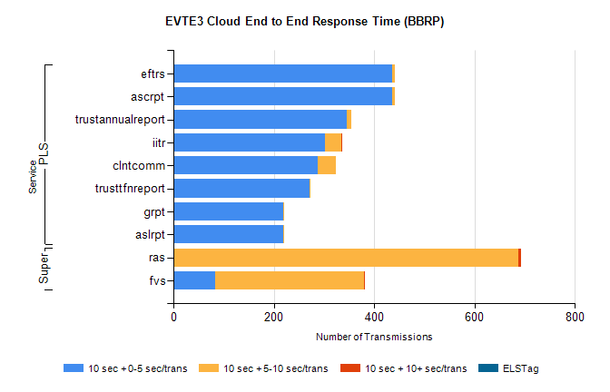
Stream | Service | 10 sec + 0-5 sec /trans | 10 sec + 5-10 sec /trans | 10 sec + >10 sec /trans | Processing Incomplete | ELStag | Total
PLS | ascrpt | 436 | 6 | 0 | 0 | 0 | 442
PLS | eftrs | 436 | 6 | 0 | 0 | 0 | 442
PLS | trustannualreport | 345 | 9 | 0 | 0 | 0 | 354
PLS | iitr | 302 | 32 | 2 | 0 | 0 | 342
PLS | clntcomm | 287 | 36 | 0 | 0 | 0 | 323
PLS | trusttfnreport | 271 | 1 | 0 | 0 | 0 | 272
PLS | aslrpt | 218 | 3 | 0 | 0 | 0 | 221
PLS | grpt | 218 | 3 | 0 | 0 | 0 | 221
Super | ras | 0 | 688 | 5 | 0 | 0 | 719
Super | fvs | 83 | 297 | 1 | 4 | 0 | 434

