Transmission Timings Report Week - 7
10/02/2025 - 16/02/2025

SBR2 Cloud Production2 - Single Requests (SRP)

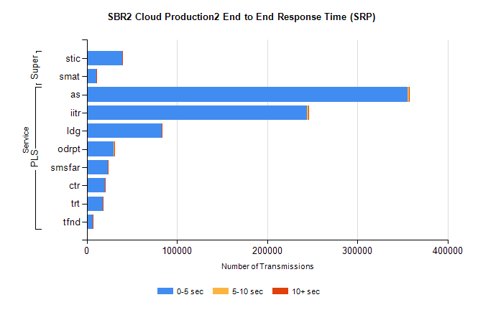
Stream | Service | 0-5 sec | 5-10 sec | >10 sec | Total | % within 5 sec timing target
PLS | as | 355942 | 1172 | 312 | 357430 | 99.6%
PLS | iitr | 243741 | 1695 | 388 | 245847 | 99.1%
PLS | ldg | 83078 | 200 | 57 | 83336 | 99.7%
PLS | odrpt | 29710 | 836 | 99 | 30645 | 96.9%
PLS | smsfar | 23487 | 69 | 38 | 23596 | 99.5%
PLS | ctr | 20458 | 58 | 24 | 20540 | 99.6%
PLS | trt | 18180 | 61 | 24 | 18266 | 99.5%
PLS | tfnd | 7012 | 32 | 4 | 7048 | 99.5%
Super | stic | 39326 | 177 | 71 | 39574 | 99.4%
Super | smat | 10398 | 160 | 63 | 10621 | 97.9%

SBR2 Cloud Production2 - Bulk or Batch Requests (BBRP)

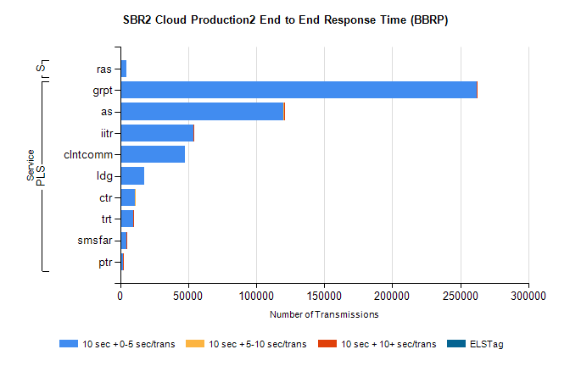
Stream | Service | 10 sec + 0-5 sec /trans | 10 sec + 5-10 sec /trans | 10 sec + >10 sec /trans | Processing Incomplete | ELStag | Total
PLS | grpt | 262272 | 144 | 7 | 0 | 0 | 262555
PLS | as | 120229 | 25 | 25 | 0 | 0 | 120287
PLS | iitr | 53718 | 27 | 6 | 0 | 0 | 53760
PLS | clntcomm | 47829 | 0 | 0 | 0 | 0 | 47829
PLS | ldg | 17851 | 0 | 0 | 0 | 0 | 17851
PLS | ctr | 10811 | 4 | 0 | 0 | 0 | 10816
PLS | trt | 9509 | 0 | 3 | 0 | 0 | 9512
PLS | smsfar | 4310 | 4 | 1 | 0 | 0 | 4315
PLS | ptr | 1996 | 2 | 2 | 0 | 0 | 2000
Super | ras | 4445 | 0 | 0 | 0 | 0 | 4445

SBR2 Cloud Production2 - ...

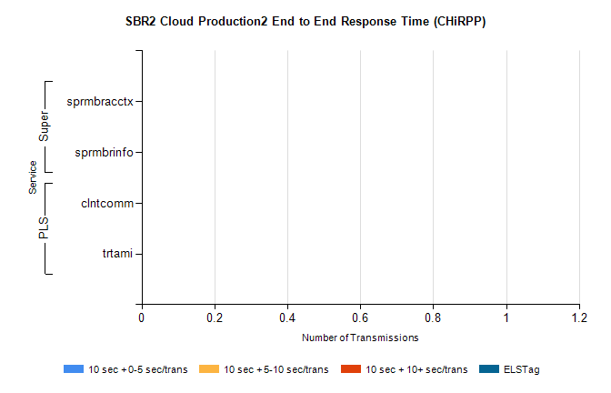
Stream | Service | 10 sec + 0-5 sec /trans | 10 sec + 5-10 sec /trans | 10 sec + >10 sec /trans | Total | % within 5 sec timing target
PLS | clntcomm | 0 | 0 | 0 | 16631 | 0.0%
PLS | trtami | 0 | 0 | 0 | 68 | 0.0%
Super | sprmbracctx | 0 | 0 | 0 | 3212 | 0.0%
Super | sprmbrinfo | 0 | 0 | 0 | 3055 | 0.0%

SBR1 Production Transactions

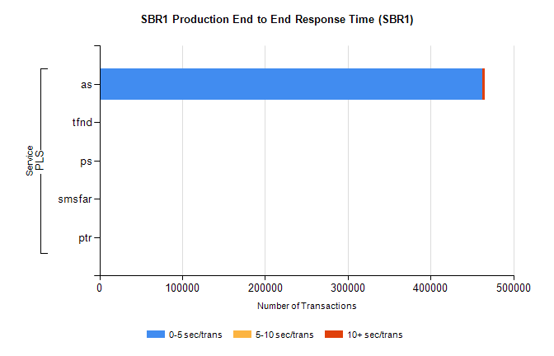
Stream | Service | 0-5 sec/trans | 5-10 sec/trans | 10+ sec/trans | Total | % within 5 sec timing target
PLS | as | 462431 | 202 | 3307 | 465940 | 99.2%
PLS | tfnd | 267 | 62 | 2 | 331 | 80.7%
PLS | ps | 31 | 37 | 104 | 172 | 18.0%
PLS | smsfar | 1 | 16 | 6 | 23 | 4.3%
PLS | ptr | 1 |  | 3 | 4 | 25.0%

