Transmission Timings Report Week - 8
17/02/2025 - 23/02/2025

SBR2 External Vendor Testing Environment (EVTE3)

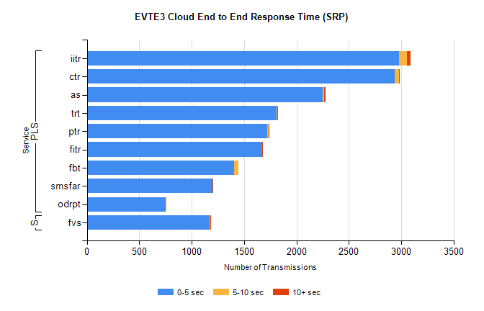
Stream | Service | 0-5 sec | 5-10 sec | >10 sec | Total | % within 5 sec timing target
PLS | iitr | 2979 | 77 | 30 | 3087 | 96.5%
PLS | ctr | 2935 | 41 | 3 | 2982 | 98.4%
PLS | as | 2252 | 14 | 13 | 2331 | 96.6%
PLS | trt | 1813 | 5 | 4 | 1829 | 99.1%
PLS | ptr | 1719 | 13 | 3 | 1741 | 98.7%
PLS | fitr | 1671 | 4 | 1 | 1684 | 99.2%
PLS | fbt | 1408 | 36 | 0 | 1498 | 94.0%
PLS | smsfar | 1199 | 2 | 2 | 1203 | 99.7%
PLS | odrpt | 755 | 1 | 0 | 759 | 99.5%
Super | fvs | 1172 | 6 | 1 | 1179 | 99.4%

SBR2 External Vendor Testing Environment (EVTE3)

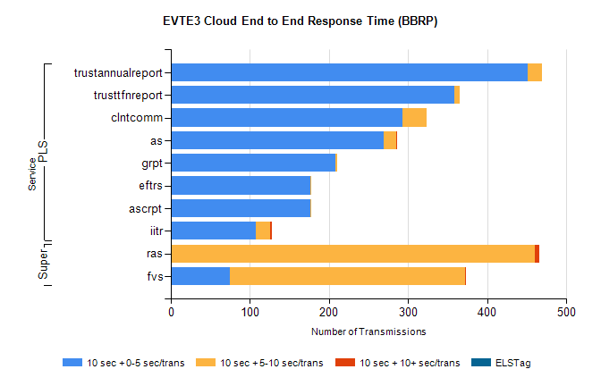
Stream | Service | 10 sec + 0-5 sec /trans | 10 sec + 5-10 sec /trans | 10 sec + >10 sec /trans | Processing Incomplete | ELStag | Total
PLS | trustannualreport | 451 | 18 | 0 | 0 | 0 | 471
PLS | trusttfnreport | 358 | 7 | 0 | 0 | 0 | 365
PLS | clntcomm | 293 | 30 | 0 | 0 | 0 | 326
PLS | as | 269 | 16 | 1 | 0 | 0 | 287
PLS | grpt | 208 | 2 | 0 | 0 | 0 | 211
PLS | ascrpt | 176 | 2 | 0 | 0 | 0 | 180
PLS | eftrs | 176 | 2 | 0 | 0 | 0 | 180
PLS | iitr | 107 | 19 | 2 | 0 | 0 | 137
Super | ras | 0 | 460 | 6 | 0 | 0 | 490
Super | fvs | 75 | 297 | 1 | 5 | 0 | 420

