Transmission Timings Report Week - 8
17/02/2025 - 23/02/2025

SBR2 Cloud Production2 - Single Requests (SRP)

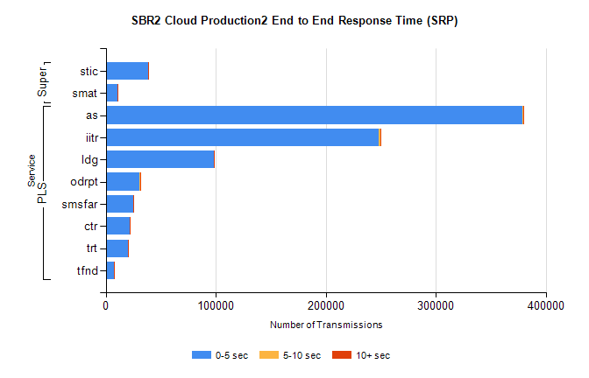
Stream | Service | 0-5 sec | 5-10 sec | >10 sec | Total | % within 5 sec timing target
PLS | as | 378360 | 995 | 417 | 379783 | 99.6%
PLS | iitr | 247928 | 1820 | 285 | 250040 | 99.2%
PLS | ldg | 98146 | 204 | 52 | 98410 | 99.7%
PLS | odrpt | 30883 | 566 | 55 | 31504 | 98.0%
PLS | smsfar | 24644 | 69 | 18 | 24731 | 99.6%
PLS | ctr | 22047 | 75 | 18 | 22141 | 99.6%
PLS | trt | 20108 | 56 | 16 | 20183 | 99.6%
PLS | tfnd | 7559 | 28 | 6 | 7593 | 99.6%
Super | stic | 38541 | 282 | 71 | 38894 | 99.1%
Super | smat | 10605 | 173 | 54 | 10833 | 97.9%

SBR2 Cloud Production2 - Bulk or Batch Requests (BBRP)

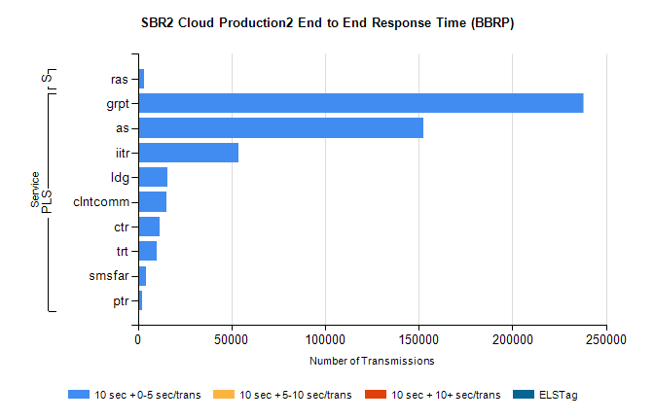
Stream | Service | 10 sec + 0-5 sec /trans | 10 sec + 5-10 sec /trans | 10 sec + >10 sec /trans | Processing Incomplete | ELStag | Total
PLS | grpt | 237661 | 202 | 0 | 0 | 0 | 238024
PLS | as | 152374 | 0 | 0 | 0 | 0 | 152374
PLS | iitr | 53441 | 0 | 0 | 0 | 0 | 53441
PLS | ldg | 15693 | 0 | 0 | 0 | 0 | 15693
PLS | clntcomm | 15228 | 0 | 0 | 0 | 0 | 15228
PLS | ctr | 11693 | 0 | 0 | 0 | 0 | 11693
PLS | trt | 9830 | 0 | 0 | 0 | 0 | 9830
PLS | smsfar | 4228 | 0 | 0 | 0 | 0 | 4228
PLS | ptr | 2022 | 0 | 0 | 0 | 0 | 2022
Super | ras | 3331 | 0 | 0 | 0 | 0 | 3331

SBR2 Cloud Production2 - ...

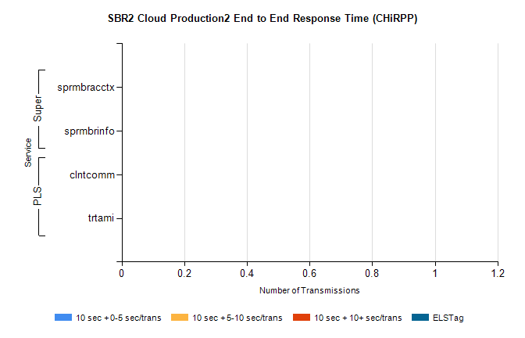
Stream | Service | 10 sec + 0-5 sec /trans | 10 sec + 5-10 sec /trans | 10 sec + >10 sec /trans | Total | % within 5 sec timing target
PLS | clntcomm | 0 | 0 | 0 | 20939 | 0.0%
PLS | trtami | 0 | 0 | 0 | 13 | 0.0%
Super | sprmbracctx | 0 | 0 | 0 | 6741 | 0.0%
Super | sprmbrinfo | 0 | 0 | 0 | 2932 | 0.0%

SBR1 Production Transactions

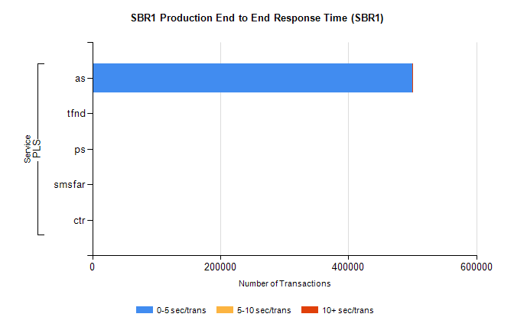
Stream | Service | 0-5 sec/trans | 5-10 sec/trans | 10+ sec/trans | Total | % within 5 sec timing target
PLS | as | 499985 | 283 | 294 | 500562 | 99.9%
PLS | tfnd | 283 | 52 | 6 | 341 | 83.0%
PLS | ps | 28 | 42 | 94 | 164 | 17.1%
PLS | smsfar | 1 | 14 | 5 | 20 | 5.0%
PLS | ctr | 1 |  | 1 | 2 | 50.0%

