Transmission Timings Report Week - 10
3/03/2025 - 9/03/2025

SBR2 External Vendor Testing Environment (EVTE3)

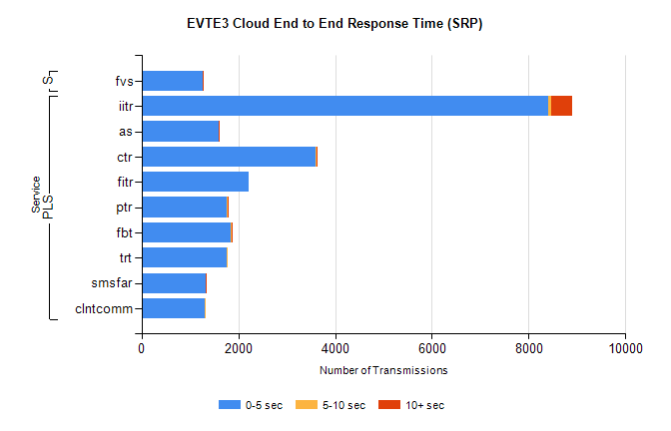
Stream | Service | 0-5 sec | 5-10 sec | >10 sec | Total | % within 5 sec timing target
PLS | iitr | 8413 | 63 | 433 | 9445 | 89.1%
PLS | as | 1587 | 13 | 6 | 4002 | 39.7%
PLS | ctr | 3595 | 28 | 3 | 3982 | 90.3%
PLS | fitr | 2222 | 0 | 0 | 2536 | 87.6%
PLS | ptr | 1770 | 12 | 3 | 2133 | 83.0%
PLS | fbt | 1839 | 34 | 1 | 2106 | 87.3%
PLS | trt | 1768 | 7 | 0 | 2098 | 84.3%
PLS | smsfar | 1318 | 14 | 2 | 1495 | 88.2%
PLS | clntcomm | 1300 | 1 | 0 | 1407 | 92.4%
Super | fvs | 1258 | 5 | 2 | 1270 | 99.1%

SBR2 External Vendor Testing Environment (EVTE3)

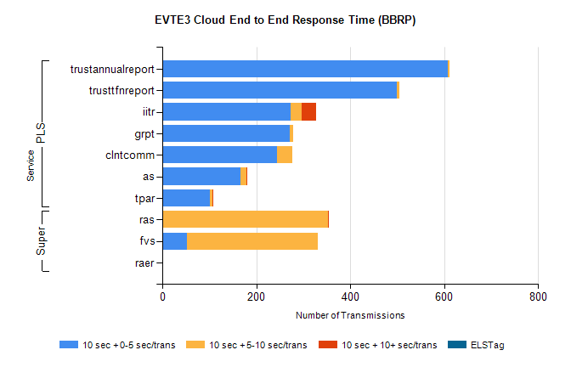
Stream | Service | 10 sec + 0-5 sec /trans | 10 sec + 5-10 sec /trans | 10 sec + >10 sec /trans | Processing Incomplete | ELStag | Total
PLS | trustannualreport | 608 | 4 | 0 | 140 | 0 | 752
PLS | trusttfnreport | 499 | 6 | 0 | 129 | 0 | 634
PLS | iitr | 274 | 23 | 30 | 155 | 0 | 487
PLS | grpt | 272 | 6 | 0 | 13 | 0 | 292
PLS | clntcomm | 245 | 31 | 0 | 0 | 0 | 276
PLS | as | 167 | 12 | 1 | 6 | 0 | 187
PLS | tpar | 101 | 6 | 1 | 26 | 0 | 138
Super | ras | 0 | 352 | 2 | 48 | 0 | 411
Super | fvs | 53 | 278 | 0 | 31 | 0 | 400
Super | raer | 0 | 0 | 0 | 103 | 0 | 103

