Transmission Timings Report Week - 10
3/03/2025 - 9/03/2025

SBR2 Cloud Production2 - Single Requests (SRP)

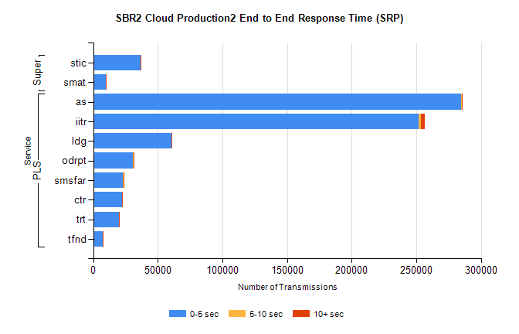
Stream | Service | 0-5 sec | 5-10 sec | >10 sec | Total | % within 5 sec timing target
PLS | as | 284814 | 688 | 137 | 285647 | 99.7%
PLS | iitr | 251892 | 1608 | 2870 | 256392 | 98.2%
PLS | ldg | 60563 | 92 | 14 | 60681 | 99.8%
PLS | odrpt | 30766 | 612 | 61 | 31440 | 97.9%
PLS | smsfar | 23256 | 45 | 15 | 23316 | 99.7%
PLS | ctr | 22551 | 81 | 16 | 22648 | 99.6%
PLS | trt | 20202 | 55 | 8 | 20267 | 99.7%
PLS | tfnd | 7224 | 42 | 2 | 7268 | 99.4%
Super | stic | 36631 | 203 | 476 | 37310 | 98.2%
Super | smat | 9854 | 99 | 77 | 10097 | 97.6%

SBR2 Cloud Production2 - Bulk or Batch Requests (BBRP)

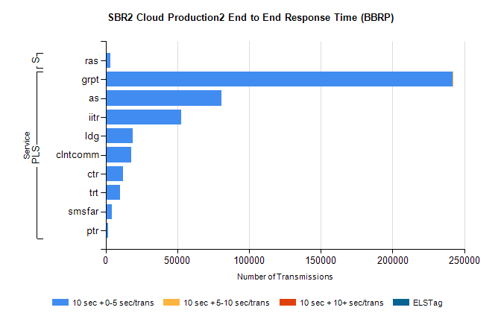
Stream | Service | 10 sec + 0-5 sec /trans | 10 sec + 5-10 sec /trans | 10 sec + >10 sec /trans | Processing Incomplete | ELStag | Total
PLS | grpt | 241648 | 45 | 0 | 0 | 0 | 241712
PLS | as | 80835 | 0 | 0 | 0 | 0 | 80835
PLS | iitr | 52401 | 0 | 0 | 0 | 0 | 52401
PLS | ldg | 19015 | 0 | 0 | 0 | 0 | 19015
PLS | clntcomm | 17797 | 0 | 0 | 0 | 0 | 17797
PLS | ctr | 11984 | 0 | 0 | 0 | 0 | 11984
PLS | trt | 10060 | 0 | 0 | 0 | 0 | 10060
PLS | smsfar | 4071 | 0 | 0 | 0 | 0 | 4071
PLS | ptr | 1944 | 0 | 0 | 0 | 0 | 1944
Super | ras | 3217 | 0 | 0 | 0 | 0 | 3217

SBR2 Cloud Production2 - ...

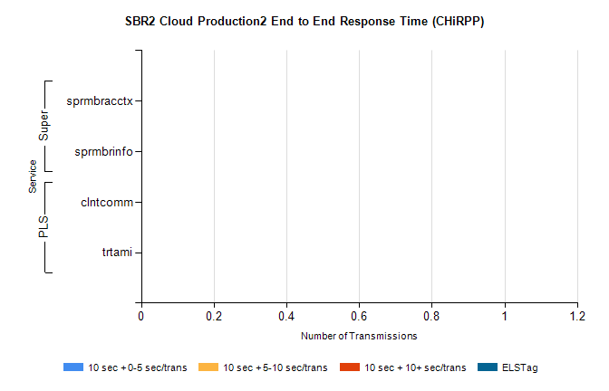
Stream | Service | 10 sec + 0-5 sec /trans | 10 sec + 5-10 sec /trans | 10 sec + >10 sec /trans | Total | % within 5 sec timing target
PLS | clntcomm | 0 | 0 | 0 | 29809 | 0.0%
PLS | trtami | 0 | 0 | 0 | 84 | 0.0%
Super | sprmbracctx | 0 | 0 | 0 | 3186 | 0.0%
Super | sprmbrinfo | 0 | 0 | 0 | 2476 | 0.0%

SBR1 Production Transactions

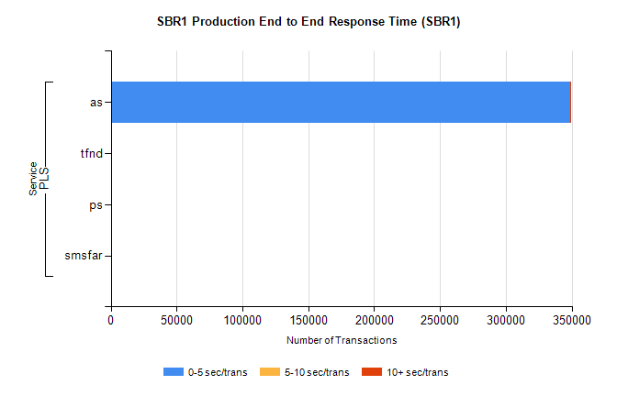
Stream | Service | 0-5 sec/trans | 5-10 sec/trans | 10+ sec/trans | Total | % within 5 sec timing target
PLS | as | 348806 | 165 | 141 | 349112 | 99.9%
PLS | tfnd | 250 | 49 | 7 | 306 | 81.7%
PLS | ps | 34 | 51 | 95 | 180 | 18.9%
PLS | smsfar |  | 17 | 5 | 22 | 0.0%

