Transmission Timings Report Week - 11
10/03/2025 - 16/03/2025

SBR2 External Vendor Testing Environment (EVTE3)

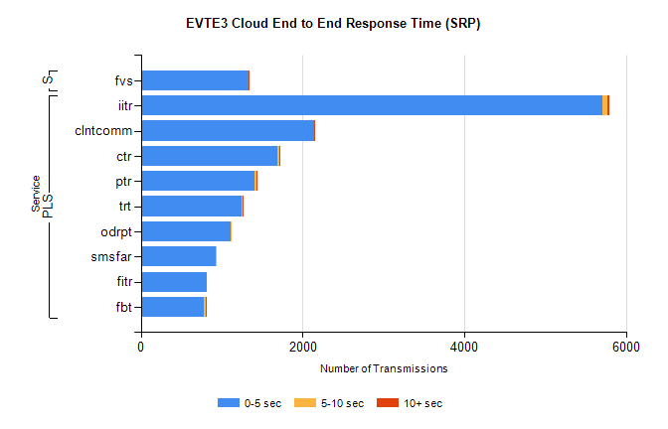
Stream | Service | 0-5 sec | 5-10 sec | >10 sec | Total | % within 5 sec timing target
PLS | iitr | 5710 | 57 | 23 | 5792 | 98.6%
PLS | clntcomm | 2142 | 0 | 2 | 2144 | 99.9%
PLS | ctr | 1686 | 23 | 4 | 1827 | 92.3%
PLS | ptr | 1401 | 26 | 3 | 1431 | 97.9%
PLS | trt | 1242 | 13 | 2 | 1292 | 96.1%
PLS | odrpt | 1113 | 1 | 0 | 1128 | 98.7%
PLS | smsfar | 921 | 1 | 0 | 922 | 99.9%
PLS | fitr | 821 | 0 | 0 | 821 | 100.0%
PLS | fbt | 784 | 22 | 1 | 810 | 96.8%
Super | fvs | 1329 | 5 | 1 | 1335 | 99.6%

SBR2 External Vendor Testing Environment (EVTE3)

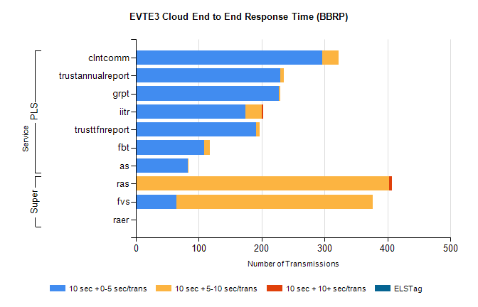
Stream | Service | 10 sec + 0-5 sec /trans | 10 sec + 5-10 sec /trans | 10 sec + >10 sec /trans | Processing Incomplete | ELStag | Total
PLS | clntcomm | 296 | 26 | 0 | 0 | 0 | 327
PLS | trustannualreport | 229 | 6 | 0 | 0 | 0 | 236
PLS | grpt | 227 | 2 | 0 | 0 | 0 | 229
PLS | iitr | 174 | 26 | 2 | 0 | 0 | 210
PLS | trusttfnreport | 191 | 6 | 0 | 0 | 0 | 197
PLS | fbt | 108 | 9 | 0 | 1 | 0 | 119
PLS | as | 82 | 2 | 0 | 1 | 0 | 116
Super | ras | 0 | 402 | 5 | 0 | 0 | 421
Super | fvs | 64 | 312 | 0 | 6 | 0 | 419
Super | raer | 0 | 0 | 0 | 95 | 0 | 95

