Transmission Timings Report Week - 12
17/03/2025 - 23/03/2025

SBR2 External Vendor Testing Environment (EVTE3)

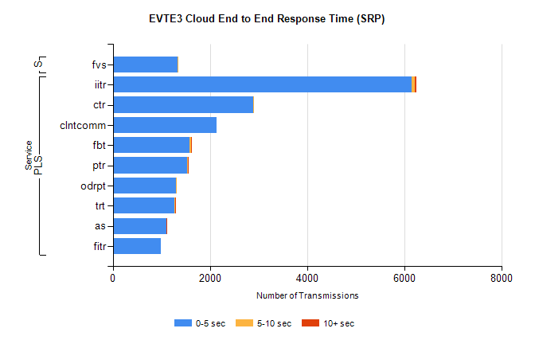
Stream | Service | 0-5 sec | 5-10 sec | >10 sec | Total | % within 5 sec timing target
PLS | iitr | 6152 | 69 | 30 | 6272 | 98.1%
PLS | ctr | 2891 | 22 | 0 | 2941 | 98.3%
PLS | clntcomm | 2134 | 0 | 0 | 2134 | 100.0%
PLS | fbt | 1577 | 27 | 4 | 1625 | 97.0%
PLS | ptr | 1525 | 16 | 2 | 1563 | 97.6%
PLS | odrpt | 1308 | 2 | 0 | 1347 | 97.1%
PLS | trt | 1269 | 9 | 3 | 1312 | 96.7%
PLS | as | 1100 | 10 | 3 | 1202 | 91.5%
PLS | fitr | 989 | 0 | 0 | 1012 | 97.7%
Super | fvs | 1327 | 5 | 0 | 1332 | 99.6%

SBR2 External Vendor Testing Environment (EVTE3)

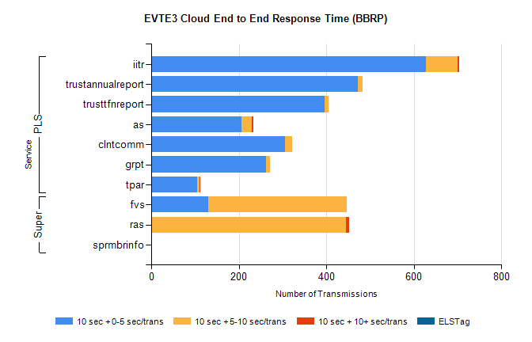
Stream | Service | 10 sec + 0-5 sec /trans | 10 sec + 5-10 sec /trans | 10 sec + >10 sec /trans | Processing Incomplete | ELStag | Total
PLS | iitr | 628 | 72 | 4 | 0 | 0 | 716
PLS | trustannualreport | 473 | 10 | 0 | 22 | 0 | 505
PLS | trusttfnreport | 397 | 9 | 0 | 38 | 0 | 444
PLS | as | 206 | 24 | 4 | 5 | 0 | 416
PLS | clntcomm | 305 | 17 | 0 | 0 | 0 | 347
PLS | grpt | 263 | 8 | 0 | 0 | 0 | 271
PLS | tpar | 105 | 5 | 2 | 0 | 0 | 116
Super | fvs | 130 | 316 | 0 | 11 | 0 | 486
Super | ras | 0 | 445 | 7 | 0 | 0 | 473
Super | sprmbrinfo | 0 | 0 | 0 | 0 | 0 | 110

