Transmission Timings Report Week - 12
17/03/2025 - 23/03/2025

SBR2 Cloud Production2 - Single Requests (SRP)

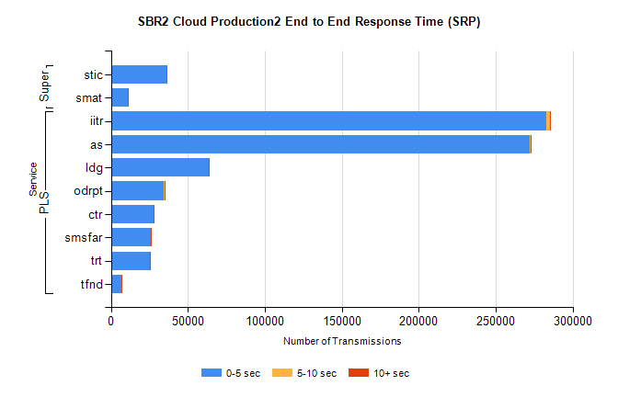
Stream | Service | 0-5 sec | 5-10 sec | >10 sec | Total | % within 5 sec timing target
PLS | iitr | 282857 | 2127 | 292 | 285309 | 99.1%
PLS | as | 272051 | 657 | 312 | 273189 | 99.6%
PLS | ldg | 63418 | 152 | 36 | 63610 | 99.7%
PLS | odrpt | 34160 | 1010 | 80 | 35251 | 96.9%
PLS | ctr | 27564 | 97 | 15 | 27680 | 99.6%
PLS | smsfar | 26033 | 63 | 9 | 26109 | 99.7%
PLS | trt | 25340 | 86 | 24 | 25454 | 99.6%
PLS | tfnd | 7059 | 30 | 1 | 7091 | 99.5%
Super | stic | 36168 | 234 | 72 | 36477 | 99.2%
Super | smat | 10717 | 114 | 27 | 10858 | 98.7%

SBR2 Cloud Production2 - Bulk or Batch Requests (BBRP)

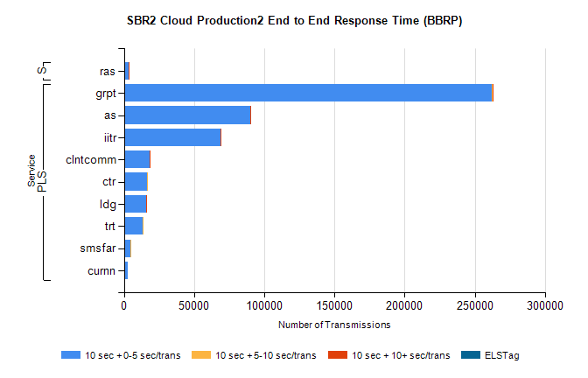
Stream | Service | 10 sec + 0-5 sec /trans | 10 sec + 5-10 sec /trans | 10 sec + >10 sec /trans | Processing Incomplete | ELStag | Total
PLS | grpt | 262362 | 511 | 153 | 1 | 0 | 263372
PLS | as | 90254 | 16 | 9 | 2 | 0 | 90299
PLS | iitr | 68689 | 40 | 11 | 1 | 0 | 68762
PLS | clntcomm | 18353 | 0 | 1 | 0 | 0 | 18356
PLS | ctr | 16421 | 5 | 0 | 0 | 0 | 16426
PLS | ldg | 15795 | 13 | 4 | 0 | 0 | 15824
PLS | trt | 13226 | 9 | 0 | 0 | 0 | 13237
PLS | smsfar | 4518 | 1 | 0 | 0 | 0 | 4519
PLS | curnn | 2500 | 0 | 0 | 0 | 0 | 2501
Super | ras | 3201 | 0 | 1 | 0 | 0 | 3202

SBR2 Cloud Production2 - ...

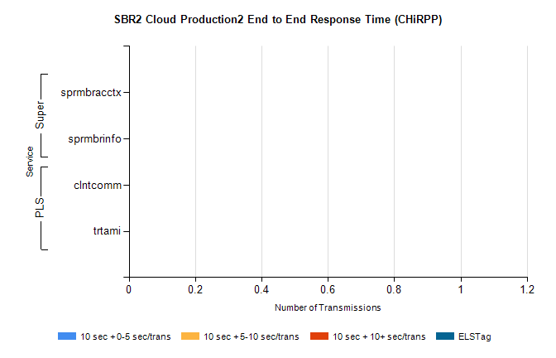
Stream | Service | 10 sec + 0-5 sec /trans | 10 sec + 5-10 sec /trans | 10 sec + >10 sec /trans | Total | % within 5 sec timing target
PLS | clntcomm | 0 | 0 | 0 | 33363 | 0.0%
PLS | trtami | 0 | 0 | 0 | 13 | 0.0%
Super | sprmbracctx | 0 | 0 | 0 | 9642 | 0.0%
Super | sprmbrinfo | 0 | 0 | 0 | 2956 | 0.0%

SBR1 Production Transactions

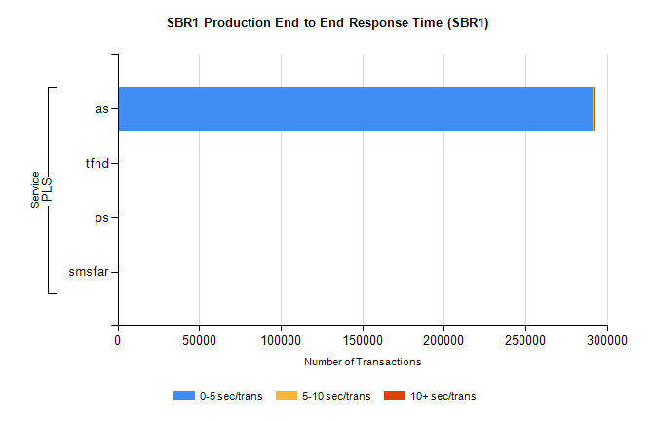
Stream | Service | 0-5 sec/trans | 5-10 sec/trans | 10+ sec/trans | Total | % within 5 sec timing target
PLS | as | 291477 | 451 | 260 | 292188 | 99.8%
PLS | tfnd | 292 | 49 | 9 | 350 | 83.4%
PLS | ps | 22 | 36 | 122 | 180 | 12.2%
PLS | smsfar | 4 | 16 | 2 | 22 | 18.2%

