Transmission Timings Report Week - 9
24/02/2025 - 2/03/2025

SBR2 External Vendor Testing Environment (EVTE3)

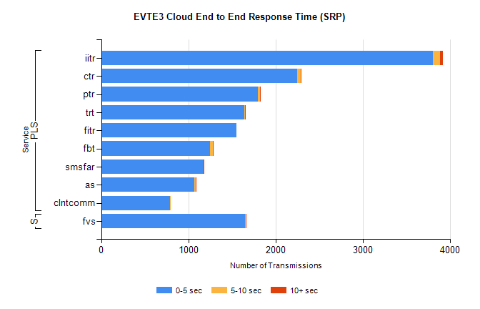
Stream | Service | 0-5 sec | 5-10 sec | >10 sec | Total | % within 5 sec timing target
PLS | iitr | 3806 | 83 | 28 | 3917 | 97.2%
PLS | ctr | 2252 | 37 | 4 | 2308 | 97.6%
PLS | ptr | 1799 | 21 | 4 | 1844 | 97.6%
PLS | trt | 1642 | 7 | 1 | 1660 | 98.9%
PLS | fitr | 1553 | 0 | 0 | 1554 | 99.9%
PLS | fbt | 1250 | 35 | 3 | 1315 | 95.1%
PLS | smsfar | 1172 | 3 | 1 | 1177 | 99.6%
PLS | as | 1067 | 14 | 6 | 1135 | 94.0%
PLS | clntcomm | 790 | 4 | 0 | 794 | 99.5%
Super | fvs | 1651 | 4 | 1 | 1656 | 99.7%

SBR2 External Vendor Testing Environment (EVTE3)

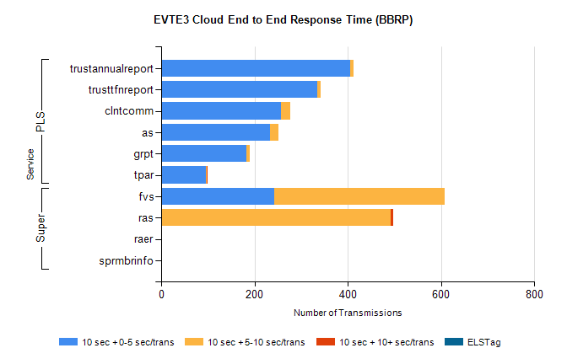
Stream | Service | 10 sec + 0-5 sec /trans | 10 sec + 5-10 sec /trans | 10 sec + >10 sec /trans | Processing Incomplete | ELStag | Total
PLS | trustannualreport | 405 | 7 | 0 | 80 | 0 | 493
PLS | trusttfnreport | 335 | 6 | 0 | 77 | 0 | 418
PLS | clntcomm | 256 | 21 | 0 | 0 | 0 | 278
PLS | as | 233 | 18 | 0 | 3 | 0 | 254
PLS | grpt | 182 | 8 | 0 | 0 | 0 | 191
PLS | tpar | 95 | 3 | 2 | 0 | 0 | 109
Super | fvs | 243 | 365 | 0 | 7 | 0 | 671
Super | ras | 0 | 492 | 5 | 0 | 0 | 518
Super | raer | 0 | 0 | 0 | 125 | 0 | 125
Super | sprmbrinfo | 0 | 0 | 0 | 0 | 0 | 96

