Transmission Timings Report Week - 9
24/02/2025 - 2/03/2025

SBR2 Cloud Production2 - Single Requests (SRP)

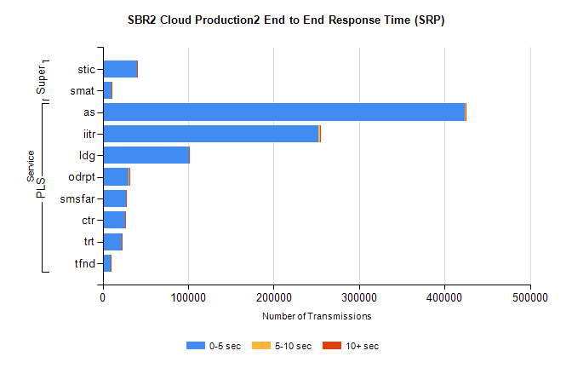
Stream | Service | 0-5 sec | 5-10 sec | >10 sec | Total | % within 5 sec timing target
PLS | as | 423390 | 1072 | 319 | 424784 | 99.7%
PLS | iitr | 252326 | 1557 | 325 | 254219 | 99.3%
PLS | ldg | 100957 | 173 | 49 | 101179 | 99.8%
PLS | odrpt | 30369 | 489 | 49 | 30907 | 98.3%
PLS | smsfar | 27735 | 44 | 15 | 27794 | 99.8%
PLS | ctr | 26434 | 83 | 26 | 26543 | 99.6%
PLS | trt | 22139 | 43 | 15 | 22197 | 99.7%
PLS | tfnd | 9460 | 32 | 6 | 9498 | 99.6%
Super | stic | 39962 | 473 | 628 | 41064 | 97.3%
Super | smat | 10433 | 227 | 169 | 10830 | 96.3%

SBR2 Cloud Production2 - Bulk or Batch Requests (BBRP)

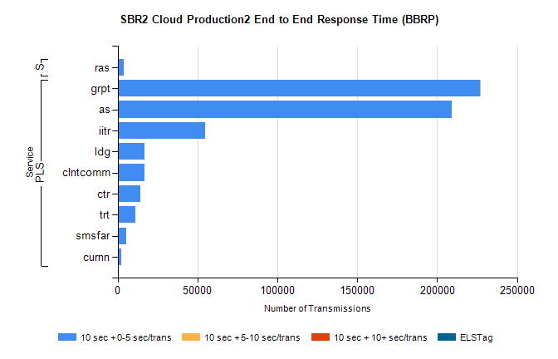
Stream | Service | 10 sec + 0-5 sec /trans | 10 sec + 5-10 sec /trans | 10 sec + >10 sec /trans | Processing Incomplete | ELStag | Total
PLS | grpt | 226896 | 81 | 0 | 0 | 0 | 227043
PLS | as | 208917 | 0 | 0 | 0 | 0 | 208917
PLS | iitr | 54666 | 0 | 0 | 0 | 0 | 54666
PLS | ldg | 16961 | 0 | 0 | 0 | 0 | 16961
PLS | clntcomm | 16617 | 0 | 0 | 0 | 0 | 16617
PLS | ctr | 13977 | 0 | 0 | 0 | 0 | 13977
PLS | trt | 10969 | 0 | 0 | 0 | 0 | 10969
PLS | smsfar | 5168 | 0 | 0 | 0 | 0 | 5168
PLS | curnn | 2073 | 0 | 0 | 0 | 0 | 2073
Super | ras | 3884 | 0 | 0 | 0 | 0 | 3884

SBR2 Cloud Production2 - ...

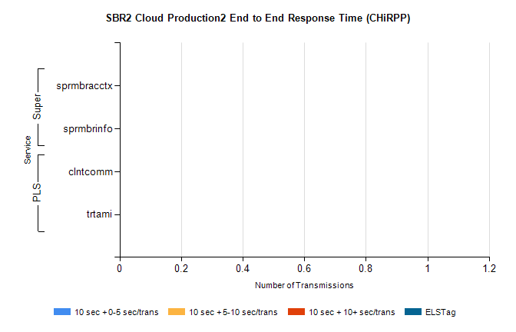
Stream | Service | 10 sec + 0-5 sec /trans | 10 sec + 5-10 sec /trans | 10 sec + >10 sec /trans | Total | % within 5 sec timing target
PLS | clntcomm | 0 | 0 | 0 | 42949 | 0.0%
PLS | trtami | 0 | 0 | 0 | 41 | 0.0%
Super | sprmbracctx | 0 | 0 | 0 | 2799 | 0.0%
Super | sprmbrinfo | 0 | 0 | 0 | 2522 | 0.0%

SBR1 Production Transactions

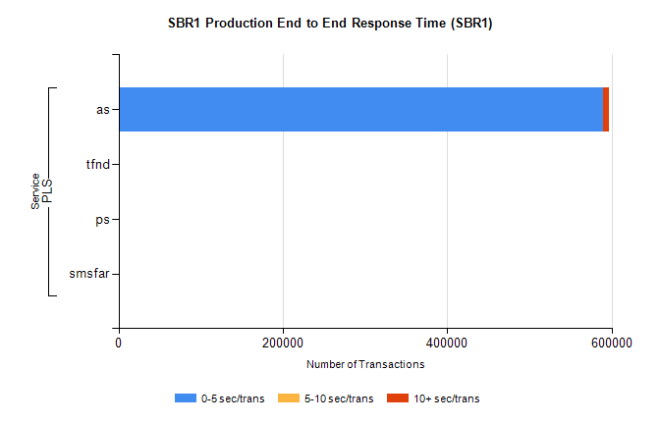
Stream | Service | 0-5 sec/trans | 5-10 sec/trans | 10+ sec/trans | Total | % within 5 sec timing target
PLS | as | 589340 | 445 | 7063 | 596848 | 98.7%
PLS | tfnd | 259 | 52 | 5 | 316 | 82.0%
PLS | ps | 28 | 22 | 101 | 151 | 18.5%
PLS | smsfar | 5 | 8 |  | 13 | 38.5%

