Transmission Timings Report Week - 13
24/03/2025 - 30/03/2025

SBR2 External Vendor Testing Environment (EVTE3)

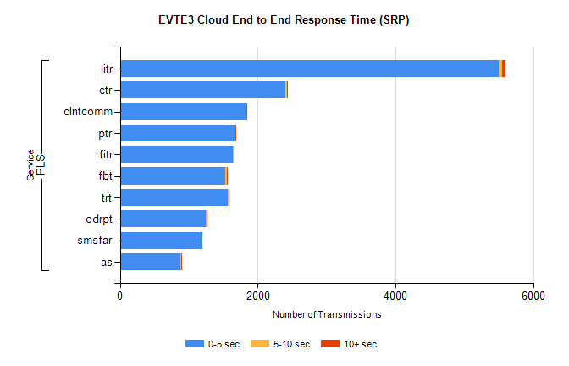
Stream | Service | 0-5 sec | 5-10 sec | >10 sec | Total | % within 5 sec timing target
PLS | iitr | 5503 | 47 | 51 | 5603 | 98.2%
PLS | ctr | 2398 | 25 | 1 | 2428 | 98.8%
PLS | clntcomm | 1830 | 2 | 4 | 1836 | 99.7%
PLS | ptr | 1666 | 15 | 2 | 1712 | 97.3%
PLS | fitr | 1640 | 1 | 0 | 1641 | 99.9%
PLS | fbt | 1530 | 21 | 3 | 1582 | 96.7%
PLS | trt | 1569 | 5 | 2 | 1578 | 99.4%
PLS | odrpt | 1249 | 4 | 1 | 1262 | 99.0%
PLS | smsfar | 1202 | 0 | 0 | 1202 | 100.0%
PLS | as | 880 | 14 | 3 | 993 | 88.6%

SBR2 External Vendor Testing Environment (EVTE3)

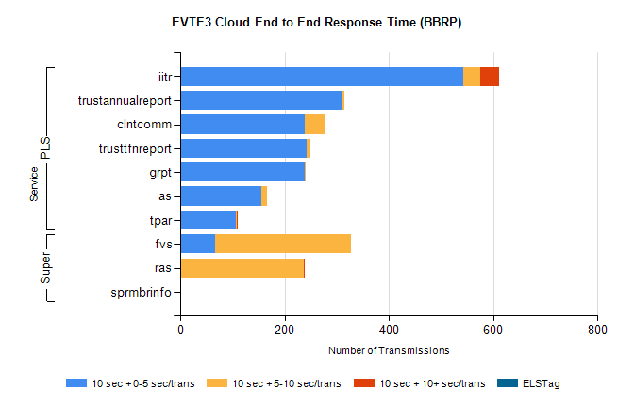
Stream | Service | 10 sec + 0-5 sec /trans | 10 sec + 5-10 sec /trans | 10 sec + >10 sec /trans | Processing Incomplete | ELStag | Total
PLS | iitr | 543 | 33 | 35 | 1 | 0 | 615
PLS | trustannualreport | 312 | 2 | 0 | 0 | 0 | 314
PLS | clntcomm | 239 | 37 | 0 | 0 | 0 | 277
PLS | trusttfnreport | 242 | 8 | 0 | 0 | 0 | 250
PLS | grpt | 238 | 1 | 0 | 0 | 0 | 239
PLS | as | 155 | 11 | 0 | 33 | 0 | 203
PLS | tpar | 107 | 1 | 1 | 0 | 0 | 115
Super | fvs | 67 | 261 | 0 | 7 | 0 | 352
Super | ras | 0 | 237 | 2 | 54 | 0 | 301
Super | sprmbrinfo | 0 | 0 | 0 | 0 | 0 | 136

