Transmission Timings Report Week - 13
24/03/2025 - 30/03/2025

SBR2 Cloud Production2 - Single Requests (SRP)

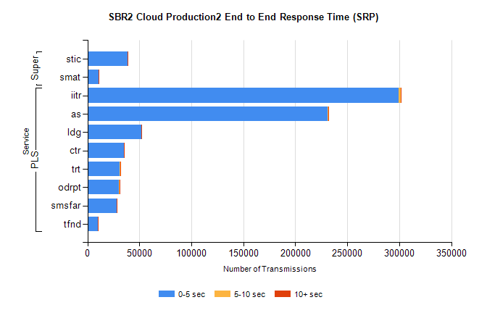
Stream | Service | 0-5 sec | 5-10 sec | >10 sec | Total | % within 5 sec timing target
PLS | iitr | 299579 | 2125 | 374 | 302125 | 99.2%
PLS | as | 231181 | 725 | 222 | 232168 | 99.6%
PLS | ldg | 51627 | 117 | 29 | 51776 | 99.7%
PLS | ctr | 35289 | 118 | 25 | 35436 | 99.6%
PLS | trt | 31256 | 103 | 31 | 31403 | 99.5%
PLS | odrpt | 30302 | 561 | 71 | 30934 | 98.0%
PLS | smsfar | 27904 | 60 | 15 | 27979 | 99.7%
PLS | tfnd | 10333 | 42 | 4 | 10379 | 99.6%
Super | stic | 38464 | 339 | 818 | 39626 | 97.1%
Super | smat | 10572 | 139 | 229 | 10940 | 96.6%

SBR2 Cloud Production2 - Bulk or Batch Requests (BBRP)

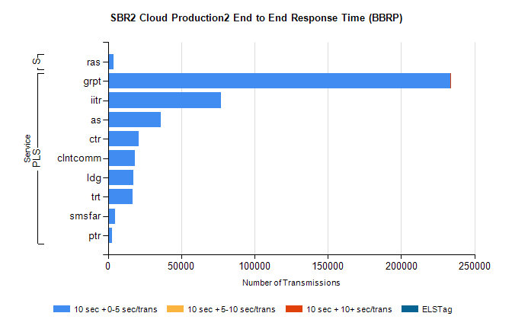
Stream | Service | 10 sec + 0-5 sec /trans | 10 sec + 5-10 sec /trans | 10 sec + >10 sec /trans | Processing Incomplete | ELStag | Total
PLS | grpt | 233288 | 240 | 1 | 151 | 0 | 233955
PLS | iitr | 77239 | 0 | 0 | 357 | 0 | 77596
PLS | as | 36236 | 0 | 0 | 269 | 0 | 36505
PLS | ctr | 20781 | 0 | 0 | 91 | 0 | 20872
PLS | clntcomm | 18573 | 0 | 0 | 0 | 0 | 18573
PLS | ldg | 17409 | 0 | 0 | 8 | 0 | 17417
PLS | trt | 16917 | 0 | 0 | 80 | 0 | 16997
PLS | smsfar | 5053 | 0 | 0 | 27 | 0 | 5080
PLS | ptr | 2700 | 0 | 0 | 15 | 0 | 2715
Super | ras | 3908 | 0 | 0 | 32 | 0 | 3940

SBR2 Cloud Production2 - ...

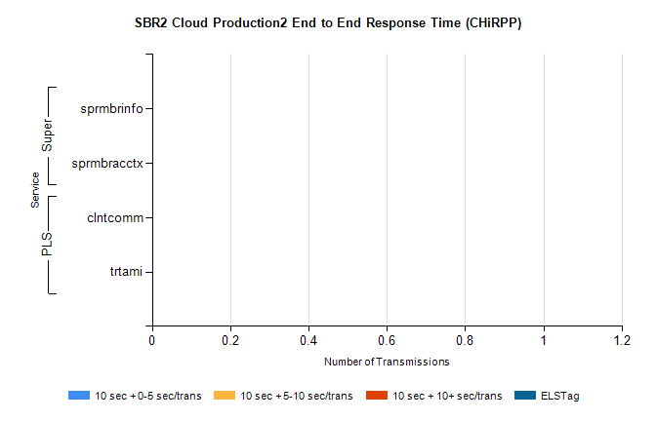
Stream | Service | 10 sec + 0-5 sec /trans | 10 sec + 5-10 sec /trans | 10 sec + >10 sec /trans | Total | % within 5 sec timing target
PLS | clntcomm | 0 | 0 | 0 | 28821 | 0.0%
PLS | trtami | 0 | 0 | 0 | 42 | 0.0%
Super | sprmbrinfo | 0 | 0 | 0 | 3150 | 0.0%
Super | sprmbracctx | 0 | 0 | 0 | 2921 | 0.0%

SBR1 Production Transactions

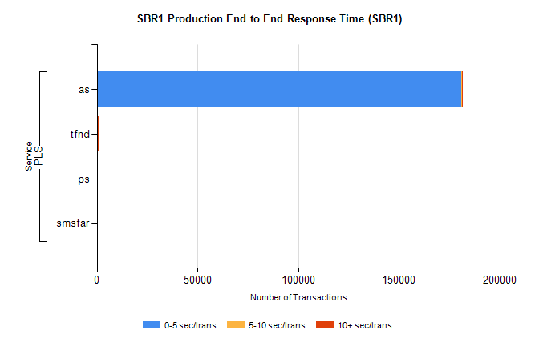
Stream | Service | 0-5 sec/trans | 5-10 sec/trans | 10+ sec/trans | Total | % within 5 sec timing target
PLS | as | 181019 | 233 | 225 | 181477 | 99.7%
PLS | tfnd | 432 | 44 | 12 | 488 | 88.5%
PLS | ps | 22 | 42 | 112 | 176 | 12.5%
PLS | smsfar | 12 | 15 | 4 | 31 | 38.7%

