Transmission Timings Report Week - 14
31/03/2025 - 6/04/2025

SBR2 External Vendor Testing Environment (EVTE3)

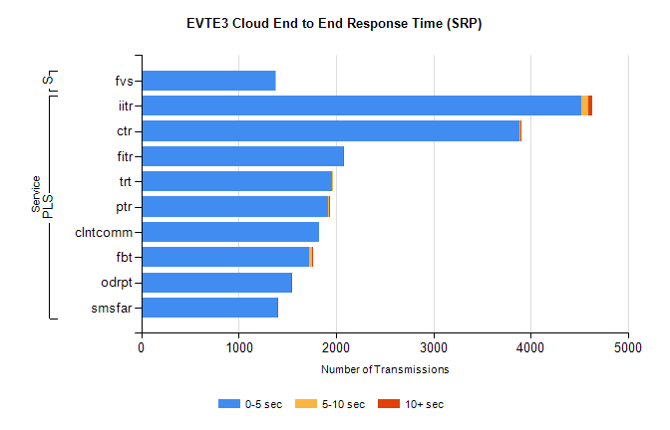
Stream | Service | 0-5 sec | 5-10 sec | >10 sec | Total | % within 5 sec timing target
PLS | iitr | 4524 | 64 | 42 | 4636 | 97.6%
PLS | ctr | 3882 | 18 | 3 | 3914 | 99.2%
PLS | fitr | 2070 | 6 | 1 | 2097 | 98.7%
PLS | trt | 1956 | 11 | 0 | 1972 | 99.2%
PLS | ptr | 1922 | 11 | 2 | 1961 | 98.0%
PLS | clntcomm | 1831 | 0 | 0 | 1832 | 99.9%
PLS | fbt | 1729 | 30 | 3 | 1772 | 97.6%
PLS | odrpt | 1535 | 1 | 5 | 1553 | 98.8%
PLS | smsfar | 1394 | 0 | 1 | 1395 | 99.9%
Super | fvs | 1380 | 5 | 0 | 1385 | 99.6%

SBR2 External Vendor Testing Environment (EVTE3)

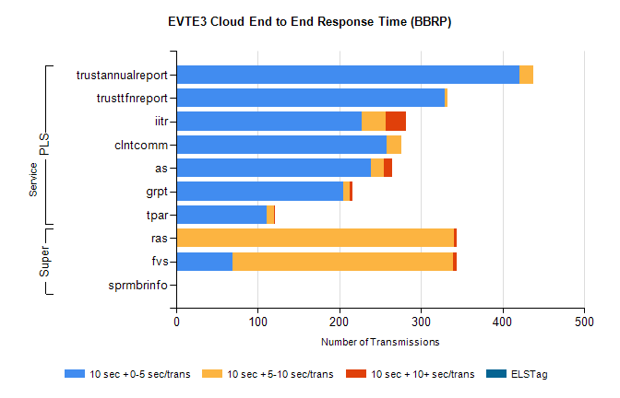
Stream | Service | 10 sec + 0-5 sec /trans | 10 sec + 5-10 sec /trans | 10 sec + >10 sec /trans | Processing Incomplete | ELStag | Total
PLS | trustannualreport | 421 | 16 | 0 | 0 | 0 | 439
PLS | trusttfnreport | 329 | 3 | 0 | 0 | 0 | 332
PLS | iitr | 227 | 30 | 24 | 0 | 0 | 287
PLS | clntcomm | 258 | 18 | 0 | 0 | 0 | 276
PLS | as | 238 | 16 | 10 | 1 | 0 | 274
PLS | grpt | 205 | 8 | 3 | 0 | 0 | 217
PLS | tpar | 111 | 9 | 1 | 0 | 0 | 128
Super | ras | 0 | 340 | 4 | 155 | 0 | 519
Super | fvs | 69 | 270 | 5 | 7 | 0 | 382
Super | sprmbrinfo | 0 | 0 | 0 | 0 | 0 | 127

