Transmission Timings Report Week - 14
31/03/2025 - 6/04/2025

SBR2 Cloud Production2 - Single Requests (SRP)

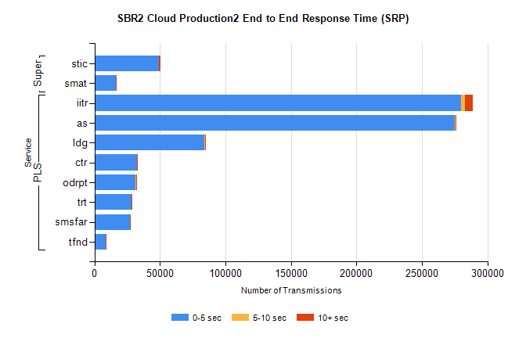
Stream | Service | 0-5 sec | 5-10 sec | >10 sec | Total | % within 5 sec timing target
PLS | iitr | 279795 | 2796 | 6263 | 288863 | 96.9%
PLS | as | 274948 | 900 | 330 | 276179 | 99.6%
PLS | ldg | 84079 | 231 | 40 | 84350 | 99.7%
PLS | ctr | 32608 | 172 | 34 | 32814 | 99.4%
PLS | odrpt | 31334 | 838 | 95 | 32267 | 97.1%
PLS | trt | 28365 | 131 | 48 | 28552 | 99.3%
PLS | smsfar | 27244 | 114 | 33 | 27391 | 99.5%
PLS | tfnd | 8633 | 68 | 14 | 8715 | 99.1%
Super | stic | 49228 | 198 | 937 | 50363 | 97.7%
Super | smat | 16300 | 246 | 133 | 16784 | 97.1%

SBR2 Cloud Production2 - Bulk or Batch Requests (BBRP)

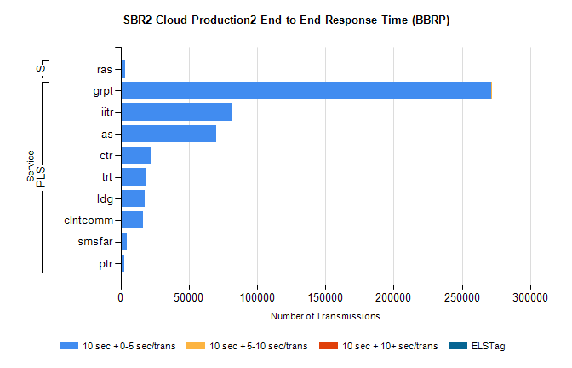
Stream | Service | 10 sec + 0-5 sec /trans | 10 sec + 5-10 sec /trans | 10 sec + >10 sec /trans | Processing Incomplete | ELStag | Total
PLS | grpt | 271525 | 2 | 0 | 9 | 0 | 271543
PLS | iitr | 82028 | 0 | 0 | 0 | 0 | 82028
PLS | as | 69731 | 0 | 0 | 0 | 0 | 69731
PLS | ctr | 22060 | 0 | 0 | 0 | 0 | 22060
PLS | trt | 18036 | 0 | 0 | 0 | 0 | 18036
PLS | ldg | 17765 | 0 | 0 | 0 | 0 | 17765
PLS | clntcomm | 16620 | 0 | 0 | 0 | 0 | 16620
PLS | smsfar | 4834 | 0 | 0 | 0 | 0 | 4834
PLS | ptr | 2700 | 0 | 0 | 0 | 0 | 2700
Super | ras | 3527 | 0 | 0 | 0 | 0 | 3527

SBR2 Cloud Production2 - ...

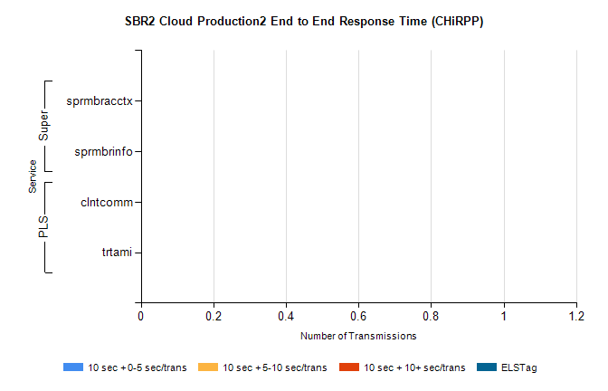
Stream | Service | 10 sec + 0-5 sec /trans | 10 sec + 5-10 sec /trans | 10 sec + >10 sec /trans | Total | % within 5 sec timing target
PLS | clntcomm | 0 | 0 | 0 | 36360 | 0.0%
PLS | trtami | 0 | 0 | 0 | 13 | 0.0%
Super | sprmbracctx | 0 | 0 | 0 | 5285 | 0.0%
Super | sprmbrinfo | 0 | 0 | 0 | 3072 | 0.0%

SBR1 Production Transactions

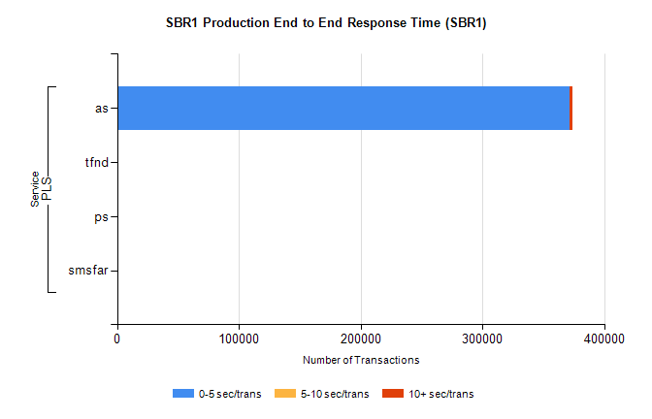
Stream | Service | 0-5 sec/trans | 5-10 sec/trans | 10+ sec/trans | Total | % within 5 sec timing target
PLS | as | 371354 | 169 | 2505 | 374028 | 99.3%
PLS | tfnd | 349 | 42 | 9 | 400 | 87.3%
PLS | ps | 27 | 27 | 111 | 165 | 16.4%
PLS | smsfar | 14 | 28 | 8 | 50 | 28.0%

