Transmission Timings Report Week - 15
7/04/2025 - 13/04/2025

SBR2 External Vendor Testing Environment (EVTE3)

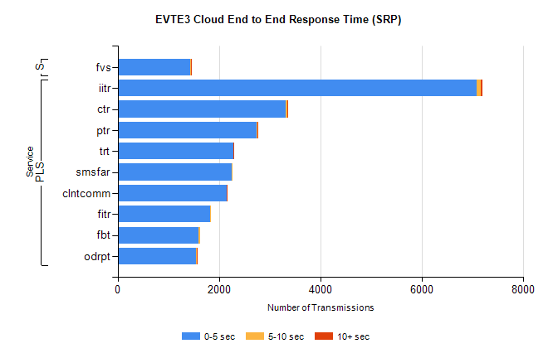
Stream | Service | 0-5 sec | 5-10 sec | >10 sec | Total | % within 5 sec timing target
PLS | iitr | 7090 | 74 | 36 | 7219 | 98.2%
PLS | ctr | 3323 | 27 | 2 | 3369 | 98.6%
PLS | ptr | 2750 | 13 | 1 | 2851 | 96.5%
PLS | trt | 2279 | 5 | 3 | 2302 | 99.0%
PLS | smsfar | 2256 | 4 | 0 | 2263 | 99.7%
PLS | clntcomm | 2149 | 6 | 1 | 2156 | 99.7%
PLS | fitr | 1832 | 5 | 0 | 1864 | 98.3%
PLS | fbt | 1603 | 32 | 0 | 1638 | 97.9%
PLS | odrpt | 1552 | 14 | 9 | 1593 | 97.4%
Super | fvs | 1439 | 7 | 4 | 1450 | 99.2%

SBR2 External Vendor Testing Environment (EVTE3)

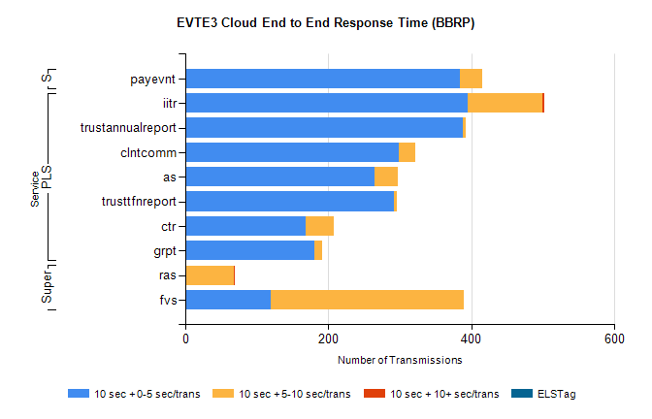
Stream | Service | 10 sec + 0-5 sec /trans | 10 sec + 5-10 sec /trans | 10 sec + >10 sec /trans | Processing Incomplete | ELStag | Total
PLS | iitr | 395 | 104 | 3 | 43 | 0 | 552
PLS | trustannualreport | 388 | 4 | 0 | 0 | 0 | 392
PLS | clntcomm | 298 | 24 | 0 | 0 | 0 | 322
PLS | as | 265 | 32 | 0 | 5 | 0 | 306
PLS | trusttfnreport | 291 | 5 | 0 | 0 | 0 | 296
PLS | ctr | 168 | 39 | 0 | 73 | 0 | 280
PLS | grpt | 180 | 11 | 0 | 0 | 0 | 192
Super | ras | 0 | 68 | 1 | 459 | 0 | 531
Super | fvs | 119 | 271 | 0 | 7 | 0 | 407
STP | payevnt | 384 | 31 | 0 | 9 | 0 | 426

SBR2 External Vendor Testing Environment (EVTE3)

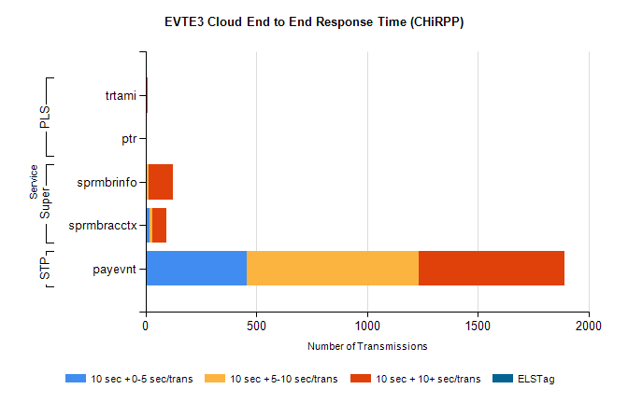
Stream | Service | 10 sec + 0-5 sec /trans | 10 sec + 5-10 sec /trans | 10 sec + >10 sec /trans | Total | % within 5 sec timing target
STP | payevnt | 456 | 777 | 659 | 2764 | 16.5%
Super | sprmbrinfo | 7 | 8 | 107 | 140 | 5.1%
Super | sprmbracctx | 18 | 12 | 63 | 99 | 18.2%
PLS | trtami | 0 | 0 | 11 | 11 | 0.0%
PLS | ptr | 0 | 0 | 1 | 1 | 0.0%

