Transmission Timings Report Week - 15
7/04/2025 - 13/04/2025

SBR2 Cloud Production2 - Single | Bulk or Batch Requests | (SRP, BBRP & CHiRPP)

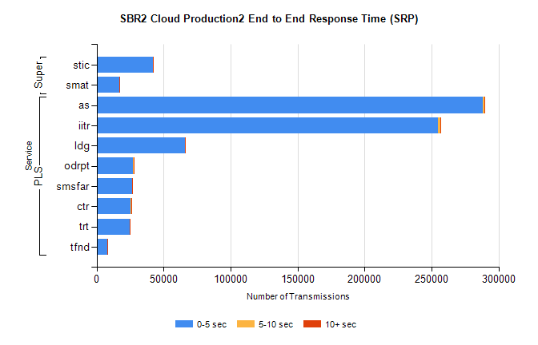
Stream | Service | 0-5 sec | 5-10 sec | >10 sec | Total | % within 5 sec timing target
PLS | as | 288400 | 969 | 226 | 289595 | 99.6%
PLS | iitr | 254710 | 2011 | 286 | 257007 | 99.1%
PLS | ldg | 65925 | 166 | 13 | 66104 | 99.7%
PLS | odrpt | 27145 | 660 | 49 | 27854 | 97.5%
PLS | smsfar | 26383 | 76 | 12 | 26471 | 99.7%
PLS | ctr | 25569 | 103 | 11 | 25683 | 99.6%
PLS | trt | 24815 | 83 | 21 | 24919 | 99.6%
PLS | tfnd | 8183 | 38 | 5 | 8226 | 99.5%
Super | stic | 42123 | 124 | 74 | 42321 | 99.5%
Super | smat | 16859 | 180 | 55 | 17094 | 98.6%

SBR2 Cloud Production2 - Single | Bulk or Batch Requests | (SRP, BBRP & CHiRPP)

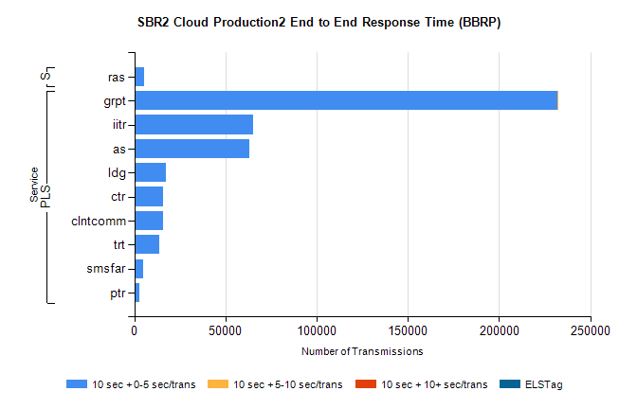
Stream | Service | 10 sec + 0-5 sec /trans | 10 sec + 5-10 sec /trans | 10 sec + >10 sec /trans | Processing Incomplete | ELStag | Total
PLS | grpt | 232092 | 12 | 0 | 0 | 0 | 232106
PLS | iitr | 65305 | 0 | 0 | 0 | 0 | 65305
PLS | as | 63004 | 0 | 0 | 0 | 0 | 63004
PLS | ldg | 17079 | 0 | 0 | 0 | 0 | 17079
PLS | ctr | 15550 | 0 | 0 | 0 | 0 | 15550
PLS | clntcomm | 15514 | 0 | 0 | 0 | 0 | 15514
PLS | trt | 13826 | 0 | 0 | 0 | 0 | 13826
PLS | smsfar | 4918 | 0 | 0 | 0 | 0 | 4918
PLS | ptr | 2541 | 0 | 0 | 0 | 0 | 2541
Super | ras | 5245 | 0 | 0 | 0 | 0 | 5245

SBR2 Cloud Production2 - Single | Bulk or Batch Requests | (SRP, BBRP & CHiRPP)

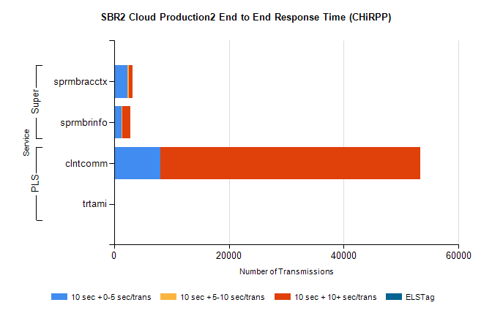
Stream | Service | 10 sec + 0-5 sec /trans | 10 sec + 5-10 sec /trans | 10 sec + >10 sec /trans | Total | % within 5 sec timing target
PLS | clntcomm | 8068 | 0 | 45261 | 53360 | 15.1%
PLS | trtami | 1 | 0 | 27 | 28 | 3.6%
Super | sprmbracctx | 2351 | 248 | 618 | 3434 | 68.5%
Super | sprmbrinfo | 1283 | 160 | 1352 | 2965 | 43.3%

SBR1 Production Transactions

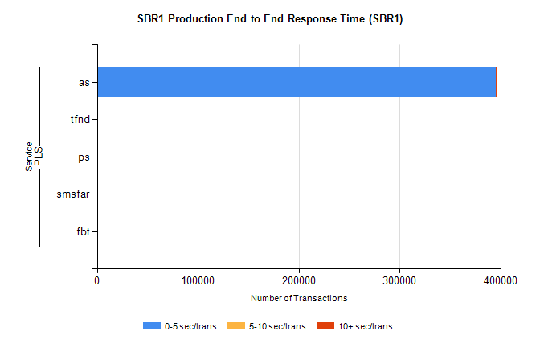
Stream | Service | 0-5 sec/trans | 5-10 sec/trans | 10+ sec/trans | Total | % within 5 sec timing target
PLS | as | 395354 | 124 | 252 | 395730 | 99.9%
PLS | tfnd | 473 | 59 | 7 | 539 | 87.8%
PLS | ps | 28 | 35 | 87 | 150 | 18.7%
PLS | smsfar | 10 | 23 | 2 | 35 | 28.6%
PLS | fbt |  | 1 |  | 1 | 0.0%

