Transmission Timings Report Week - 16
14/04/2025 - 20/04/2025

SBR2 External Vendor Testing Environment (EVTE3)

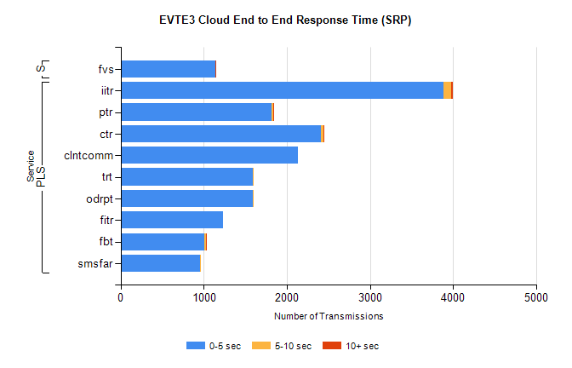
Stream | Service | 0-5 sec | 5-10 sec | >10 sec | Total | % within 5 sec timing target
PLS | iitr | 3883 | 97 | 23 | 4047 | 95.9%
PLS | ptr | 1816 | 19 | 1 | 2892 | 62.8%
PLS | ctr | 2412 | 34 | 1 | 2459 | 98.1%
PLS | clntcomm | 2133 | 0 | 0 | 2134 | 100.0%
PLS | trt | 1590 | 14 | 0 | 1628 | 97.7%
PLS | odrpt | 1594 | 4 | 0 | 1603 | 99.4%
PLS | fitr | 1237 | 0 | 0 | 1247 | 99.2%
PLS | fbt | 1007 | 25 | 1 | 1068 | 94.3%
PLS | smsfar | 958 | 1 | 0 | 979 | 97.9%
Super | fvs | 1140 | 3 | 2 | 1145 | 99.6%

SBR2 External Vendor Testing Environment (EVTE3)

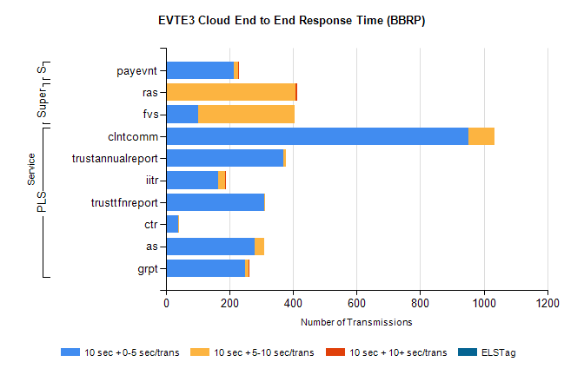
Stream | Service | 10 sec + 0-5 sec /trans | 10 sec + 5-10 sec /trans | 10 sec + >10 sec /trans | Processing Incomplete | ELStag | Total
PLS | clntcomm | 952 | 81 | 0 | 0 | 0 | 1033
PLS | trustannualreport | 370 | 8 | 0 | 80 | 0 | 458
PLS | iitr | 164 | 23 | 1 | 204 | 0 | 396
PLS | trusttfnreport | 310 | 2 | 0 | 77 | 0 | 389
PLS | ctr | 38 | 1 | 0 | 337 | 0 | 376
PLS | as | 278 | 31 | 0 | 16 | 0 | 325
PLS | grpt | 250 | 11 | 1 | 0 | 0 | 267
Super | ras | 0 | 407 | 6 | 0 | 0 | 441
Super | fvs | 102 | 304 | 0 | 5 | 0 | 419
STP | payevnt | 212 | 15 | 2 | 26 | 0 | 255

SBR2 External Vendor Testing Environment (EVTE3)

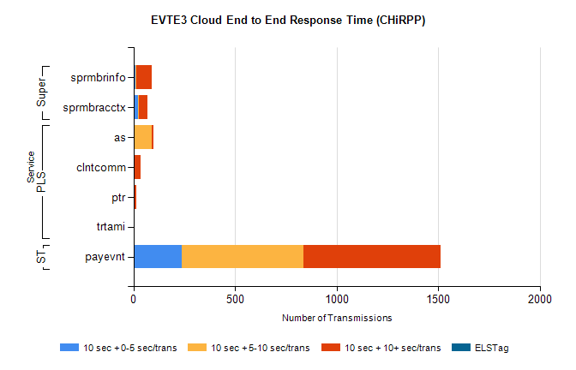
Stream | Service | 10 sec + 0-5 sec /trans | 10 sec + 5-10 sec /trans | 10 sec + >10 sec /trans | Total | % within 5 sec timing target
STP | payevnt | 237 | 600 | 673 | 2259 | 10.5%
Super | sprmbrinfo | 9 | 5 | 74 | 102 | 8.8%
Super | sprmbracctx | 22 | 6 | 41 | 87 | 25.3%
PLS | as | 0 | 89 | 7 | 114 | 0.0%
PLS | clntcomm | 0 | 0 | 35 | 35 | 0.0%
PLS | ptr | 4 | 0 | 10 | 16 | 25.0%
PLS | trtami | 0 | 0 | 3 | 3 | 0.0%

