Transmission Timings Report Week - 16
14/04/2025 - 20/04/2025

SBR2 Cloud Production2 - Single | Bulk or Batch Requests | (SRP, BBRP & CHiRPP)

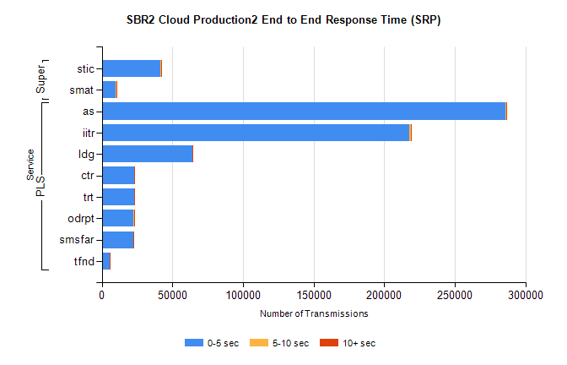
Stream | Service | 0-5 sec | 5-10 sec | >10 sec | Total | % within 5 sec timing target
PLS | as | 285664 | 1049 | 202 | 286915 | 99.6%
PLS | iitr | 217641 | 1471 | 256 | 219368 | 99.2%
PLS | ldg | 64013 | 99 | 26 | 64138 | 99.8%
PLS | ctr | 23137 | 67 | 13 | 23217 | 99.7%
PLS | trt | 22912 | 78 | 21 | 23011 | 99.6%
PLS | odrpt | 22221 | 600 | 44 | 22865 | 97.2%
PLS | smsfar | 22337 | 71 | 30 | 22438 | 99.5%
PLS | tfnd | 5663 | 18 | 3 | 5684 | 99.6%
Super | stic | 41609 | 191 | 53 | 41853 | 99.4%
Super | smat | 10077 | 103 | 33 | 10213 | 98.7%

SBR2 Cloud Production2 - Single | Bulk or Batch Requests | (SRP, BBRP & CHiRPP)

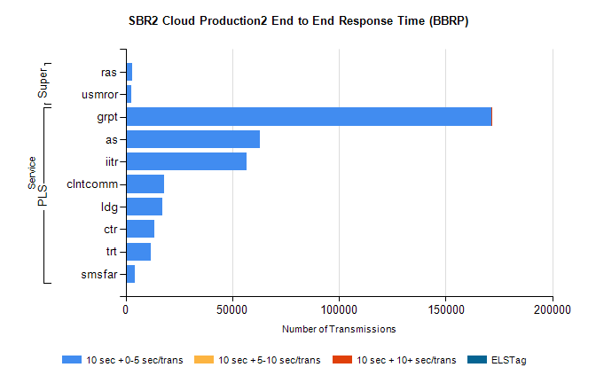
Stream | Service | 10 sec + 0-5 sec /trans | 10 sec + 5-10 sec /trans | 10 sec + >10 sec /trans | Processing Incomplete | ELStag | Total
PLS | grpt | 171553 | 0 | 25 | 0 | 0 | 171578
PLS | as | 62750 | 0 | 0 | 0 | 0 | 62750
PLS | iitr | 56552 | 0 | 0 | 0 | 0 | 56552
PLS | clntcomm | 18097 | 0 | 0 | 0 | 0 | 18097
PLS | ldg | 17313 | 0 | 0 | 0 | 0 | 17313
PLS | ctr | 13541 | 0 | 0 | 0 | 0 | 13541
PLS | trt | 11836 | 0 | 0 | 0 | 0 | 11836
PLS | smsfar | 4146 | 0 | 0 | 0 | 0 | 4146
Super | ras | 3165 | 0 | 0 | 0 | 0 | 3165
Super | usmror | 2558 | 0 | 0 | 0 | 0 | 2558

SBR2 Cloud Production2 - Single | Bulk or Batch Requests | (SRP, BBRP & CHiRPP)

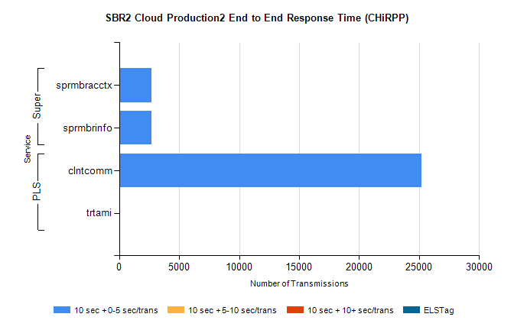
Stream | Service | 10 sec + 0-5 sec /trans | 10 sec + 5-10 sec /trans | 10 sec + >10 sec /trans | Total | % within 5 sec timing target
PLS | clntcomm | 25217 | 0 | 0 | 25217 | 100.0%
PLS | trtami | 6 | 0 | 0 | 6 | 100.0%
Super | sprmbracctx | 2666 | 0 | 0 | 2666 | 100.0%
Super | sprmbrinfo | 2664 | 0 | 0 | 2664 | 100.0%

SBR1 Production Transactions

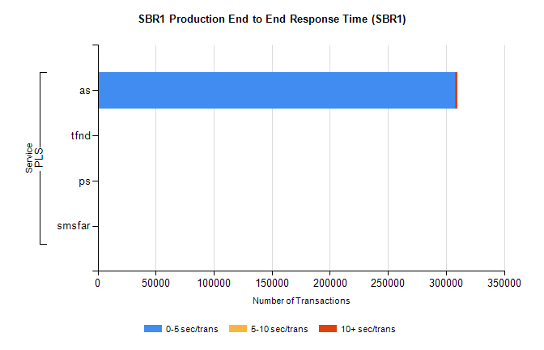
Stream | Service | 0-5 sec/trans | 5-10 sec/trans | 10+ sec/trans | Total | % within 5 sec timing target
PLS | as | 307695 | 158 | 2266 | 310119 | 99.2%
PLS | tfnd | 387 | 49 | 10 | 446 | 86.8%
PLS | ps | 21 | 32 | 93 | 146 | 14.4%
PLS | smsfar | 2 | 19 | 4 | 25 | 8.0%

