Transmission Timings Report Week - 17
21/04/2025 - 27/04/2025

SBR2 External Vendor Testing Environment (EVTE3)

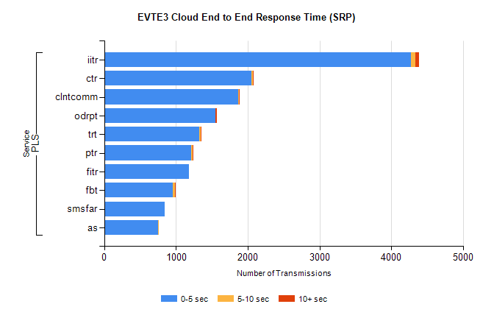
Stream | Service | 0-5 sec | 5-10 sec | >10 sec | Total | % within 5 sec timing target
PLS | iitr | 4274 | 66 | 52 | 4406 | 97.0%
PLS | ctr | 2050 | 27 | 3 | 2118 | 96.8%
PLS | clntcomm | 1872 | 1 | 16 | 1899 | 98.6%
PLS | odrpt | 1545 | 6 | 22 | 1615 | 95.7%
PLS | trt | 1326 | 19 | 2 | 1375 | 96.4%
PLS | ptr | 1217 | 13 | 1 | 1259 | 96.7%
PLS | fitr | 1177 | 0 | 0 | 1200 | 98.1%
PLS | fbt | 957 | 33 | 2 | 1009 | 94.8%
PLS | smsfar | 839 | 0 | 0 | 843 | 99.5%
PLS | as | 756 | 4 | 0 | 780 | 96.9%

SBR2 External Vendor Testing Environment (EVTE3)

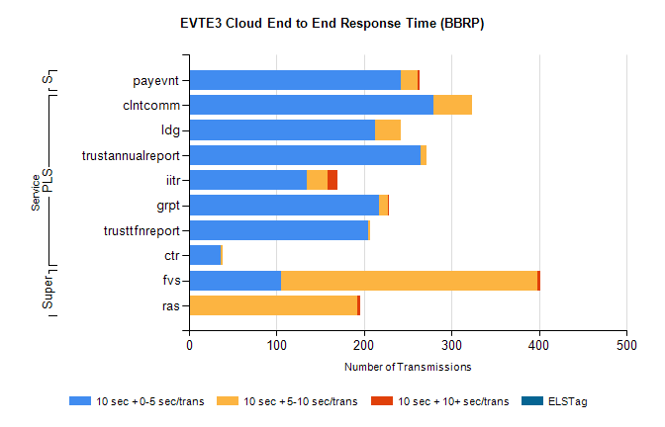
Stream | Service | 10 sec + 0-5 sec /trans | 10 sec + 5-10 sec /trans | 10 sec + >10 sec /trans | Processing Incomplete | ELStag | Total
PLS | clntcomm | 279 | 44 | 0 | 0 | 0 | 323
PLS | ldg | 212 | 30 | 0 | 50 | 0 | 299
PLS | trustannualreport | 265 | 6 | 0 | 0 | 0 | 271
PLS | iitr | 134 | 24 | 12 | 51 | 0 | 234
PLS | grpt | 217 | 10 | 1 | 0 | 0 | 228
PLS | trusttfnreport | 205 | 2 | 0 | 0 | 0 | 207
PLS | ctr | 36 | 2 | 0 | 103 | 0 | 141
Super | fvs | 105 | 293 | 3 | 5 | 0 | 415
Super | ras | 0 | 192 | 4 | 0 | 0 | 202
STP | payevnt | 242 | 19 | 2 | 25 | 0 | 291

SBR2 External Vendor Testing Environment (EVTE3)

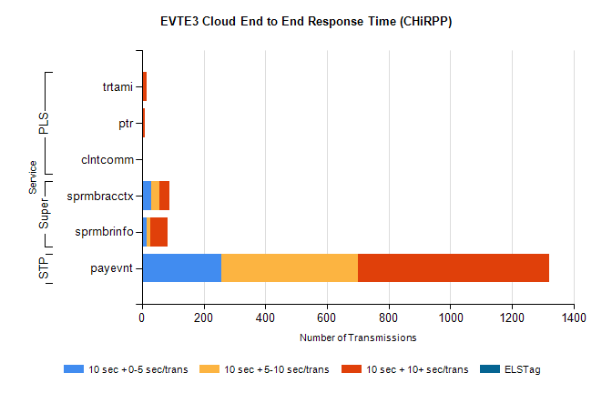
Stream | Service | 10 sec + 0-5 sec /trans | 10 sec + 5-10 sec /trans | 10 sec + >10 sec /trans | Total | % within 5 sec timing target
STP | payevnt | 259 | 441 | 622 | 1889 | 13.7%
Super | sprmbracctx | 31 | 26 | 32 | 95 | 32.6%
Super | sprmbrinfo | 16 | 10 | 57 | 93 | 17.2%
PLS | trtami | 0 | 2 | 13 | 15 | 0.0%
PLS | ptr | 0 | 0 | 9 | 9 | 0.0%
PLS | clntcomm | 0 | 0 | 3 | 5 | 0.0%

