Transmission Timings Report Week - 17
21/04/2025 - 27/04/2025

SBR2 Cloud Production2 - Single | Bulk or Batch Requests | (SRP, BBRP & CHiRPP)

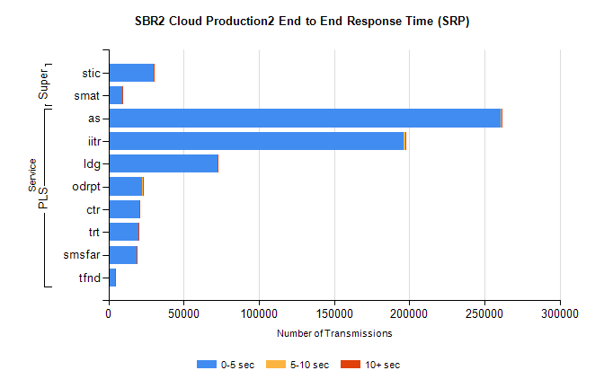
Stream | Service | 0-5 sec | 5-10 sec | >10 sec | Total | % within 5 sec timing target
PLS | as | 260660 | 396 | 79 | 261135 | 99.8%
PLS | iitr | 196331 | 1120 | 226 | 197677 | 99.3%
PLS | ldg | 72721 | 76 | 18 | 72815 | 99.9%
PLS | odrpt | 22468 | 416 | 34 | 22918 | 98.0%
PLS | ctr | 20785 | 36 | 12 | 20833 | 99.8%
PLS | trt | 19698 | 51 | 19 | 19768 | 99.6%
PLS | smsfar | 18990 | 20 | 21 | 19031 | 99.8%
PLS | tfnd | 4708 | 11 | 3 | 4722 | 99.7%
Super | stic | 30228 | 153 | 59 | 30440 | 99.3%
Super | smat | 9203 | 86 | 39 | 9328 | 98.7%

SBR2 Cloud Production2 - Single | Bulk or Batch Requests | (SRP, BBRP & CHiRPP)

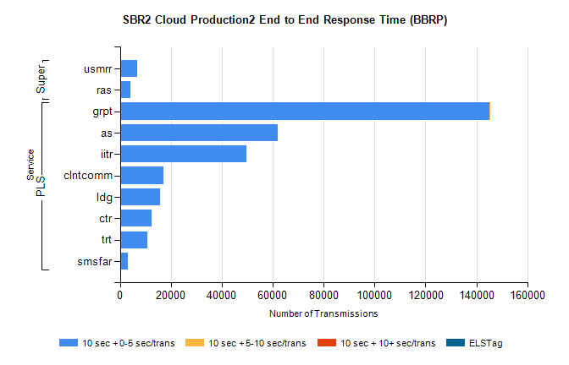
Stream | Service | 10 sec + 0-5 sec /trans | 10 sec + 5-10 sec /trans | 10 sec + >10 sec /trans | Processing Incomplete | ELStag | Total
PLS | grpt | 145006 | 18 | 0 | 0 | 0 | 145032
PLS | as | 61806 | 0 | 0 | 0 | 0 | 61806
PLS | iitr | 49785 | 0 | 0 | 0 | 0 | 49785
PLS | clntcomm | 17198 | 0 | 0 | 0 | 0 | 17198
PLS | ldg | 15859 | 0 | 0 | 0 | 0 | 15859
PLS | ctr | 12439 | 0 | 0 | 0 | 0 | 12439
PLS | trt | 10797 | 0 | 0 | 0 | 0 | 10797
PLS | smsfar | 3157 | 0 | 0 | 0 | 0 | 3157
Super | usmrr | 6809 | 0 | 0 | 0 | 0 | 6809
Super | ras | 3997 | 0 | 0 | 0 | 0 | 3997

SBR2 Cloud Production2 - Single | Bulk or Batch Requests | (SRP, BBRP & CHiRPP)

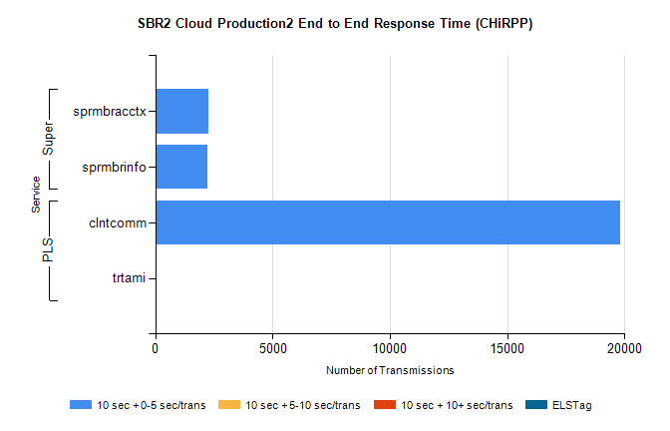
Stream | Service | 10 sec + 0-5 sec /trans | 10 sec + 5-10 sec /trans | 10 sec + >10 sec /trans | Total | % within 5 sec timing target
PLS | clntcomm | 19814 | 0 | 0 | 19814 | 100.0%
PLS | trtami | 6 | 0 | 0 | 6 | 100.0%
Super | sprmbracctx | 2276 | 0 | 0 | 2276 | 100.0%
Super | sprmbrinfo | 2213 | 0 | 0 | 2213 | 100.0%

SBR1 Production Transactions

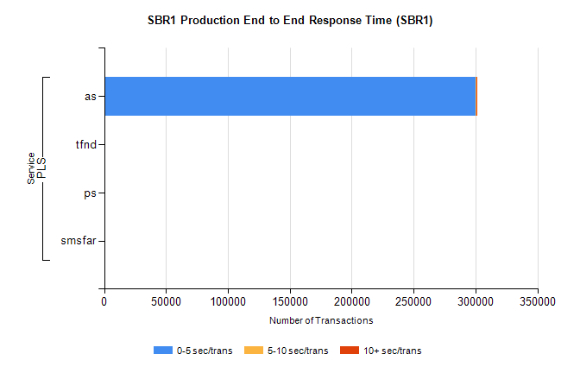
Stream | Service | 0-5 sec/trans | 5-10 sec/trans | 10+ sec/trans | Total | % within 5 sec timing target
PLS | as | 300254 | 152 | 69 | 300475 | 99.9%
PLS | tfnd | 289 | 54 | 12 | 355 | 81.4%
PLS | ps | 27 | 21 | 80 | 128 | 21.1%
PLS | smsfar | 2 | 5 |  | 7 | 28.6%

