Transmission Timings Report Week - 18
28/04/2025 - 4/05/2025

SBR2 External Vendor Testing Environment (EVTE3)

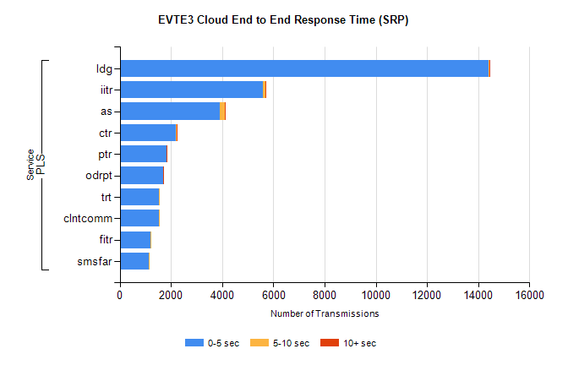
Stream | Service | 0-5 sec | 5-10 sec | >10 sec | Total | % within 5 sec timing target
PLS | ldg | 14407 | 46 | 4 | 14459 | 99.6%
PLS | iitr | 5606 | 75 | 31 | 5724 | 97.9%
PLS | as | 3916 | 199 | 16 | 4227 | 92.6%
PLS | ctr | 2205 | 29 | 1 | 2309 | 95.5%
PLS | ptr | 1819 | 22 | 1 | 1905 | 95.5%
PLS | odrpt | 1702 | 4 | 1 | 1711 | 99.5%
PLS | trt | 1531 | 10 | 0 | 1556 | 98.4%
PLS | clntcomm | 1531 | 1 | 0 | 1532 | 99.9%
PLS | fitr | 1183 | 4 | 0 | 1188 | 99.6%
PLS | smsfar | 1130 | 3 | 0 | 1139 | 99.2%

SBR2 External Vendor Testing Environment (EVTE3)

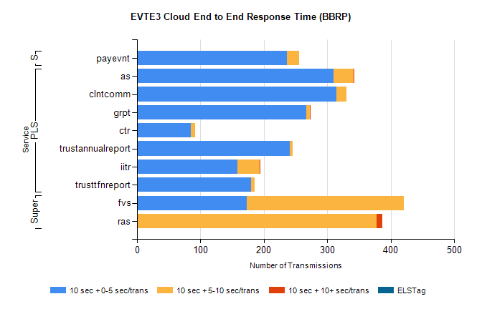
Stream | Service | 10 sec + 0-5 sec /trans | 10 sec + 5-10 sec /trans | 10 sec + >10 sec /trans | Processing Incomplete | ELStag | Total
PLS | as | 310 | 31 | 2 | 16 | 0 | 359
PLS | clntcomm | 314 | 16 | 0 | 1 | 0 | 331
PLS | grpt | 267 | 5 | 1 | 0 | 0 | 273
PLS | ctr | 85 | 6 | 0 | 177 | 0 | 272
PLS | trustannualreport | 241 | 4 | 0 | 0 | 0 | 245
PLS | iitr | 158 | 35 | 1 | 37 | 0 | 240
PLS | trusttfnreport | 180 | 5 | 0 | 0 | 0 | 185
Super | fvs | 173 | 248 | 0 | 6 | 0 | 444
Super | ras | 0 | 378 | 9 | 0 | 0 | 399
STP | payevnt | 236 | 19 | 0 | 40 | 0 | 296

SBR2 External Vendor Testing Environment (EVTE3)

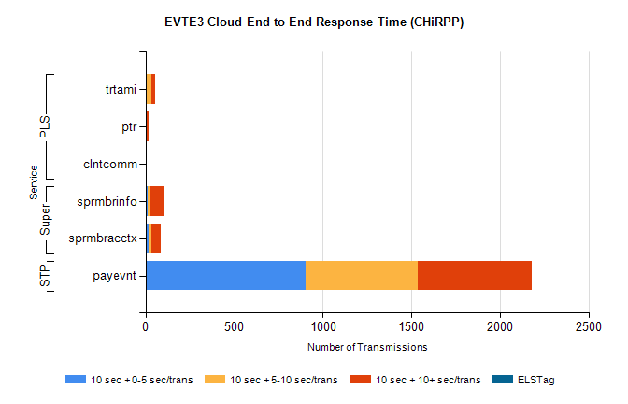
Stream | Service | 10 sec + 0-5 sec /trans | 10 sec + 5-10 sec /trans | 10 sec + >10 sec /trans | Total | % within 5 sec timing target
STP | payevnt | 904 | 632 | 643 | 2948 | 30.7%
Super | sprmbrinfo | 12 | 15 | 81 | 121 | 9.9%
Super | sprmbracctx | 19 | 13 | 54 | 110 | 17.3%
PLS | trtami | 1 | 30 | 22 | 56 | 1.8%
PLS | ptr | 1 | 7 | 7 | 17 | 5.9%
PLS | clntcomm | 0 | 0 | 6 | 7 | 0.0%

