Transmission Timings Report Week - 18
28/04/2025 - 4/05/2025

SBR2 Cloud Production2 - Single | Bulk or Batch Requests | (SRP, BBRP & CHiRPP)

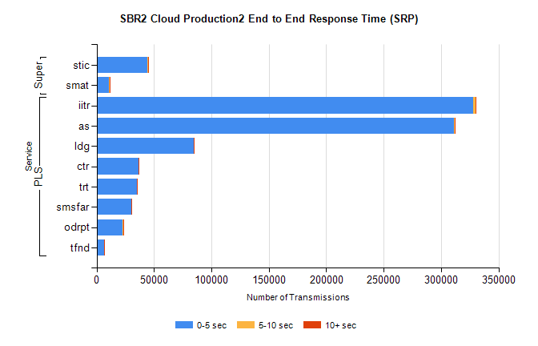
Stream | Service | 0-5 sec | 5-10 sec | >10 sec | Total | % within 5 sec timing target
PLS | iitr | 327797 | 1915 | 336 | 330048 | 99.3%
PLS | as | 310883 | 728 | 453 | 312064 | 99.6%
PLS | ldg | 84524 | 133 | 50 | 84707 | 99.8%
PLS | ctr | 36621 | 68 | 16 | 36705 | 99.8%
PLS | trt | 35079 | 71 | 31 | 35181 | 99.7%
PLS | smsfar | 30096 | 55 | 14 | 30165 | 99.8%
PLS | odrpt | 22766 | 620 | 46 | 23432 | 97.2%
PLS | tfnd | 6763 | 24 | 3 | 6790 | 99.6%
Super | stic | 44493 | 182 | 118 | 44793 | 99.3%
Super | smat | 11043 | 91 | 43 | 11177 | 98.8%

SBR2 Cloud Production2 - Single | Bulk or Batch Requests | (SRP, BBRP & CHiRPP)

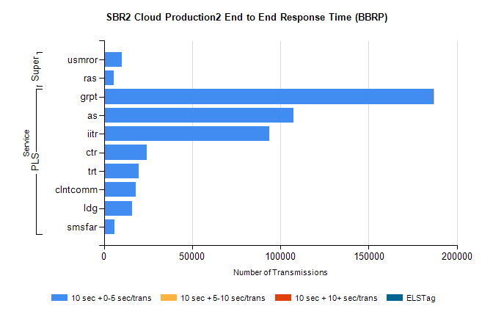
Stream | Service | 10 sec + 0-5 sec /trans | 10 sec + 5-10 sec /trans | 10 sec + >10 sec /trans | Processing Incomplete | ELStag | Total
PLS | grpt | 186773 | 21 | 0 | 0 | 0 | 186812
PLS | as | 107441 | 0 | 0 | 0 | 0 | 107441
PLS | iitr | 93636 | 0 | 0 | 0 | 0 | 93636
PLS | ctr | 24336 | 0 | 0 | 0 | 0 | 24336
PLS | trt | 19820 | 0 | 0 | 0 | 0 | 19820
PLS | clntcomm | 18057 | 0 | 0 | 0 | 0 | 18057
PLS | ldg | 15791 | 0 | 0 | 0 | 0 | 15791
PLS | smsfar | 5782 | 0 | 0 | 0 | 0 | 5782
Super | usmror | 10072 | 0 | 0 | 0 | 0 | 10072
Super | ras | 5677 | 0 | 0 | 0 | 0 | 5677

SBR2 Cloud Production2 - Single | Bulk or Batch Requests | (SRP, BBRP & CHiRPP)

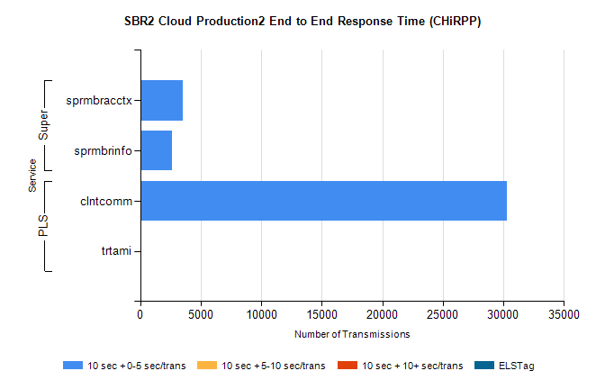
Stream | Service | 10 sec + 0-5 sec /trans | 10 sec + 5-10 sec /trans | 10 sec + >10 sec /trans | Total | % within 5 sec timing target
PLS | clntcomm | 30283 | 0 | 0 | 30283 | 100.0%
PLS | trtami | 63 | 0 | 0 | 63 | 100.0%
Super | sprmbracctx | 3502 | 0 | 0 | 3502 | 100.0%
Super | sprmbrinfo | 2609 | 0 | 0 | 2609 | 100.0%

SBR1 Production Transactions

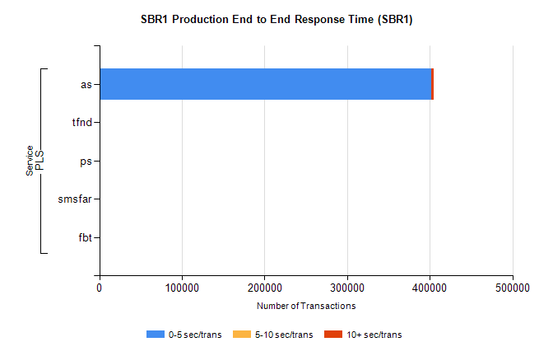
Stream | Service | 0-5 sec/trans | 5-10 sec/trans | 10+ sec/trans | Total | % within 5 sec timing target
PLS | as | 401702 | 180 | 2540 | 404422 | 99.3%
PLS | tfnd | 313 | 41 | 16 | 370 | 84.6%
PLS | ps | 43 | 36 | 113 | 192 | 22.4%
PLS | smsfar | 12 | 30 | 10 | 52 | 23.1%
PLS | fbt |  | 1 |  | 1 | 0.0%

