Transmission Timings Report Week - 19
5/05/2025 - 11/05/2025

SBR2 External Vendor Testing Environment (EVTE3)

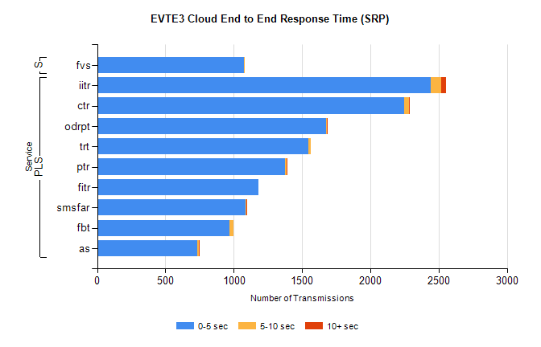
Stream | Service | 0-5 sec | 5-10 sec | >10 sec | Total | % within 5 sec timing target
PLS | iitr | 2440 | 80 | 32 | 2554 | 95.5%
PLS | ctr | 2247 | 35 | 2 | 2322 | 96.8%
PLS | odrpt | 1675 | 9 | 2 | 1702 | 98.4%
PLS | trt | 1547 | 16 | 0 | 1584 | 97.7%
PLS | ptr | 1377 | 8 | 2 | 1392 | 98.9%
PLS | fitr | 1179 | 0 | 0 | 1179 | 100.0%
PLS | smsfar | 1087 | 4 | 1 | 1092 | 99.5%
PLS | fbt | 971 | 25 | 0 | 1019 | 95.3%
PLS | as | 734 | 8 | 3 | 902 | 81.4%
Super | fvs | 1076 | 6 | 0 | 1082 | 99.4%

SBR2 External Vendor Testing Environment (EVTE3)

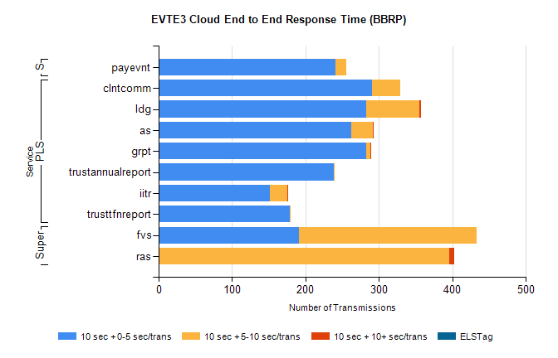
Stream | Service | 10 sec + 0-5 sec /trans | 10 sec + 5-10 sec /trans | 10 sec + >10 sec /trans | Processing Incomplete | ELStag | Total
PLS | clntcomm | 291 | 38 | 0 | 198 | 0 | 527
PLS | ldg | 283 | 72 | 2 | 3 | 0 | 395
PLS | as | 262 | 30 | 1 | 7 | 0 | 301
PLS | grpt | 283 | 5 | 1 | 0 | 0 | 289
PLS | trustannualreport | 238 | 2 | 0 | 0 | 0 | 240
PLS | iitr | 152 | 23 | 1 | 13 | 0 | 194
PLS | trusttfnreport | 179 | 1 | 0 | 0 | 0 | 180
Super | fvs | 191 | 242 | 0 | 7 | 0 | 451
Super | ras | 0 | 396 | 6 | 0 | 0 | 416
STP | payevnt | 241 | 14 | 0 | 43 | 0 | 298

SBR2 External Vendor Testing Environment (EVTE3)

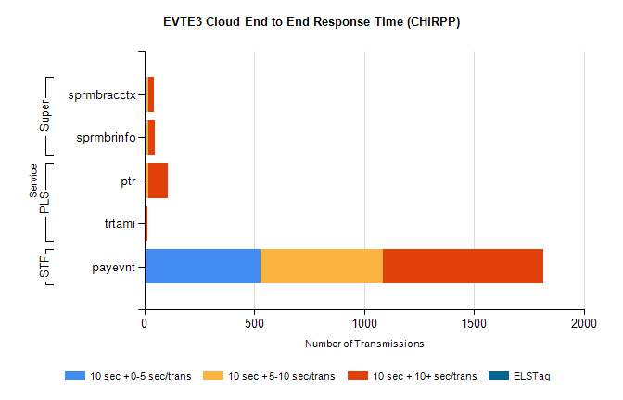
Stream | Service | 10 sec + 0-5 sec /trans | 10 sec + 5-10 sec /trans | 10 sec + >10 sec /trans | Total | % within 5 sec timing target
STP | payevnt | 528 | 558 | 728 | 2526 | 20.9%
PLS | ptr | 4 | 15 | 89 | 149 | 2.7%
PLS | trtami | 0 | 3 | 9 | 18 | 0.0%
Super | sprmbracctx | 9 | 8 | 28 | 57 | 15.8%
Super | sprmbrinfo | 9 | 7 | 30 | 53 | 17.0%

