Transmission Timings Report Week - 19
5/05/2025 - 11/05/2025

SBR2 Cloud Production2 - Single | Bulk or Batch Requests | (SRP, BBRP & CHiRPP)

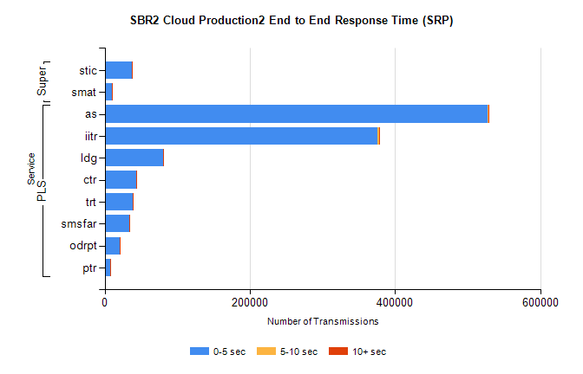
Stream | Service | 0-5 sec | 5-10 sec | >10 sec | Total | % within 5 sec timing target
PLS | as | 527146 | 1228 | 286 | 528660 | 99.7%
PLS | iitr | 375706 | 2598 | 568 | 378872 | 99.2%
PLS | ldg | 80297 | 128 | 22 | 80447 | 99.8%
PLS | ctr | 43459 | 86 | 26 | 43571 | 99.7%
PLS | trt | 38587 | 78 | 31 | 38696 | 99.7%
PLS | smsfar | 34302 | 71 | 41 | 34414 | 99.7%
PLS | odrpt | 20547 | 497 | 31 | 21075 | 97.5%
PLS | ptr | 7419 | 26 | 7 | 7452 | 99.6%
Super | stic | 37709 | 141 | 99 | 37949 | 99.4%
Super | smat | 10387 | 109 | 40 | 10536 | 98.6%

SBR2 Cloud Production2 - Single | Bulk or Batch Requests | (SRP, BBRP & CHiRPP)

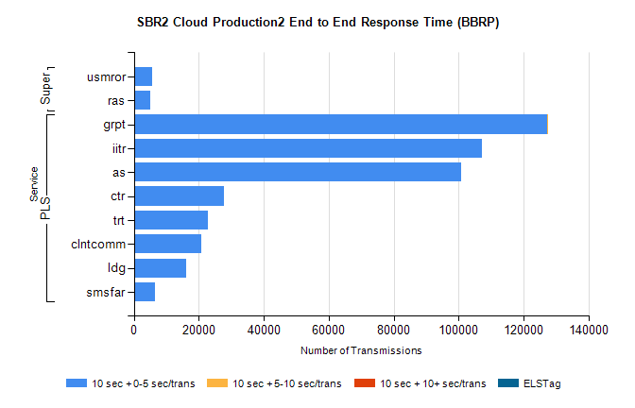
Stream | Service | 10 sec + 0-5 sec /trans | 10 sec + 5-10 sec /trans | 10 sec + >10 sec /trans | Processing Incomplete | ELStag | Total
PLS | grpt | 127413 | 25 | 0 | 0 | 0 | 127452
PLS | iitr | 107337 | 0 | 0 | 0 | 0 | 107337
PLS | as | 100910 | 0 | 0 | 0 | 0 | 100910
PLS | ctr | 27675 | 0 | 0 | 0 | 0 | 27675
PLS | trt | 22669 | 0 | 0 | 0 | 0 | 22669
PLS | clntcomm | 20735 | 0 | 0 | 0 | 0 | 20735
PLS | ldg | 16111 | 0 | 0 | 0 | 0 | 16111
PLS | smsfar | 6618 | 0 | 0 | 0 | 0 | 6618
Super | usmror | 5733 | 0 | 0 | 0 | 0 | 5733
Super | ras | 5098 | 0 | 0 | 0 | 0 | 5098

SBR2 Cloud Production2 - Single | Bulk or Batch Requests | (SRP, BBRP & CHiRPP)

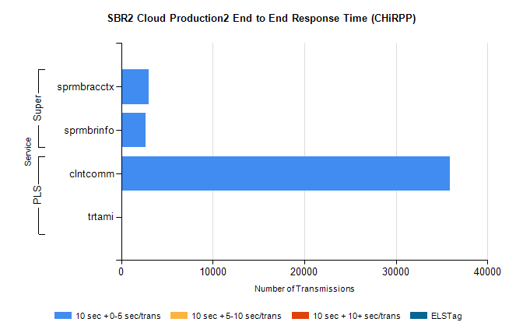
Stream | Service | 10 sec + 0-5 sec /trans | 10 sec + 5-10 sec /trans | 10 sec + >10 sec /trans | Total | % within 5 sec timing target
PLS | clntcomm | 35904 | 0 | 0 | 35904 | 100.0%
PLS | trtami | 45 | 0 | 0 | 45 | 100.0%
Super | sprmbracctx | 2956 | 0 | 0 | 2956 | 100.0%
Super | sprmbrinfo | 2662 | 0 | 0 | 2662 | 100.0%

SBR1 Production Transactions

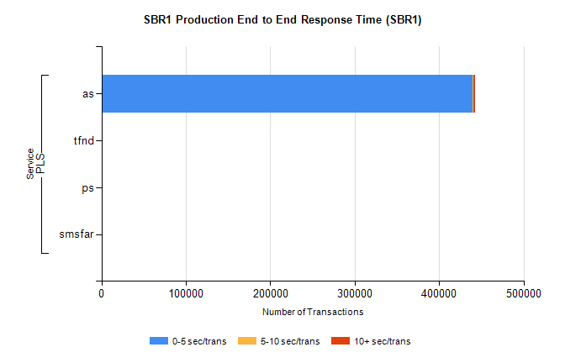
Stream | Service | 0-5 sec/trans | 5-10 sec/trans | 10+ sec/trans | Total | % within 5 sec timing target
PLS | as | 439783 | 601 | 2492 | 442876 | 99.3%
PLS | tfnd | 265 | 53 | 15 | 333 | 79.6%
PLS | ps | 71 | 61 | 145 | 277 | 25.6%
PLS | smsfar | 6 | 20 | 6 | 32 | 18.8%

