Transmission Timings Report Week - 20
12/05/2025 - 18/05/2025

SBR2 External Vendor Testing Environment (EVTE3)

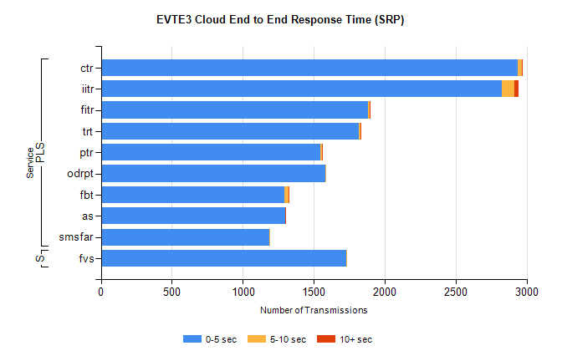
Stream | Service | 0-5 sec | 5-10 sec | >10 sec | Total | % within 5 sec timing target
PLS | ctr | 2939 | 28 | 4 | 3105 | 94.7%
PLS | iitr | 2827 | 86 | 28 | 2956 | 95.6%
PLS | fitr | 1885 | 6 | 1 | 1953 | 96.5%
PLS | trt | 1819 | 11 | 2 | 1895 | 96.0%
PLS | ptr | 1547 | 10 | 4 | 1639 | 94.4%
PLS | odrpt | 1584 | 3 | 0 | 1608 | 98.5%
PLS | fbt | 1293 | 28 | 1 | 1428 | 90.5%
PLS | as | 1296 | 3 | 5 | 1378 | 94.0%
PLS | smsfar | 1186 | 2 | 0 | 1188 | 99.8%
Super | fvs | 1726 | 4 | 0 | 1730 | 99.8%

SBR2 External Vendor Testing Environment (EVTE3)

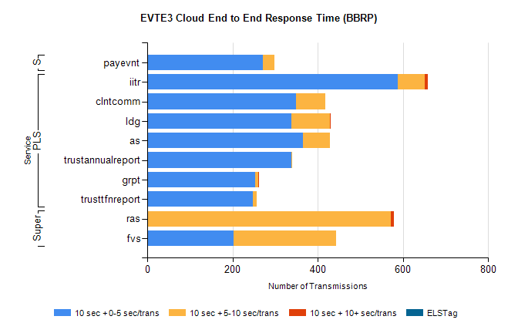
Stream | Service | 10 sec + 0-5 sec /trans | 10 sec + 5-10 sec /trans | 10 sec + >10 sec /trans | Processing Incomplete | ELStag | Total
PLS | iitr | 587 | 65 | 6 | 6 | 0 | 673
PLS | clntcomm | 349 | 68 | 0 | 161 | 0 | 578
PLS | ldg | 339 | 89 | 2 | 3 | 0 | 469
PLS | as | 365 | 63 | 0 | 1 | 0 | 430
PLS | trustannualreport | 338 | 2 | 0 | 0 | 0 | 340
PLS | grpt | 253 | 8 | 1 | 2 | 0 | 264
PLS | trusttfnreport | 248 | 8 | 0 | 0 | 0 | 256
Super | ras | 0 | 571 | 8 | 0 | 0 | 595
Super | fvs | 202 | 242 | 0 | 11 | 0 | 465
STP | payevnt | 271 | 27 | 0 | 33 | 0 | 332

SBR2 External Vendor Testing Environment (EVTE3)

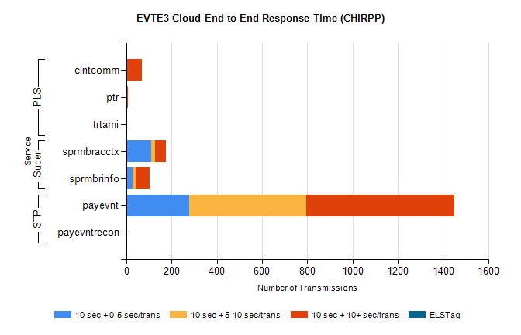
Stream | Service | 10 sec + 0-5 sec /trans | 10 sec + 5-10 sec /trans | 10 sec + >10 sec /trans | Total | % within 5 sec timing target
STP | payevnt | 279 | 518 | 652 | 2072 | 13.5%
STP | payevntrecon | 0 | 0 | 0 | 4 | 0.0%
Super | sprmbracctx | 109 | 19 | 49 | 199 | 54.8%
Super | sprmbrinfo | 27 | 13 | 63 | 119 | 22.9%
PLS | clntcomm | 0 | 0 | 70 | 71 | 0.0%
PLS | ptr | 0 | 1 | 7 | 8 | 0.0%
PLS | trtami | 0 | 1 | 3 | 4 | 0.0%

