Transmission Timings Report Week - 20
12/05/2025 - 18/05/2025

SBR2 Cloud Production2 - Single | Bulk or Batch Requests | (SRP, BBRP & CHiRPP)

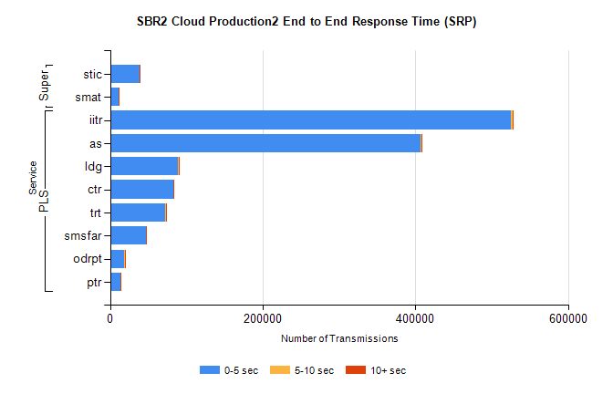
Stream | Service | 0-5 sec | 5-10 sec | >10 sec | Total | % within 5 sec timing target
PLS | iitr | 524792 | 3283 | 644 | 528719 | 99.3%
PLS | as | 406771 | 1094 | 146 | 408011 | 99.7%
PLS | ldg | 89449 | 158 | 14 | 89621 | 99.8%
PLS | ctr | 83019 | 158 | 40 | 83217 | 99.8%
PLS | trt | 72775 | 132 | 46 | 72953 | 99.8%
PLS | smsfar | 47206 | 95 | 43 | 47344 | 99.7%
PLS | odrpt | 19023 | 586 | 116 | 19725 | 96.4%
PLS | ptr | 13284 | 25 | 6 | 13315 | 99.8%
Super | stic | 38453 | 144 | 95 | 38692 | 99.4%
Super | smat | 11435 | 105 | 47 | 11587 | 98.7%

SBR2 Cloud Production2 - Single | Bulk or Batch Requests | (SRP, BBRP & CHiRPP)

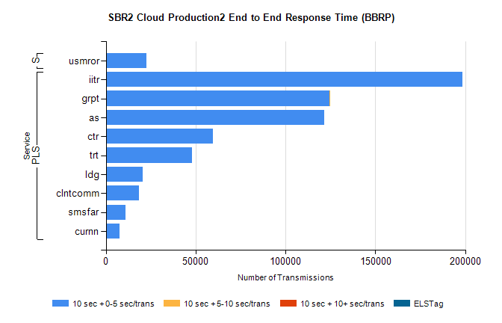
Stream | Service | 10 sec + 0-5 sec /trans | 10 sec + 5-10 sec /trans | 10 sec + >10 sec /trans | Processing Incomplete | ELStag | Total
PLS | iitr | 198299 | 0 | 0 | 0 | 0 | 198299
PLS | grpt | 124311 | 14 | 0 | 0 | 0 | 124329
PLS | as | 121551 | 0 | 0 | 0 | 0 | 121551
PLS | ctr | 59666 | 0 | 0 | 0 | 0 | 59666
PLS | trt | 48031 | 0 | 0 | 0 | 0 | 48031
PLS | ldg | 20364 | 0 | 0 | 0 | 0 | 20364
PLS | clntcomm | 18330 | 0 | 0 | 0 | 0 | 18330
PLS | smsfar | 11063 | 0 | 0 | 0 | 0 | 11063
PLS | curnn | 7677 | 0 | 0 | 0 | 0 | 7677
Super | usmror | 22667 | 0 | 0 | 0 | 0 | 22667

SBR2 Cloud Production2 - Single | Bulk or Batch Requests | (SRP, BBRP & CHiRPP)

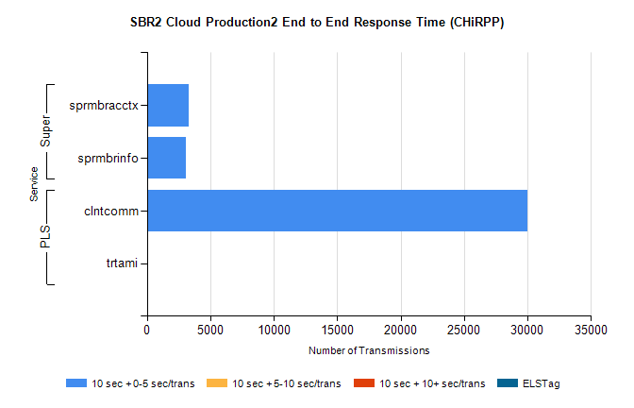
Stream | Service | 10 sec + 0-5 sec /trans | 10 sec + 5-10 sec /trans | 10 sec + >10 sec /trans | Total | % within 5 sec timing target
PLS | clntcomm | 30006 | 0 | 0 | 30006 | 100.0%
PLS | trtami | 31 | 0 | 0 | 31 | 100.0%
Super | sprmbracctx | 3275 | 0 | 0 | 3275 | 100.0%
Super | sprmbrinfo | 3050 | 0 | 0 | 3050 | 100.0%

SBR1 Production Transactions

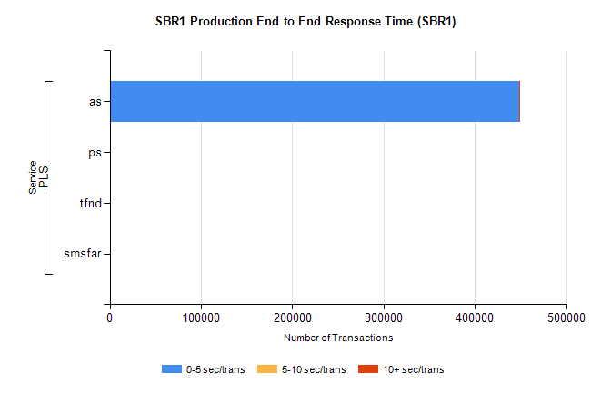
Stream | Service | 0-5 sec/trans | 5-10 sec/trans | 10+ sec/trans | Total | % within 5 sec timing target
PLS | as | 448112 | 144 | 121 | 448377 | 99.9%
PLS | ps | 109 | 79 | 196 | 384 | 28.4%
PLS | tfnd | 310 | 48 | 10 | 368 | 84.2%
PLS | smsfar | 2 | 11 |  | 13 | 15.4%

