Transmission Timings Report Week - 21
19/05/2025 - 25/05/2025

SBR2 External Vendor Testing Environment (EVTE3)

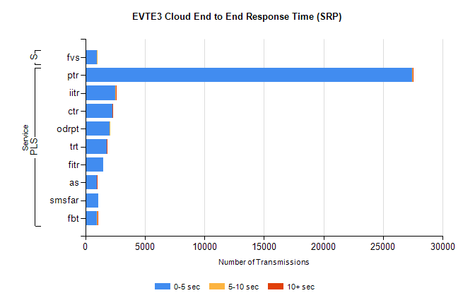
Stream | Service | 0-5 sec | 5-10 sec | >10 sec | Total | % within 5 sec timing target
PLS | ptr | 27463 | 26 | 2 | 27520 | 99.8%
PLS | iitr | 2501 | 65 | 41 | 2649 | 94.4%
PLS | ctr | 2287 | 21 | 3 | 2399 | 95.3%
PLS | odrpt | 2043 | 8 | 0 | 2061 | 99.1%
PLS | trt | 1816 | 14 | 2 | 1868 | 97.2%
PLS | fitr | 1522 | 0 | 0 | 1547 | 98.4%
PLS | as | 971 | 3 | 4 | 1145 | 84.8%
PLS | smsfar | 1123 | 0 | 0 | 1133 | 99.1%
PLS | fbt | 992 | 28 | 4 | 1070 | 92.7%
Super | fvs | 981 | 3 | 0 | 984 | 99.7%

SBR2 External Vendor Testing Environment (EVTE3)

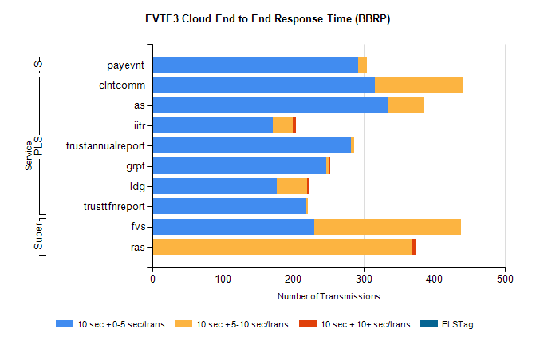
Stream | Service | 10 sec + 0-5 sec /trans | 10 sec + 5-10 sec /trans | 10 sec + >10 sec /trans | Processing Incomplete | ELStag | Total
PLS | clntcomm | 315 | 125 | 0 | 81 | 0 | 521
PLS | as | 335 | 49 | 0 | 3 | 0 | 387
PLS | iitr | 171 | 28 | 4 | 127 | 0 | 333
PLS | trustannualreport | 282 | 4 | 0 | 0 | 0 | 287
PLS | grpt | 246 | 5 | 1 | 0 | 0 | 252
PLS | ldg | 176 | 43 | 3 | 2 | 0 | 240
PLS | trusttfnreport | 218 | 2 | 0 | 0 | 0 | 220
Super | fvs | 230 | 208 | 0 | 4 | 0 | 457
Super | ras | 0 | 369 | 4 | 6 | 0 | 389
STP | payevnt | 292 | 12 | 0 | 32 | 0 | 339

SBR2 External Vendor Testing Environment (EVTE3)

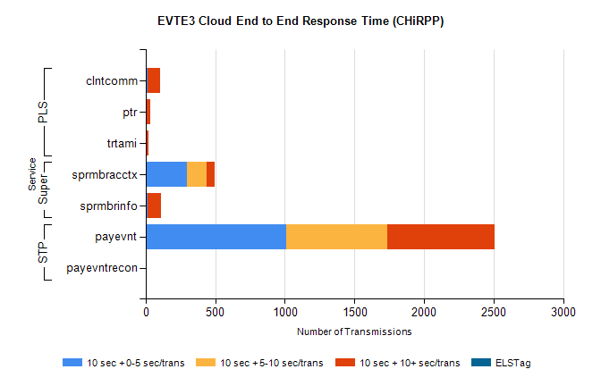
Stream | Service | 10 sec + 0-5 sec /trans | 10 sec + 5-10 sec /trans | 10 sec + >10 sec /trans | Total | % within 5 sec timing target
STP | payevnt | 1007 | 732 | 766 | 3271 | 30.9%
STP | payevntrecon | 0 | 0 | 5 | 7 | 0.0%
Super | sprmbracctx | 294 | 146 | 55 | 573 | 51.9%
Super | sprmbrinfo | 14 | 1 | 96 | 115 | 12.2%
PLS | clntcomm | 11 | 3 | 87 | 105 | 10.5%
PLS | ptr | 1 | 5 | 25 | 31 | 3.2%
PLS | trtami | 4 | 4 | 14 | 23 | 17.4%

