Transmission Timings Report Week - 21
19/05/2025 - 25/05/2025

SBR2 Cloud Production2 - Single | Bulk or Batch Requests | (SRP, BBRP & CHiRPP)

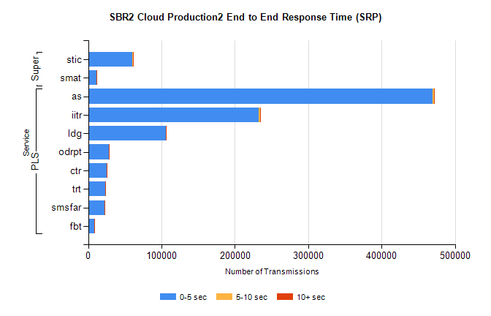
Stream | Service | 0-5 sec | 5-10 sec | >10 sec | Total | % within 5 sec timing target
PLS | as | 469220 | 1803 | 593 | 471616 | 99.5%
PLS | iitr | 232180 | 2524 | 643 | 235347 | 98.7%
PLS | ldg | 105932 | 288 | 89 | 106309 | 99.6%
PLS | odrpt | 27823 | 683 | 70 | 28576 | 97.4%
PLS | ctr | 25344 | 92 | 46 | 25482 | 99.5%
PLS | trt | 23601 | 78 | 48 | 23727 | 99.5%
PLS | smsfar | 22704 | 73 | 51 | 22828 | 99.5%
PLS | fbt | 8017 | 56 | 8 | 8081 | 99.2%
Super | stic | 60659 | 342 | 137 | 61138 | 99.2%
Super | smat | 10959 | 151 | 78 | 11188 | 98.0%

SBR2 Cloud Production2 - Single | Bulk or Batch Requests | (SRP, BBRP & CHiRPP)

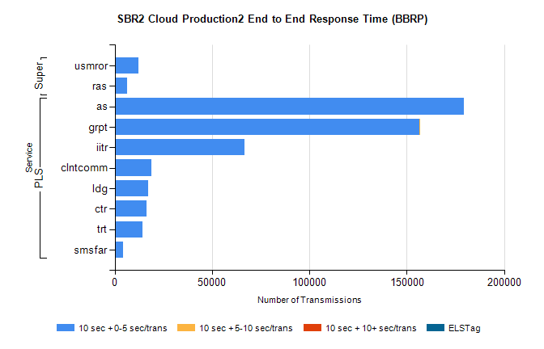
Stream | Service | 10 sec + 0-5 sec /trans | 10 sec + 5-10 sec /trans | 10 sec + >10 sec /trans | Processing Incomplete | ELStag | Total
PLS | as | 179378 | 0 | 0 | 0 | 0 | 179378
PLS | grpt | 156662 | 12 | 0 | 0 | 0 | 156680
PLS | iitr | 66847 | 0 | 0 | 0 | 0 | 66847
PLS | clntcomm | 18676 | 0 | 0 | 0 | 0 | 18676
PLS | ldg | 17149 | 0 | 0 | 0 | 0 | 17149
PLS | ctr | 16201 | 0 | 0 | 0 | 0 | 16201
PLS | trt | 14305 | 0 | 0 | 0 | 0 | 14305
PLS | smsfar | 4374 | 0 | 0 | 0 | 0 | 4374
Super | usmror | 12292 | 0 | 0 | 0 | 0 | 12292
Super | ras | 6261 | 0 | 0 | 0 | 0 | 6261

SBR2 Cloud Production2 - Single | Bulk or Batch Requests | (SRP, BBRP & CHiRPP)

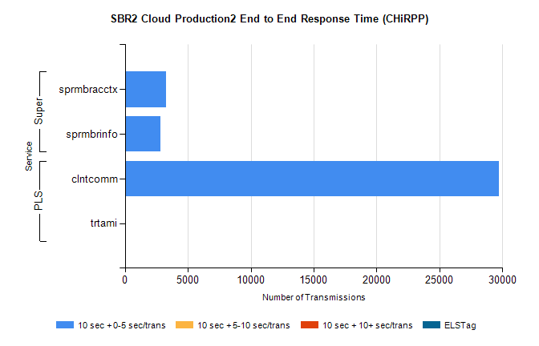
Stream | Service | 10 sec + 0-5 sec /trans | 10 sec + 5-10 sec /trans | 10 sec + >10 sec /trans | Total | % within 5 sec timing target
PLS | clntcomm | 29725 | 0 | 0 | 29725 | 100.0%
PLS | trtami | 10 | 0 | 0 | 10 | 100.0%
Super | sprmbracctx | 3271 | 0 | 0 | 3271 | 100.0%
Super | sprmbrinfo | 2801 | 0 | 0 | 2801 | 100.0%

SBR1 Production Transactions

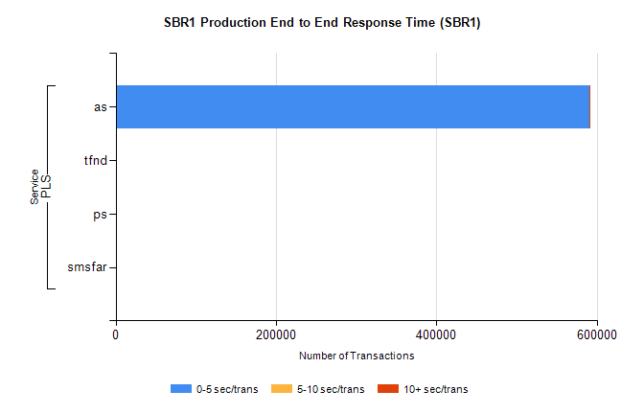
Stream | Service | 0-5 sec/trans | 5-10 sec/trans | 10+ sec/trans | Total | % within 5 sec timing target
PLS | as | 590445 | 211 | 1084 | 591740 | 99.8%
PLS | ps | 180 | 73 | 134 | 387 | 46.5%
PLS | tfnd | 328 | 50 | 9 | 387 | 84.8%
PLS | smsfar | 1 | 13 | 2 | 16 | 6.3%

