Transmission Timings Report Week - 22
26/05/2025 - 1/06/2025

SBR2 External Vendor Testing Environment (EVTE3)

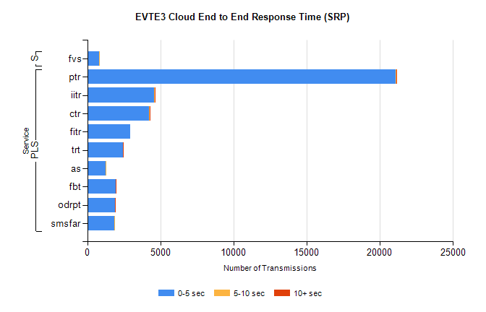
Stream | Service | 0-5 sec | 5-10 sec | >10 sec | Total | % within 5 sec timing target
PLS | ptr | 21101 | 24 | 1 | 21130 | 99.9%
PLS | iitr | 4563 | 81 | 34 | 4683 | 97.4%
PLS | ctr | 4225 | 36 | 2 | 4289 | 98.5%
PLS | fitr | 2957 | 0 | 0 | 2964 | 99.8%
PLS | trt | 2427 | 7 | 1 | 2453 | 98.9%
PLS | as | 1256 | 3 | 0 | 1965 | 63.9%
PLS | fbt | 1931 | 27 | 1 | 1962 | 98.4%
PLS | odrpt | 1921 | 0 | 1 | 1922 | 99.9%
PLS | smsfar | 1835 | 1 | 0 | 1836 | 99.9%
Super | fvs | 794 | 1 | 0 | 795 | 99.9%

SBR2 External Vendor Testing Environment (EVTE3)

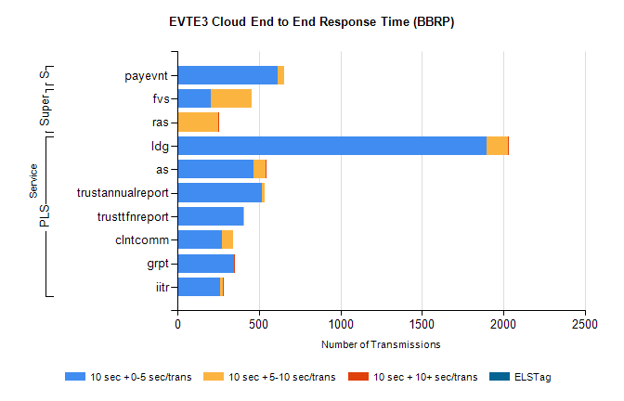
Stream | Service | 10 sec + 0-5 sec /trans | 10 sec + 5-10 sec /trans | 10 sec + >10 sec /trans | Processing Incomplete | ELStag | Total
PLS | ldg | 1899 | 129 | 1 | 4 | 0 | 2047
PLS | as | 466 | 78 | 1 | 3 | 0 | 553
PLS | trustannualreport | 518 | 18 | 0 | 0 | 0 | 536
PLS | trusttfnreport | 403 | 8 | 0 | 0 | 0 | 411
PLS | clntcomm | 273 | 70 | 0 | 44 | 0 | 387
PLS | grpt | 345 | 5 | 2 | 0 | 0 | 352
PLS | iitr | 261 | 20 | 2 | 57 | 0 | 347
Super | fvs | 206 | 247 | 0 | 4 | 0 | 466
Super | ras | 0 | 249 | 6 | 0 | 0 | 267
STP | payevnt | 617 | 36 | 0 | 42 | 0 | 696

SBR2 External Vendor Testing Environment (EVTE3)

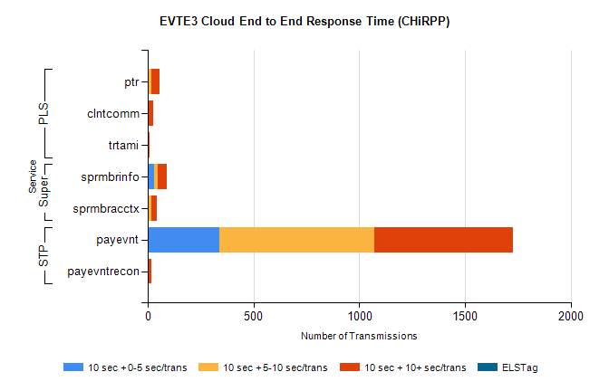
Stream | Service | 10 sec + 0-5 sec /trans | 10 sec + 5-10 sec /trans | 10 sec + >10 sec /trans | Total | % within 5 sec timing target
STP | payevnt | 340 | 730 | 659 | 2493 | 13.6%
STP | payevntrecon | 0 | 3 | 13 | 25 | 0.0%
Super | sprmbrinfo | 31 | 15 | 43 | 105 | 29.5%
Super | sprmbracctx | 5 | 11 | 27 | 54 | 9.3%
PLS | ptr | 5 | 12 | 39 | 62 | 8.8%
PLS | clntcomm | 0 | 0 | 28 | 29 | 0.0%
PLS | trtami | 0 | 0 | 8 | 8 | 0.0%

