Transmission Timings Report Week - 22
26/05/2025 - 1/06/2025

SBR2 Cloud Production2 - Single | Bulk or Batch Requests | (SRP, BBRP & CHiRPP)

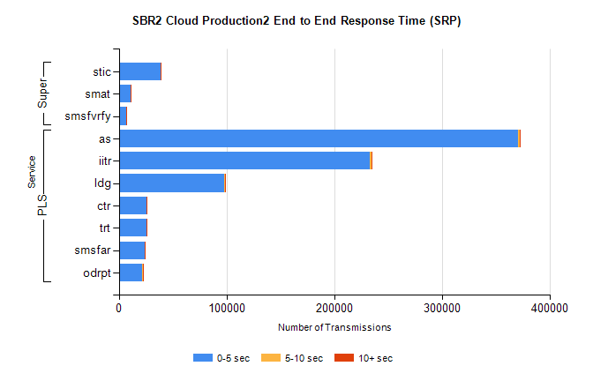
Stream | Service | 0-5 sec | 5-10 sec | >10 sec | Total | % within 5 sec timing target
PLS | as | 371082 | 1308 | 575 | 372965 | 99.5%
PLS | iitr | 232764 | 2054 | 791 | 235609 | 98.8%
PLS | ldg | 98072 | 219 | 67 | 98358 | 99.7%
PLS | ctr | 25797 | 100 | 56 | 25953 | 99.4%
PLS | trt | 25530 | 74 | 64 | 25668 | 99.5%
PLS | smsfar | 23830 | 59 | 71 | 23960 | 99.5%
PLS | odrpt | 21987 | 508 | 26 | 22521 | 97.6%
Super | stic | 38976 | 195 | 138 | 39309 | 99.2%
Super | smat | 10692 | 139 | 60 | 10891 | 98.2%
Super | smsfvrfy | 6554 | 74 | 46 | 6674 | 98.2%

SBR2 Cloud Production2 - Single | Bulk or Batch Requests | (SRP, BBRP & CHiRPP)

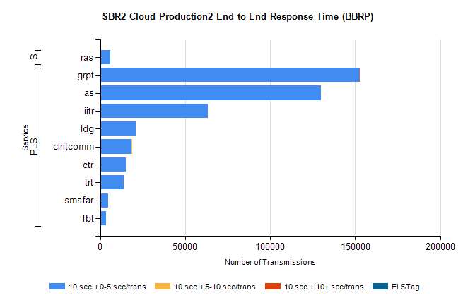
Stream | Service | 10 sec + 0-5 sec /trans | 10 sec + 5-10 sec /trans | 10 sec + >10 sec /trans | Processing Incomplete | ELStag | Total
PLS | grpt | 152736 | 6 | 1 | 0 | 0 | 152749
PLS | as | 130054 | 0 | 0 | 0 | 0 | 130054
PLS | iitr | 63142 | 0 | 0 | 0 | 0 | 63143
PLS | ldg | 20740 | 0 | 0 | 0 | 0 | 20740
PLS | clntcomm | 18425 | 1 | 0 | 0 | 0 | 18426
PLS | ctr | 14937 | 0 | 0 | 0 | 0 | 14937
PLS | trt | 13874 | 0 | 0 | 0 | 0 | 13875
PLS | smsfar | 4548 | 0 | 0 | 0 | 0 | 4548
PLS | fbt | 3347 | 0 | 0 | 0 | 0 | 3347
Super | ras | 6099 | 0 | 0 | 0 | 0 | 6099

SBR2 Cloud Production2 - Single | Bulk or Batch Requests | (SRP, BBRP & CHiRPP)

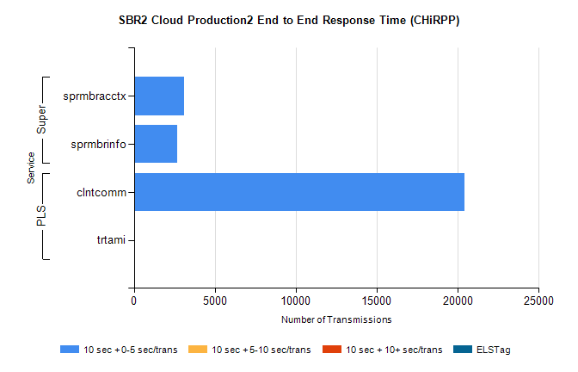
Stream | Service | 10 sec + 0-5 sec /trans | 10 sec + 5-10 sec /trans | 10 sec + >10 sec /trans | Total | % within 5 sec timing target
PLS | clntcomm | 20428 | 0 | 0 | 20428 | 100.0%
PLS | trtami | 37 | 0 | 0 | 37 | 100.0%
Super | sprmbracctx | 3119 | 0 | 0 | 3119 | 100.0%
Super | sprmbrinfo | 2683 | 0 | 0 | 2683 | 100.0%

SBR1 Production Transactions

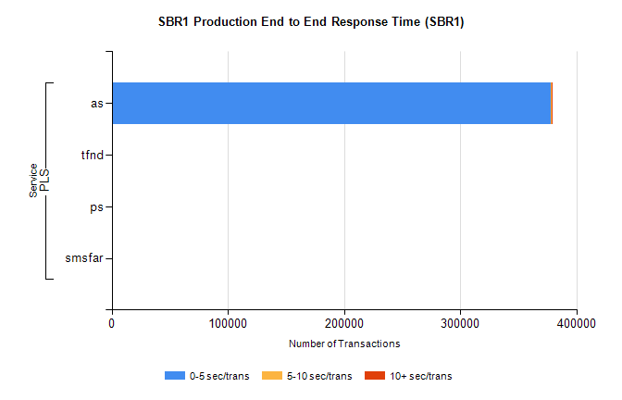
Stream | Service | 0-5 sec/trans | 5-10 sec/trans | 10+ sec/trans | Total | % within 5 sec timing target
PLS | as | 378282 | 258 | 924 | 379464 | 99.7%
PLS | tfnd | 274 | 39 | 10 | 323 | 84.8%
PLS | ps | 37 | 35 | 109 | 181 | 20.4%
PLS | smsfar | 4 | 11 |  | 15 | 26.7%

