Transmission Timings Report Week - 23
2/06/2025 - 8/06/2025

SBR2 External Vendor Testing Environment (EVTE3)

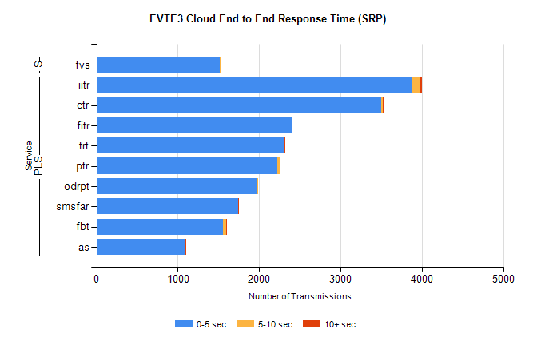
Stream | Service | 0-5 sec | 5-10 sec | >10 sec | Total | % within 5 sec timing target
PLS | iitr | 3884 | 83 | 38 | 4010 | 96.9%
PLS | ctr | 3503 | 21 | 5 | 3555 | 98.5%
PLS | fitr | 2398 | 0 | 0 | 2408 | 99.6%
PLS | trt | 2301 | 10 | 1 | 2340 | 98.3%
PLS | ptr | 2227 | 23 | 3 | 2258 | 98.6%
PLS | odrpt | 1982 | 8 | 0 | 1991 | 99.5%
PLS | smsfar | 1740 | 0 | 2 | 1742 | 99.9%
PLS | fbt | 1558 | 33 | 1 | 1592 | 97.9%
PLS | as | 1089 | 3 | 2 | 1097 | 99.3%
Super | fvs | 1518 | 4 | 1 | 1523 | 99.7%

SBR2 External Vendor Testing Environment (EVTE3)

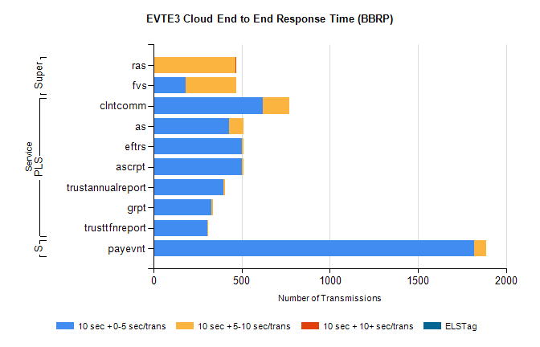
Stream | Service | 10 sec + 0-5 sec /trans | 10 sec + 5-10 sec /trans | 10 sec + >10 sec /trans | Processing Incomplete | ELStag | Total
PLS | clntcomm | 620 | 152 | 0 | 161 | 0 | 939
PLS | as | 428 | 83 | 0 | 3 | 0 | 514
PLS | ascrpt | 500 | 10 | 0 | 0 | 0 | 510
PLS | eftrs | 500 | 10 | 0 | 0 | 0 | 510
PLS | trustannualreport | 398 | 7 | 0 | 0 | 0 | 405
PLS | grpt | 330 | 6 | 0 | 0 | 0 | 336
PLS | trusttfnreport | 305 | 3 | 0 | 0 | 0 | 308
STP | payevnt | 1820 | 68 | 0 | 43 | 0 | 1935
Super | ras | 0 | 467 | 4 | 0 | 0 | 483
Super | fvs | 183 | 286 | 0 | 2 | 0 | 482

SBR2 External Vendor Testing Environment (EVTE3)

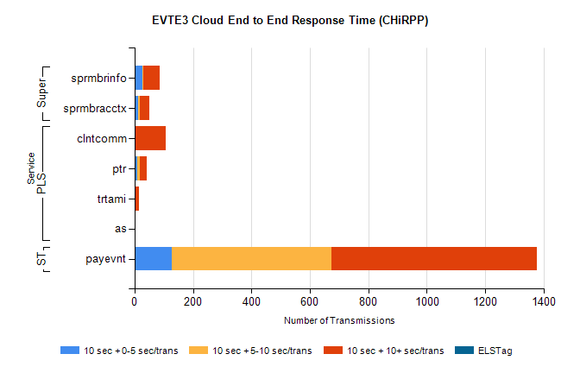
Stream | Service | 10 sec + 0-5 sec /trans | 10 sec + 5-10 sec /trans | 10 sec + >10 sec /trans | Total | % within 5 sec timing target
STP | payevnt | 127 | 546 | 704 | 1996 | 6.4%
PLS | clntcomm | 0 | 0 | 108 | 114 | 0.0%
PLS | ptr | 9 | 8 | 24 | 71 | 12.7%
PLS | trtami | 2 | 3 | 11 | 16 | 12.5%
PLS | as | 0 | 0 | 1 | 2 | 0.0%
Super | sprmbrinfo | 27 | 4 | 56 | 96 | 28.1%
Super | sprmbracctx | 12 | 7 | 33 | 71 | 16.9%

