Transmission Timings Report Week - 23
2/06/2025 - 8/06/2025

SBR2 Cloud Production2 - Single | Bulk or Batch Requests | (SRP, BBRP & CHiRPP)

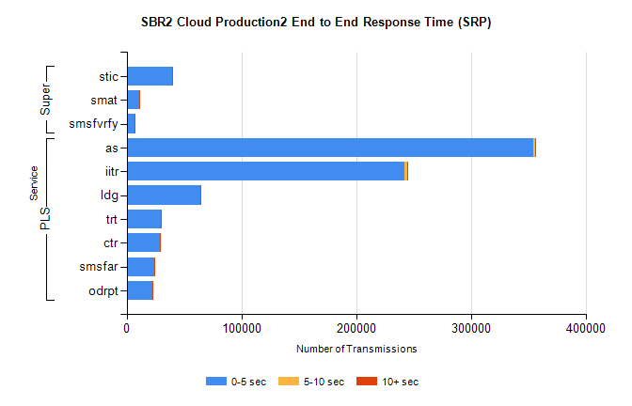
Stream | Service | 0-5 sec | 5-10 sec | >10 sec | Total | % within 5 sec timing target
PLS | as | 354734 | 1220 | 208 | 356162 | 99.6%
PLS | iitr | 242321 | 2246 | 318 | 244885 | 99.0%
PLS | ldg | 64251 | 165 | 12 | 64428 | 99.7%
PLS | trt | 30049 | 76 | 24 | 30149 | 99.7%
PLS | ctr | 28682 | 103 | 17 | 28802 | 99.6%
PLS | smsfar | 23808 | 73 | 20 | 23901 | 99.6%
PLS | odrpt | 22058 | 604 | 33 | 22695 | 97.2%
Super | stic | 39426 | 276 | 106 | 39808 | 99.0%
Super | smat | 10736 | 140 | 45 | 10921 | 98.3%
Super | smsfvrfy | 6828 | 139 | 48 | 7015 | 97.3%

SBR2 Cloud Production2 - Single | Bulk or Batch Requests | (SRP, BBRP & CHiRPP)

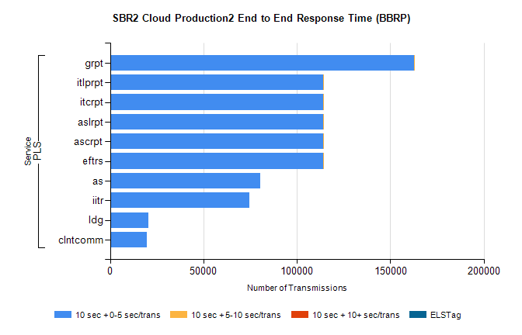
Stream | Service | 10 sec + 0-5 sec /trans | 10 sec + 5-10 sec /trans | 10 sec + >10 sec /trans | Processing Incomplete | ELStag | Total
PLS | grpt | 162880 | 2 | 0 | 0 | 0 | 162886
PLS | eftrs | 113882 | 1 | 0 | 0 | 0 | 113885
PLS | ascrpt | 113882 | 1 | 0 | 0 | 0 | 113885
PLS | aslrpt | 113882 | 1 | 0 | 0 | 0 | 113885
PLS | itcrpt | 113882 | 1 | 0 | 0 | 0 | 113885
PLS | itlprpt | 113882 | 1 | 0 | 0 | 0 | 113885
PLS | as | 80452 | 0 | 0 | 0 | 0 | 80452
PLS | iitr | 74409 | 0 | 0 | 0 | 0 | 74409
PLS | ldg | 20336 | 0 | 0 | 0 | 0 | 20336
PLS | clntcomm | 19514 | 0 | 0 | 0 | 0 | 19514

SBR2 Cloud Production2 - Single | Bulk or Batch Requests | (SRP, BBRP & CHiRPP)

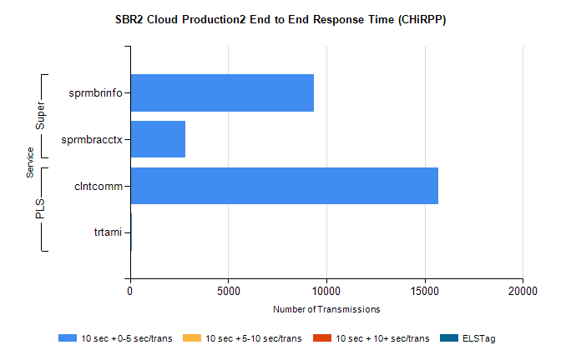
Stream | Service | 10 sec + 0-5 sec /trans | 10 sec + 5-10 sec /trans | 10 sec + >10 sec /trans | Total | % within 5 sec timing target
PLS | clntcomm | 15700 | 0 | 0 | 15700 | 100.0%
PLS | trtami | 78 | 0 | 0 | 78 | 100.0%
Super | sprmbrinfo | 9343 | 0 | 0 | 9343 | 100.0%
Super | sprmbracctx | 2829 | 0 | 0 | 2829 | 100.0%

SBR1 Production Transactions

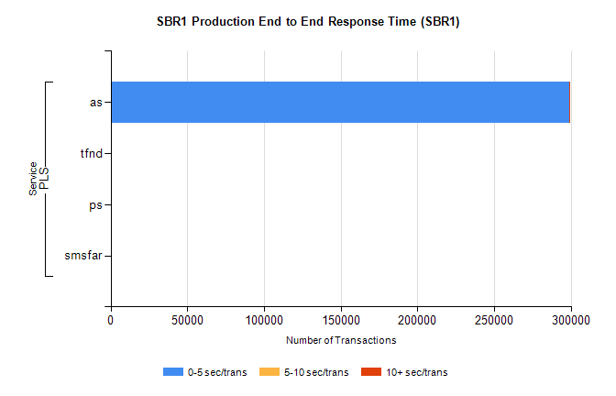
Stream | Service | 0-5 sec/trans | 5-10 sec/trans | 10+ sec/trans | Total | % within 5 sec timing target
PLS | as | 298926 | 148 | 592 | 299666 | 99.8%
PLS | tfnd | 410 | 53 | 12 | 475 | 86.3%
PLS | ps | 33 | 41 | 90 | 164 | 20.1%
PLS | smsfar | 6 | 21 | 2 | 29 | 20.7%

