Transmission Timings Report Week - 24
9/06/2025 - 15/06/2025

SBR2 External Vendor Testing Environment (EVTE3)

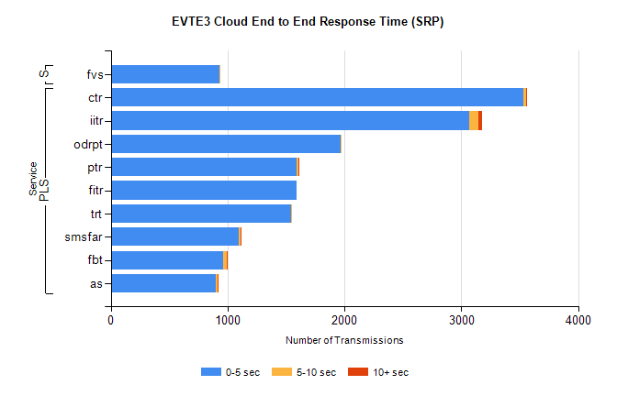
Stream | Service | 0-5 sec | 5-10 sec | >10 sec | Total | % within 5 sec timing target
PLS | ctr | 3530 | 21 | 2 | 3573 | 98.8%
PLS | iitr | 3066 | 79 | 30 | 3183 | 96.3%
PLS | odrpt | 1970 | 3 | 0 | 1974 | 99.8%
PLS | ptr | 1594 | 15 | 2 | 1623 | 98.2%
PLS | fitr | 1588 | 0 | 0 | 1595 | 99.6%
PLS | trt | 1541 | 5 | 0 | 1566 | 98.4%
PLS | smsfar | 1099 | 10 | 2 | 1111 | 98.9%
PLS | fbt | 965 | 29 | 3 | 997 | 96.8%
PLS | as | 896 | 15 | 1 | 984 | 91.1%
Super | fvs | 931 | 3 | 0 | 934 | 99.7%

SBR2 External Vendor Testing Environment (EVTE3)

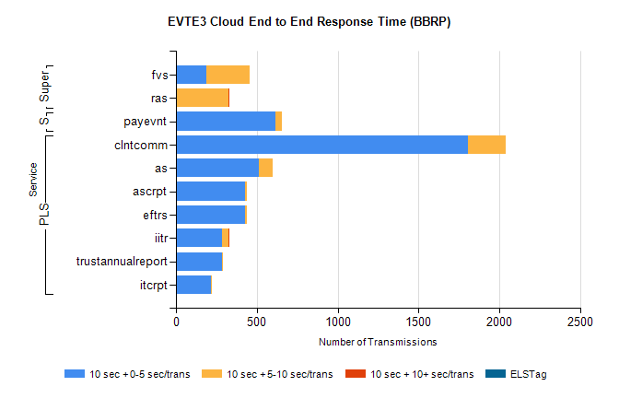
Stream | Service | 10 sec + 0-5 sec /trans | 10 sec + 5-10 sec /trans | 10 sec + >10 sec /trans | Processing Incomplete | ELStag | Total
PLS | clntcomm | 1807 | 235 | 0 | 30 | 0 | 2072
PLS | as | 512 | 88 | 0 | 6 | 0 | 607
PLS | eftrs | 428 | 10 | 0 | 14 | 0 | 452
PLS | ascrpt | 428 | 10 | 0 | 14 | 0 | 452
PLS | iitr | 287 | 39 | 4 | 4 | 0 | 340
PLS | trustannualreport | 282 | 5 | 0 | 0 | 0 | 287
PLS | itcrpt | 214 | 5 | 0 | 13 | 0 | 232
Super | fvs | 189 | 269 | 0 | 2 | 0 | 471
Super | ras | 0 | 323 | 5 | 0 | 0 | 339
STP | payevnt | 618 | 35 | 0 | 42 | 0 | 697

SBR2 External Vendor Testing Environment (EVTE3)

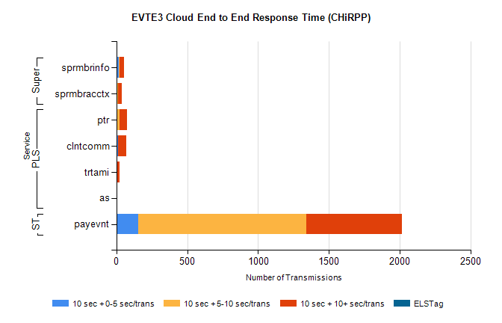
Stream | Service | 10 sec + 0-5 sec /trans | 10 sec + 5-10 sec /trans | 10 sec + >10 sec /trans | Total | % within 5 sec timing target
STP | payevnt | 152 | 1188 | 674 | 3025 | 5.0%
PLS | ptr | 0 | 23 | 53 | 85 | 0.0%
PLS | clntcomm | 13 | 0 | 59 | 73 | 17.8%
PLS | trtami | 2 | 4 | 18 | 25 | 8.0%
PLS | as | 2 | 0 | 1 | 3 | 66.7%
Super | sprmbrinfo | 15 | 5 | 35 | 67 | 22.4%
Super | sprmbracctx | 4 | 8 | 27 | 49 | 8.2%

