Transmission Timings Report Week - 24
9/06/2025 - 15/06/2025

SBR2 Cloud Production2 - Single | Bulk or Batch Requests | (SRP, BBRP & CHiRPP)

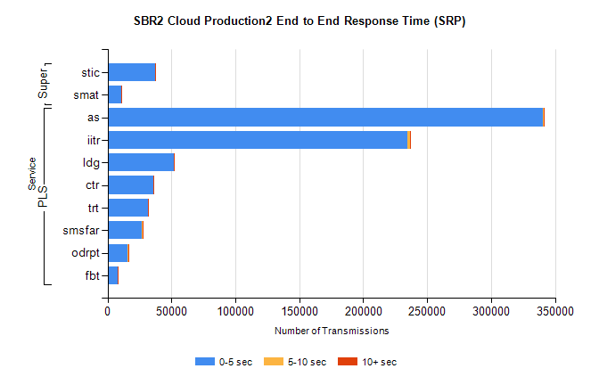
Stream | Service | 0-5 sec | 5-10 sec | >10 sec | Total | % within 5 sec timing target
PLS | as | 340211 | 1267 | 294 | 341772 | 99.5%
PLS | iitr | 234164 | 2114 | 375 | 236653 | 98.9%
PLS | ldg | 51914 | 125 | 18 | 52057 | 99.7%
PLS | ctr | 36044 | 104 | 18 | 36166 | 99.7%
PLS | trt | 31327 | 86 | 44 | 31457 | 99.6%
PLS | smsfar | 27107 | 87 | 31 | 27225 | 99.6%
PLS | odrpt | 15668 | 675 | 74 | 16417 | 95.4%
PLS | fbt | 8003 | 45 | 6 | 8054 | 99.4%
Super | stic | 37171 | 278 | 85 | 37534 | 99.0%
Super | smat | 10889 | 160 | 34 | 11083 | 98.2%

SBR2 Cloud Production2 - Single | Bulk or Batch Requests | (SRP, BBRP & CHiRPP)

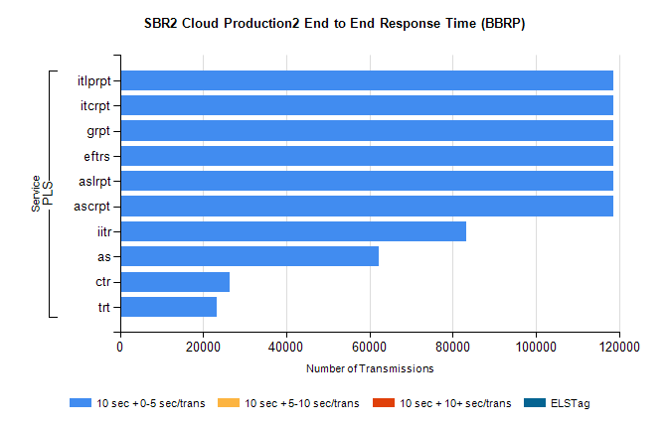
Stream | Service | 10 sec + 0-5 sec /trans | 10 sec + 5-10 sec /trans | 10 sec + >10 sec /trans | Processing Incomplete | ELStag | Total
PLS | ascrpt | 118696 | 0 | 0 | 0 | 0 | 118696
PLS | aslrpt | 118696 | 0 | 0 | 0 | 0 | 118696
PLS | eftrs | 118696 | 0 | 0 | 0 | 0 | 118696
PLS | grpt | 118696 | 0 | 0 | 0 | 0 | 118696
PLS | itcrpt | 118696 | 0 | 0 | 0 | 0 | 118696
PLS | itlprpt | 118696 | 0 | 0 | 0 | 0 | 118696
PLS | iitr | 83335 | 0 | 0 | 0 | 0 | 83335
PLS | as | 62173 | 0 | 0 | 0 | 0 | 62173
PLS | ctr | 26478 | 0 | 0 | 0 | 0 | 26478
PLS | trt | 23222 | 0 | 0 | 0 | 0 | 23222

SBR2 Cloud Production2 - Single | Bulk or Batch Requests | (SRP, BBRP & CHiRPP)

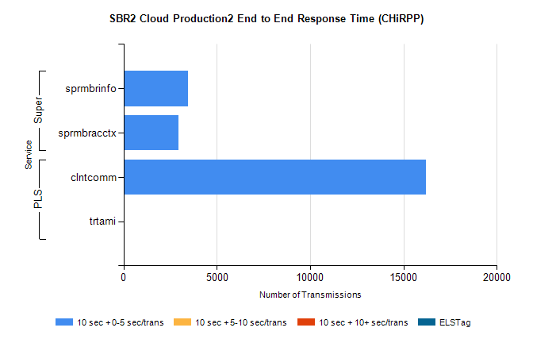
Stream | Service | 10 sec + 0-5 sec /trans | 10 sec + 5-10 sec /trans | 10 sec + >10 sec /trans | Total | % within 5 sec timing target
PLS | clntcomm | 16225 | 0 | 0 | 16225 | 100.0%
PLS | trtami | 8 | 0 | 0 | 8 | 100.0%
Super | sprmbrinfo | 3465 | 0 | 0 | 3465 | 100.0%
Super | sprmbracctx | 2955 | 0 | 0 | 2955 | 100.0%

SBR1 Production Transactions

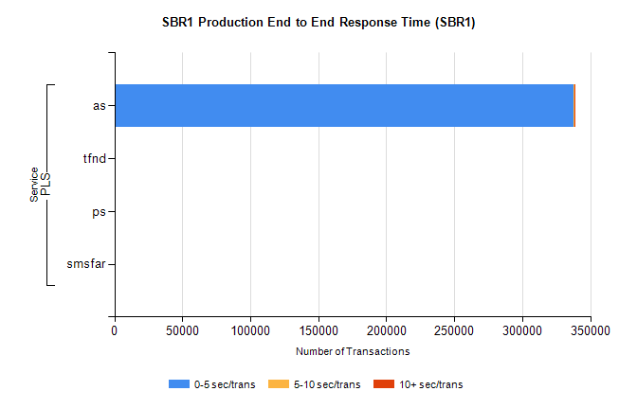
Stream | Service | 0-5 sec/trans | 5-10 sec/trans | 10+ sec/trans | Total | % within 5 sec timing target
PLS | as | 337956 | 123 | 458 | 338537 | 99.8%
PLS | tfnd | 329 | 42 | 10 | 381 | 86.4%
PLS | ps | 28 | 33 | 111 | 172 | 16.3%
PLS | smsfar | 3 | 12 | 3 | 18 | 16.7%

