Transmission Timings Report Week - 25
16/06/2025 - 22/06/2025

SBR2 External Vendor Testing Environment (EVTE3)

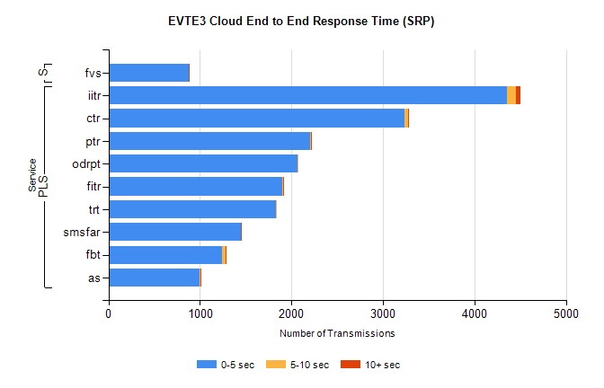
Stream | Service | 0-5 sec | 5-10 sec | >10 sec | Total | % within 5 sec timing target
PLS | iitr | 4353 | 101 | 51 | 4728 | 92.1%
PLS | ctr | 3236 | 34 | 8 | 3341 | 96.9%
PLS | ptr | 2200 | 18 | 5 | 2263 | 97.2%
PLS | odrpt | 2070 | 8 | 0 | 2081 | 99.5%
PLS | fitr | 1903 | 4 | 1 | 1930 | 98.6%
PLS | trt | 1827 | 3 | 0 | 1869 | 97.8%
PLS | smsfar | 1448 | 3 | 2 | 1454 | 99.6%
PLS | fbt | 1246 | 39 | 1 | 1317 | 94.6%
PLS | as | 997 | 12 | 5 | 1089 | 91.6%
Super | fvs | 879 | 3 | 1 | 883 | 99.5%

SBR2 External Vendor Testing Environment (EVTE3)

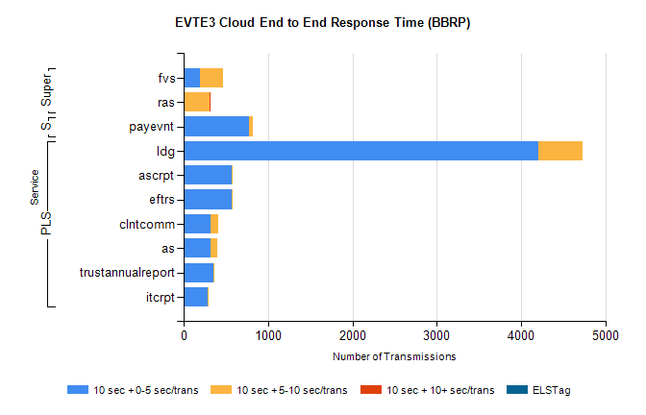
Stream | Service | 10 sec + 0-5 sec /trans | 10 sec + 5-10 sec /trans | 10 sec + >10 sec /trans | Processing Incomplete | ELStag | Total
PLS | ldg | 4201 | 527 | 0 | 20 | 0 | 4748
PLS | eftrs | 572 | 14 | 0 | 6 | 0 | 592
PLS | ascrpt | 572 | 14 | 0 | 6 | 0 | 592
PLS | clntcomm | 314 | 100 | 0 | 0 | 0 | 414
PLS | as | 323 | 71 | 0 | 4 | 0 | 398
PLS | trustannualreport | 350 | 8 | 0 | 0 | 0 | 358
PLS | itcrpt | 286 | 7 | 0 | 4 | 0 | 297
STP | payevnt | 778 | 42 | 0 | 43 | 0 | 863
Super | fvs | 194 | 276 | 0 | 3 | 0 | 489
Super | ras | 0 | 303 | 5 | 0 | 0 | 316

SBR2 External Vendor Testing Environment (EVTE3)

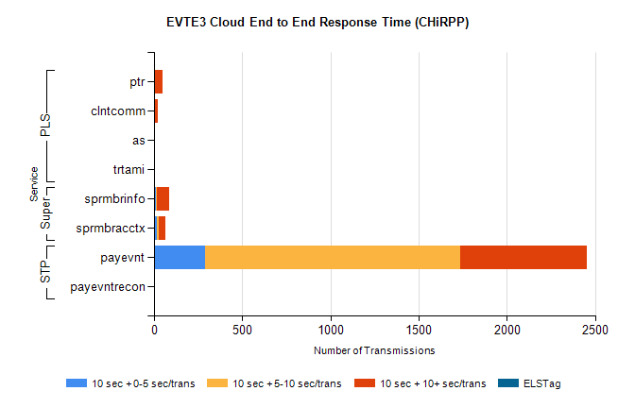
Stream | Service | 10 sec + 0-5 sec /trans | 10 sec + 5-10 sec /trans | 10 sec + >10 sec /trans | Total | % within 5 sec timing target
STP | payevnt | 289 | 1445 | 719 | 3454 | 8.4%
STP | payevntrecon | 0 | 0 | 2 | 2 | 0.0%
Super | sprmbrinfo | 10 | 7 | 70 | 101 | 10.0%
Super | sprmbracctx | 16 | 14 | 33 | 76 | 21.1%
PLS | ptr | 0 | 8 | 42 | 53 | 0.0%
PLS | clntcomm | 0 | 0 | 23 | 24 | 0.0%
PLS | as | 3 | 0 | 4 | 7 | 42.9%
PLS | trtami | 0 | 0 | 4 | 4 | 0.0%

