Transmission Timings Report Week - 25
16/06/2025 - 22/06/2025

SBR2 Cloud Production2 - Single | Bulk or Batch Requests | (SRP, BBRP & CHiRPP)

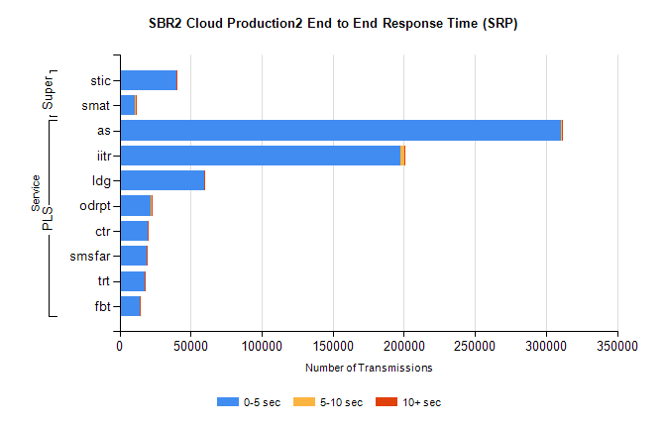
Stream | Service | 0-5 sec | 5-10 sec | >10 sec | Total | % within 5 sec timing target
PLS | as | 310249 | 789 | 427 | 311465 | 99.6%
PLS | iitr | 197519 | 2698 | 822 | 201039 | 98.2%
PLS | ldg | 59477 | 275 | 100 | 59852 | 99.4%
PLS | odrpt | 22251 | 540 | 71 | 22862 | 97.3%
PLS | ctr | 19677 | 81 | 39 | 19797 | 99.4%
PLS | smsfar | 19223 | 78 | 46 | 19347 | 99.4%
PLS | trt | 17602 | 77 | 44 | 17723 | 99.3%
PLS | fbt | 14272 | 80 | 36 | 14388 | 99.2%
Super | stic | 40003 | 265 | 64 | 40332 | 99.2%
Super | smat | 10998 | 157 | 43 | 11198 | 98.2%

SBR2 Cloud Production2 - Single | Bulk or Batch Requests | (SRP, BBRP & CHiRPP)

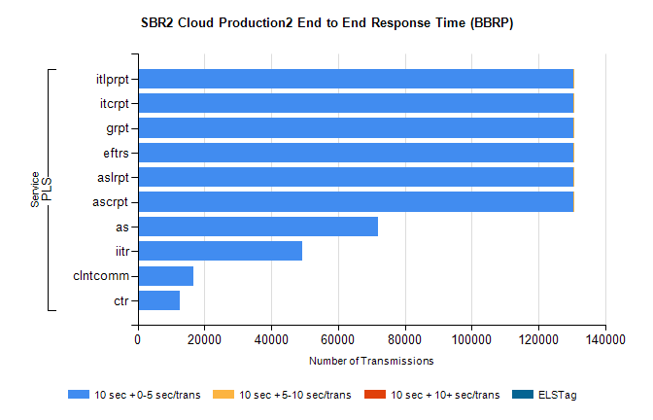
Stream | Service | 10 sec + 0-5 sec /trans | 10 sec + 5-10 sec /trans | 10 sec + >10 sec /trans | Processing Incomplete | ELStag | Total
PLS | ascrpt | 130372 | 2 | 0 | 0 | 0 | 130375
PLS | aslrpt | 130372 | 2 | 0 | 0 | 0 | 130375
PLS | eftrs | 130372 | 2 | 0 | 0 | 0 | 130375
PLS | grpt | 130372 | 2 | 0 | 0 | 0 | 130375
PLS | itcrpt | 130372 | 2 | 0 | 0 | 0 | 130375
PLS | itlprpt | 130372 | 2 | 0 | 0 | 0 | 130375
PLS | as | 71845 | 0 | 0 | 0 | 0 | 71845
PLS | iitr | 49350 | 0 | 0 | 0 | 0 | 49350
PLS | clntcomm | 16704 | 0 | 0 | 0 | 0 | 16704
PLS | ctr | 12584 | 0 | 0 | 0 | 0 | 12584

SBR2 Cloud Production2 - Single | Bulk or Batch Requests | (SRP, BBRP & CHiRPP)

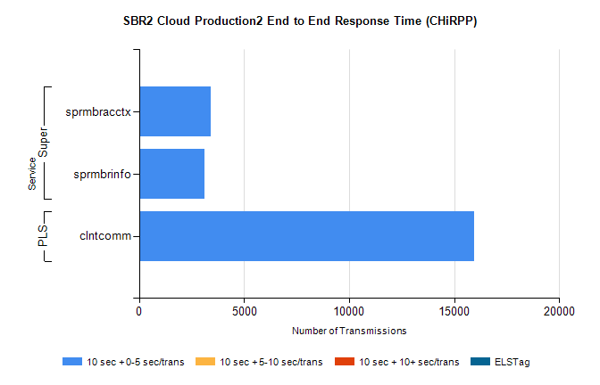
Stream | Service | 10 sec + 0-5 sec /trans | 10 sec + 5-10 sec /trans | 10 sec + >10 sec /trans | Total | % within 5 sec timing target
PLS | clntcomm | 15961 | 0 | 0 | 15961 | 100.0%
Super | sprmbracctx | 3400 | 0 | 0 | 3400 | 100.0%
Super | sprmbrinfo | 3096 | 0 | 0 | 3096 | 100.0%

SBR1 Production Transactions

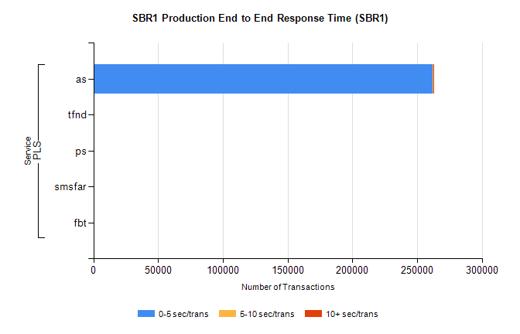
Stream | Service | 0-5 sec/trans | 5-10 sec/trans | 10+ sec/trans | Total | % within 5 sec timing target
PLS | as | 261821 | 489 | 434 | 262744 | 99.6%
PLS | tfnd | 473 | 63 | 11 | 547 | 86.5%
PLS | ps | 21 | 48 | 109 | 178 | 11.8%
PLS | smsfar | 3 | 9 | 2 | 14 | 21.4%
PLS | fbt |  | 1 | 1 | 2 | 0.0%

