Transmission Timings Report Week - 26
23/06/2025 - 29/06/2025

SBR2 External Vendor Testing Environment (EVTE3)

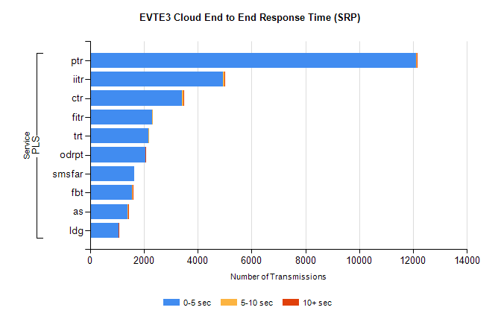
Stream | Service | 0-5 sec | 5-10 sec | >10 sec | Total | % within 5 sec timing target
PLS | ptr | 12109 | 21 | 1 | 12153 | 99.6%
PLS | iitr | 4929 | 77 | 26 | 5118 | 96.3%
PLS | ctr | 3425 | 36 | 1 | 3508 | 97.6%
PLS | fitr | 2322 | 1 | 0 | 2333 | 99.5%
PLS | trt | 2175 | 6 | 0 | 2187 | 99.5%
PLS | odrpt | 2054 | 0 | 1 | 2056 | 99.9%
PLS | smsfar | 1650 | 0 | 0 | 1660 | 99.4%
PLS | fbt | 1556 | 38 | 2 | 1596 | 97.5%
PLS | as | 1405 | 10 | 6 | 1533 | 91.7%
PLS | ldg | 1068 | 8 | 5 | 1084 | 98.5%

SBR2 External Vendor Testing Environment (EVTE3)

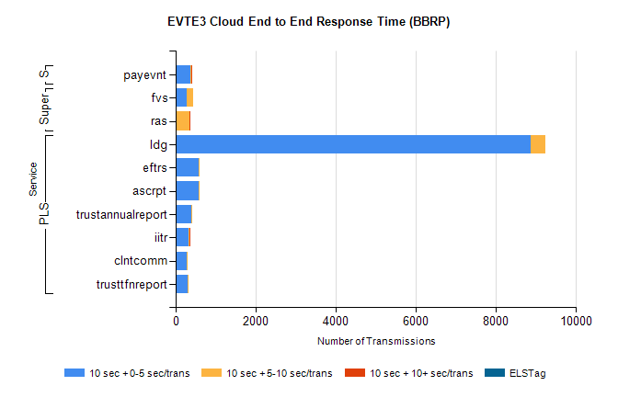
Stream | Service | 10 sec + 0-5 sec /trans | 10 sec + 5-10 sec /trans | 10 sec + >10 sec /trans | Processing Incomplete | ELStag | Total
PLS | ldg | 8865 | 375 | 0 | 41 | 0 | 9294
PLS | ascrpt | 582 | 14 | 0 | 0 | 0 | 596
PLS | eftrs | 582 | 14 | 0 | 0 | 0 | 596
PLS | trustannualreport | 385 | 4 | 0 | 0 | 0 | 389
PLS | iitr | 313 | 23 | 4 | 27 | 0 | 381
PLS | clntcomm | 270 | 31 | 0 | 12 | 0 | 313
PLS | trusttfnreport | 303 | 2 | 0 | 0 | 0 | 305
Super | fvs | 264 | 179 | 0 | 4 | 0 | 448
Super | ras | 0 | 338 | 5 | 0 | 0 | 352
STP | payevnt | 374 | 13 | 1 | 28 | 0 | 416

SBR2 External Vendor Testing Environment (EVTE3)

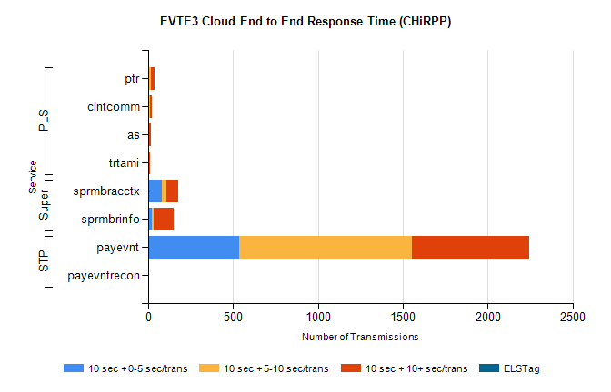
Stream | Service | 10 sec + 0-5 sec /trans | 10 sec + 5-10 sec /trans | 10 sec + >10 sec /trans | Total | % within 5 sec timing target
STP | payevnt | 537 | 1015 | 692 | 3108 | 17.3%
STP | payevntrecon | 0 | 0 | 4 | 4 | 0.0%
Super | sprmbracctx | 81 | 25 | 71 | 206 | 39.3%
Super | sprmbrinfo | 24 | 8 | 121 | 175 | 13.8%
PLS | ptr | 3 | 13 | 22 | 41 | 7.3%
PLS | clntcomm | 8 | 1 | 12 | 21 | 38.1%
PLS | as | 1 | 0 | 14 | 16 | 6.3%
PLS | trtami | 0 | 1 | 11 | 12 | 0.0%

