Transmission Timings Report Week - 26
23/06/2025 - 29/06/2025

SBR2 Cloud Production2 - Single | Bulk or Batch Requests | (SRP, BBRP & CHiRPP)

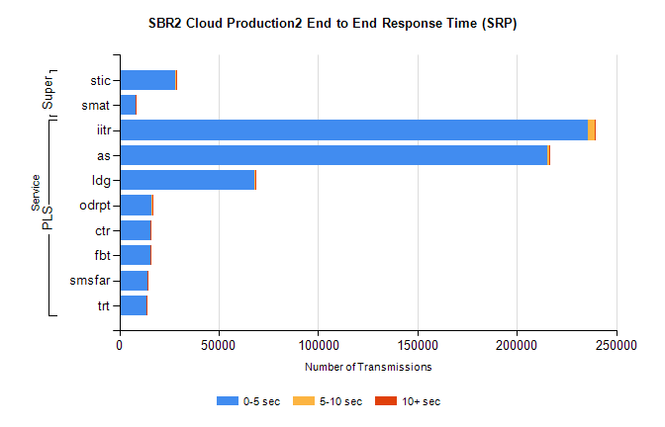
Stream | Service | 0-5 sec | 5-10 sec | >10 sec | Total | % within 5 sec timing target
PLS | iitr | 235800 | 3283 | 419 | 239502 | 98.5%
PLS | as | 215250 | 991 | 314 | 216555 | 99.4%
PLS | ldg | 68073 | 149 | 18 | 68240 | 99.8%
PLS | odrpt | 16055 | 825 | 131 | 17011 | 94.4%
PLS | ctr | 15780 | 65 | 13 | 15858 | 99.5%
PLS | fbt | 15713 | 45 | 12 | 15770 | 99.6%
PLS | smsfar | 13920 | 63 | 13 | 13996 | 99.5%
PLS | trt | 13546 | 63 | 17 | 13626 | 99.4%
Super | stic | 28275 | 162 | 82 | 28519 | 99.1%
Super | smat | 8121 | 112 | 35 | 8268 | 98.2%

SBR2 Cloud Production2 - Single | Bulk or Batch Requests | (SRP, BBRP & CHiRPP)

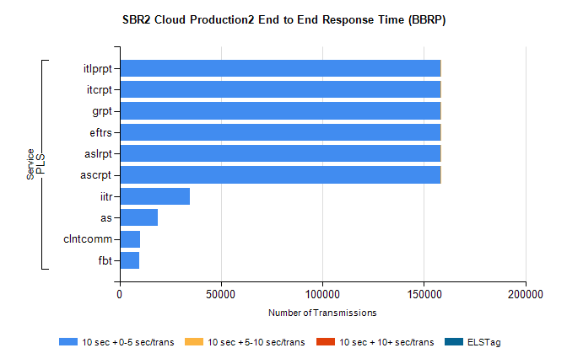
Stream | Service | 10 sec + 0-5 sec /trans | 10 sec + 5-10 sec /trans | 10 sec + >10 sec /trans | Processing Incomplete | ELStag | Total
PLS | ascrpt | 158309 | 2 | 0 | 0 | 0 | 158312
PLS | aslrpt | 158309 | 2 | 0 | 0 | 0 | 158312
PLS | eftrs | 158309 | 2 | 0 | 0 | 0 | 158312
PLS | grpt | 158309 | 2 | 0 | 0 | 0 | 158312
PLS | itcrpt | 158309 | 2 | 0 | 0 | 0 | 158312
PLS | itlprpt | 158309 | 2 | 0 | 0 | 0 | 158312
PLS | iitr | 34490 | 0 | 0 | 0 | 0 | 34490
PLS | as | 18871 | 0 | 0 | 0 | 0 | 18871
PLS | clntcomm | 10042 | 0 | 0 | 0 | 0 | 10042
PLS | fbt | 9727 | 0 | 0 | 0 | 0 | 9727

SBR2 Cloud Production2 - Single | Bulk or Batch Requests | (SRP, BBRP & CHiRPP)

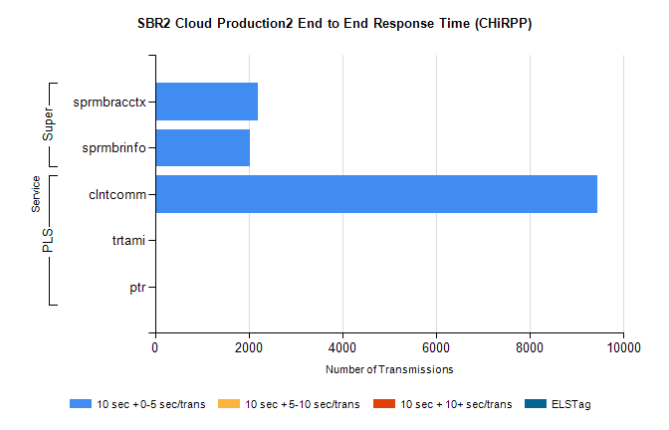
Stream | Service | 10 sec + 0-5 sec /trans | 10 sec + 5-10 sec /trans | 10 sec + >10 sec /trans | Total | % within 5 sec timing target
PLS | clntcomm | 9434 | 0 | 0 | 9434 | 100.0%
PLS | trtami | 8 | 0 | 0 | 8 | 100.0%
PLS | ptr | 2 | 0 | 0 | 2 | 100.0%
Super | sprmbracctx | 2190 | 0 | 0 | 2190 | 100.0%
Super | sprmbrinfo | 2026 | 0 | 0 | 2026 | 100.0%

SBR1 Production Transactions

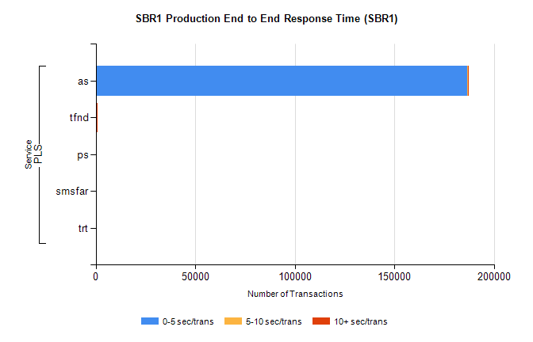
Stream | Service | 0-5 sec/trans | 5-10 sec/trans | 10+ sec/trans | Total | % within 5 sec timing target
PLS | as | 186634 | 272 | 632 | 187538 | 99.5%
PLS | tfnd | 333 | 52 | 5 | 390 | 85.4%
PLS | ps | 45 | 72 | 119 | 236 | 19.1%
PLS | smsfar | 5 | 8 |  | 13 | 38.5%
PLS | trt |  |  | 8 | 8 | 0.0%

