Transmission Timings Report Week - 27
30/06/2025 - 6/07/2025

SBR2 External Vendor Testing Environment (EVTE3)

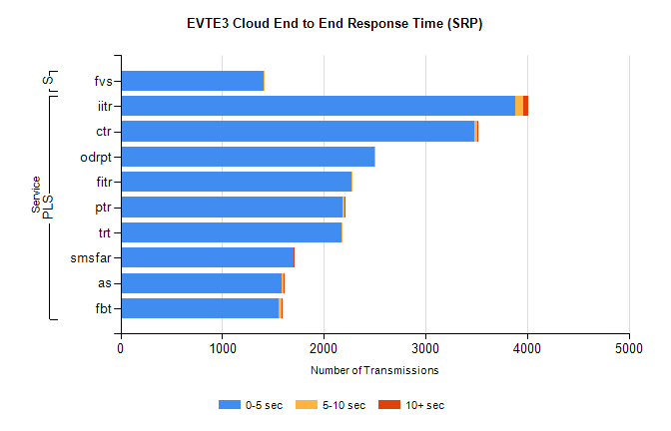
Stream | Service | 0-5 sec | 5-10 sec | >10 sec | Total | % within 5 sec timing target
PLS | iitr | 3886 | 78 | 46 | 4101 | 94.8%
PLS | ctr | 3479 | 30 | 3 | 3563 | 97.6%
PLS | odrpt | 2498 | 1 | 0 | 2499 | 100.0%
PLS | fitr | 2270 | 4 | 0 | 2291 | 99.1%
PLS | ptr | 2185 | 15 | 2 | 2256 | 96.9%
PLS | trt | 2170 | 8 | 0 | 2211 | 98.1%
PLS | smsfar | 1706 | 1 | 1 | 1721 | 99.1%
PLS | as | 1588 | 13 | 8 | 1685 | 94.2%
PLS | fbt | 1551 | 35 | 2 | 1594 | 97.3%
Super | fvs | 1410 | 1 | 0 | 1411 | 99.9%

SBR2 External Vendor Testing Environment (EVTE3)

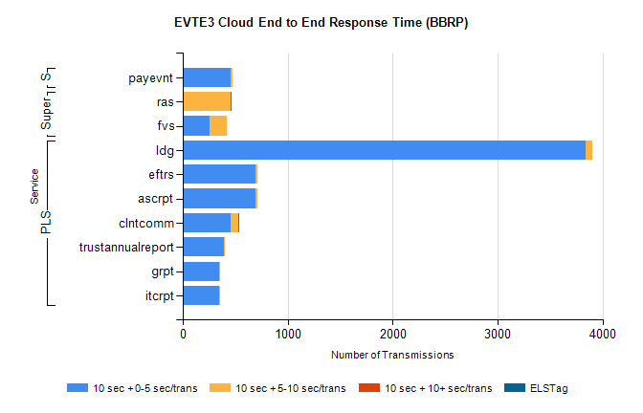
Stream | Service | 10 sec + 0-5 sec /trans | 10 sec + 5-10 sec /trans | 10 sec + >10 sec /trans | Processing Incomplete | ELStag | Total
PLS | ldg | 3834 | 69 | 0 | 91 | 0 | 3996
PLS | ascrpt | 696 | 16 | 0 | 0 | 0 | 712
PLS | eftrs | 696 | 16 | 0 | 0 | 0 | 712
PLS | clntcomm | 457 | 69 | 1 | 24 | 0 | 552
PLS | trustannualreport | 393 | 3 | 0 | 0 | 0 | 396
PLS | itcrpt | 348 | 8 | 0 | 0 | 0 | 356
PLS | grpt | 348 | 8 | 0 | 0 | 0 | 356
Super | ras | 0 | 460 | 5 | 0 | 0 | 478
Super | fvs | 259 | 160 | 0 | 5 | 0 | 426
STP | payevnt | 454 | 24 | 0 | 51 | 0 | 533

SBR2 External Vendor Testing Environment (EVTE3)

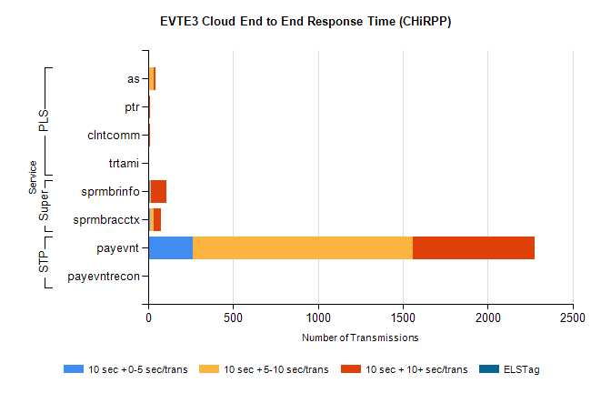
Stream | Service | 10 sec + 0-5 sec /trans | 10 sec + 5-10 sec /trans | 10 sec + >10 sec /trans | Total | % within 5 sec timing target
STP | payevnt | 262 | 1298 | 714 | 3202 | 8.2%
STP | payevntrecon | 0 | 1 | 6 | 8 | 0.0%
Super | sprmbrinfo | 11 | 4 | 91 | 113 | 9.7%
Super | sprmbracctx | 11 | 23 | 40 | 89 | 12.4%
PLS | as | 0 | 34 | 8 | 44 | 0.0%
PLS | ptr | 0 | 1 | 11 | 18 | 0.0%
PLS | clntcomm | 0 | 0 | 12 | 12 | 0.0%
PLS | trtami | 0 | 0 | 7 | 7 | 0.0%

