Transmission Timings Report Week - 27
30/06/2025 - 6/07/2025

SBR2 Cloud Production2 - Single | Bulk or Batch Requests | (SRP, BBRP & CHiRPP)

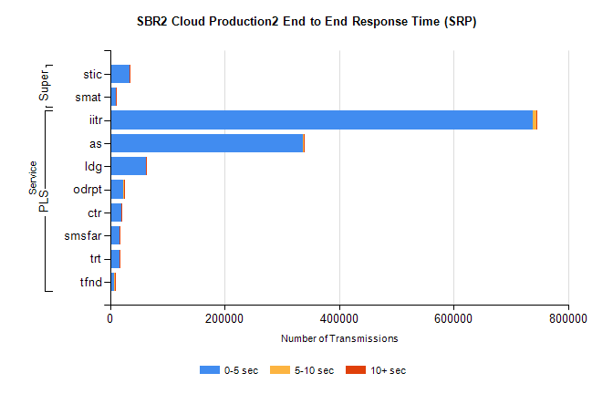
Stream | Service | 0-5 sec | 5-10 sec | >10 sec | Total | % within 5 sec timing target
PLS | iitr | 738529 | 5727 | 1618 | 745874 | 99.0%
PLS | as | 337185 | 1541 | 366 | 339092 | 99.4%
PLS | ldg | 63080 | 282 | 169 | 63531 | 99.3%
PLS | odrpt | 22797 | 1047 | 147 | 23991 | 95.0%
PLS | ctr | 19609 | 91 | 34 | 19734 | 99.4%
PLS | smsfar | 16017 | 56 | 30 | 16103 | 99.5%
PLS | trt | 15936 | 68 | 29 | 16033 | 99.4%
PLS | tfnd | 7845 | 38 | 10 | 7893 | 99.4%
Super | stic | 34161 | 174 | 92 | 34427 | 99.2%
Super | smat | 10112 | 149 | 50 | 10311 | 98.1%

SBR2 Cloud Production2 - Single | Bulk or Batch Requests | (SRP, BBRP & CHiRPP)

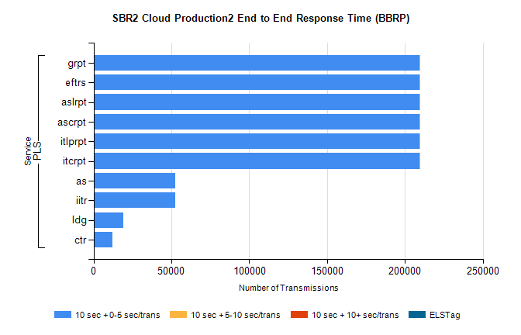
Stream | Service | 10 sec + 0-5 sec /trans | 10 sec + 5-10 sec /trans | 10 sec + >10 sec /trans | Processing Incomplete | ELStag | Total
PLS | itcrpt | 209375 | 1 | 0 | 0 | 0 | 209376
PLS | itlprpt | 209375 | 1 | 0 | 0 | 0 | 209376
PLS | ascrpt | 209375 | 1 | 0 | 0 | 0 | 209376
PLS | aslrpt | 209375 | 1 | 0 | 0 | 0 | 209376
PLS | eftrs | 209375 | 1 | 0 | 0 | 0 | 209376
PLS | grpt | 209375 | 1 | 0 | 0 | 0 | 209376
PLS | as | 52647 | 0 | 0 | 0 | 0 | 52647
PLS | iitr | 52542 | 0 | 0 | 0 | 0 | 52542
PLS | ldg | 19060 | 0 | 0 | 0 | 0 | 19060
PLS | ctr | 11989 | 0 | 0 | 0 | 0 | 11989

SBR2 Cloud Production2 - Single | Bulk or Batch Requests | (SRP, BBRP & CHiRPP)

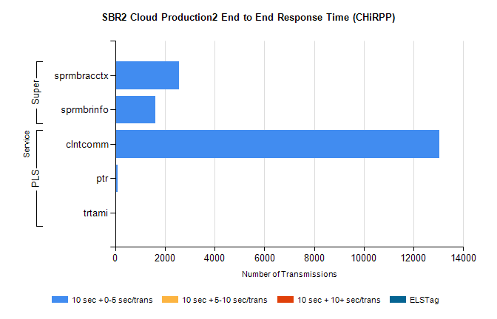
Stream | Service | 10 sec + 0-5 sec /trans | 10 sec + 5-10 sec /trans | 10 sec + >10 sec /trans | Total | % within 5 sec timing target
PLS | clntcomm | 13038 | 0 | 0 | 13038 | 100.0%
PLS | ptr | 89 | 0 | 0 | 89 | 100.0%
PLS | trtami | 1 | 0 | 0 | 1 | 100.0%
Super | sprmbracctx | 2579 | 0 | 0 | 2579 | 100.0%
Super | sprmbrinfo | 1603 | 0 | 0 | 1603 | 100.0%

SBR1 Production Transactions

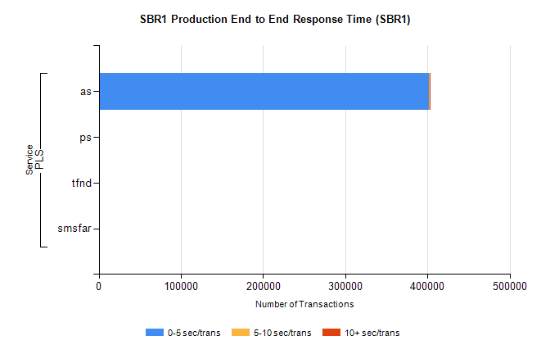
Stream | Service | 0-5 sec/trans | 5-10 sec/trans | 10+ sec/trans | Total | % within 5 sec timing target
PLS | as | 402177 | 237 | 107 | 402521 | 99.9%
PLS | ps | 167 | 179 | 295 | 641 | 26.1%
PLS | tfnd | 356 | 56 | 11 | 423 | 84.2%
PLS | smsfar | 2 | 16 | 3 | 21 | 9.5%

