Transmission Timings Report Week - 28
7/07/2025 - 13/07/2025

SBR2 External Vendor Testing Environment (EVTE3)

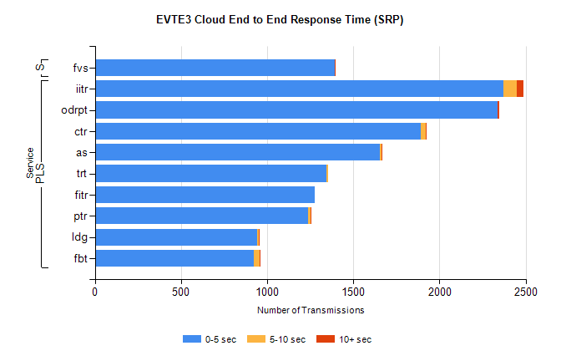
Stream | Service | 0-5 sec | 5-10 sec | >10 sec | Total | % within 5 sec timing target
PLS | iitr | 2369 | 78 | 39 | 2506 | 94.5%
PLS | odrpt | 2337 | 2 | 7 | 2352 | 99.4%
PLS | ctr | 1893 | 25 | 3 | 1929 | 98.1%
PLS | as | 1654 | 8 | 7 | 1712 | 96.6%
PLS | trt | 1343 | 11 | 0 | 1382 | 97.2%
PLS | fitr | 1274 | 0 | 0 | 1276 | 99.8%
PLS | ptr | 1239 | 15 | 1 | 1258 | 98.5%
PLS | ldg | 943 | 10 | 3 | 978 | 96.4%
PLS | fbt | 922 | 35 | 1 | 958 | 96.2%
Super | fvs | 1390 | 3 | 1 | 1394 | 99.7%

SBR2 External Vendor Testing Environment (EVTE3)

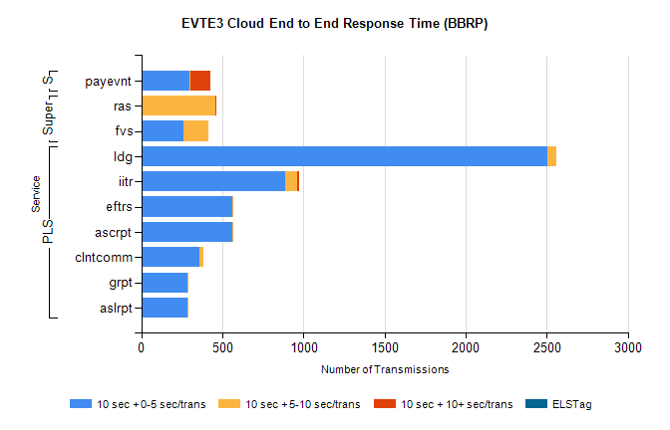
Stream | Service | 10 sec + 0-5 sec /trans | 10 sec + 5-10 sec /trans | 10 sec + >10 sec /trans | Processing Incomplete | ELStag | Total
PLS | ldg | 2501 | 58 | 0 | 59 | 0 | 2619
PLS | iitr | 887 | 76 | 7 | 0 | 0 | 976
PLS | ascrpt | 564 | 6 | 0 | 0 | 0 | 570
PLS | eftrs | 564 | 6 | 0 | 0 | 0 | 570
PLS | clntcomm | 358 | 24 | 0 | 21 | 0 | 403
PLS | aslrpt | 282 | 3 | 0 | 0 | 0 | 285
PLS | grpt | 282 | 3 | 0 | 0 | 0 | 285
Super | ras | 0 | 458 | 6 | 0 | 0 | 476
Super | fvs | 262 | 150 | 0 | 5 | 0 | 419
STP | payevnt | 298 | 6 | 125 | 53 | 0 | 482

SBR2 External Vendor Testing Environment (EVTE3)

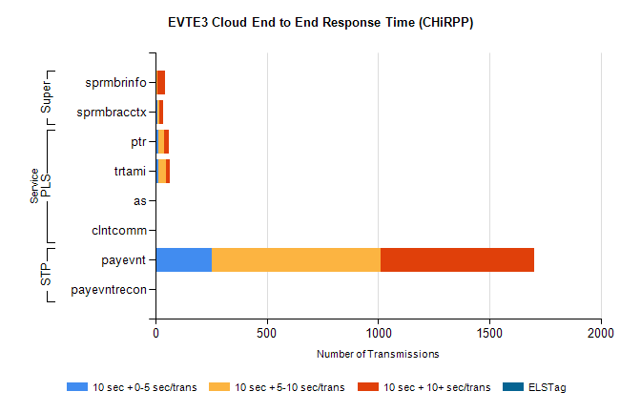
Stream | Service | 10 sec + 0-5 sec /trans | 10 sec + 5-10 sec /trans | 10 sec + >10 sec /trans | Total | % within 5 sec timing target
STP | payevnt | 253 | 758 | 691 | 2446 | 10.3%
STP | payevntrecon | 0 | 0 | 1 | 1 | 0.0%
PLS | ptr | 13 | 27 | 22 | 79 | 20.3%
PLS | trtami | 13 | 35 | 15 | 64 | 20.3%
PLS | as | 0 | 1 | 5 | 6 | 0.0%
PLS | clntcomm | 0 | 0 | 4 | 4 | 0.0%
Super | sprmbrinfo | 2 | 7 | 36 | 51 | 3.9%
Super | sprmbracctx | 11 | 6 | 17 | 35 | 31.4%

