Transmission Timings Report Week - 28
7/07/2025 - 13/07/2025

SBR2 Cloud Production2 - Single | Bulk or Batch Requests | (SRP, BBRP & CHiRPP)

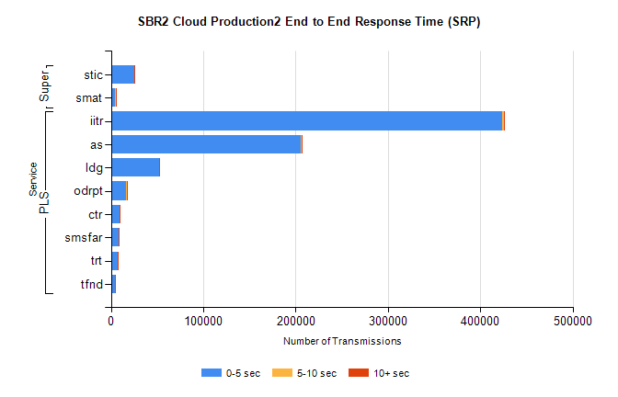
Stream | Service | 0-5 sec | 5-10 sec | >10 sec | Total | % within 5 sec timing target
PLS | iitr | 423168 | 2800 | 935 | 426903 | 99.1%
PLS | as | 205498 | 860 | 144 | 206502 | 99.5%
PLS | ldg | 51827 | 151 | 41 | 52019 | 99.6%
PLS | odrpt | 16036 | 999 | 159 | 17194 | 93.3%
PLS | ctr | 9477 | 39 | 6 | 9522 | 99.5%
PLS | smsfar | 7921 | 33 | 9 | 7963 | 99.5%
PLS | trt | 7168 | 32 | 8 | 7208 | 99.4%
PLS | tfnd | 3966 | 10 | 5 | 3981 | 99.6%
Super | stic | 24869 | 158 | 58 | 25085 | 99.1%
Super | smat | 4836 | 131 | 20 | 4987 | 97.0%

SBR2 Cloud Production2 - Single | Bulk or Batch Requests | (SRP, BBRP & CHiRPP)

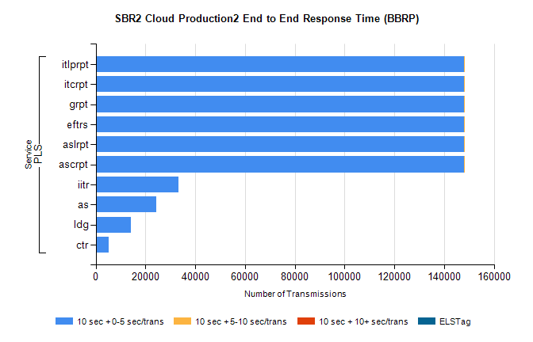
Stream | Service | 10 sec + 0-5 sec /trans | 10 sec + 5-10 sec /trans | 10 sec + >10 sec /trans | Processing Incomplete | ELStag | Total
PLS | ascrpt | 148005 | 7 | 0 | 0 | 0 | 148016
PLS | aslrpt | 148005 | 7 | 0 | 0 | 0 | 148016
PLS | eftrs | 148005 | 7 | 0 | 0 | 0 | 148016
PLS | grpt | 148005 | 7 | 0 | 0 | 0 | 148016
PLS | itcrpt | 148005 | 7 | 0 | 0 | 0 | 148016
PLS | itlprpt | 148005 | 7 | 0 | 0 | 0 | 148016
PLS | iitr | 33277 | 0 | 0 | 0 | 0 | 33277
PLS | as | 24466 | 0 | 0 | 0 | 0 | 24466
PLS | ldg | 14193 | 0 | 0 | 0 | 0 | 14193
PLS | ctr | 5159 | 0 | 0 | 0 | 0 | 5159

SBR2 Cloud Production2 - Single | Bulk or Batch Requests | (SRP, BBRP & CHiRPP)

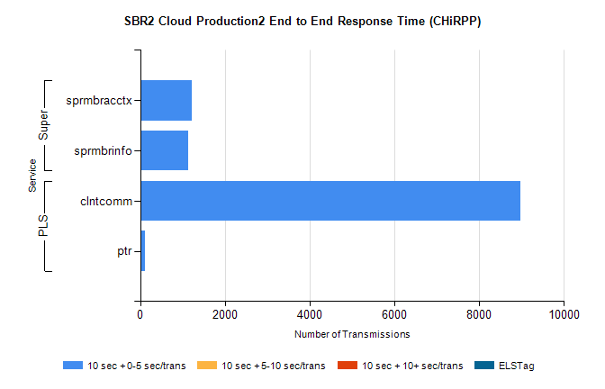
Stream | Service | 10 sec + 0-5 sec /trans | 10 sec + 5-10 sec /trans | 10 sec + >10 sec /trans | Total | % within 5 sec timing target
PLS | clntcomm | 8981 | 0 | 0 | 8981 | 100.0%
PLS | ptr | 121 | 0 | 0 | 121 | 100.0%
Super | sprmbracctx | 1219 | 0 | 0 | 1219 | 100.0%
Super | sprmbrinfo | 1129 | 0 | 0 | 1129 | 100.0%

SBR1 Production Transactions

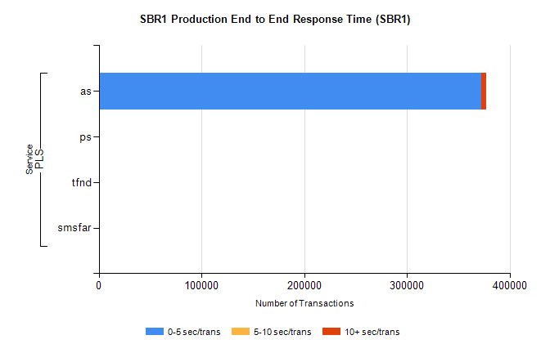
Stream | Service | 0-5 sec/trans | 5-10 sec/trans | 10+ sec/trans | Total | % within 5 sec timing target
PLS | as | 372024 | 258 | 4892 | 377174 | 98.6%
PLS | ps | 248 | 214 | 376 | 838 | 29.6%
PLS | tfnd | 270 | 47 | 10 | 327 | 82.6%
PLS | smsfar | 4 | 12 | 2 | 18 | 22.2%

