Transmission Timings Report Week - 29
14/07/2025 - 20/07/2025

SBR2 External Vendor Testing Environment (EVTE3)

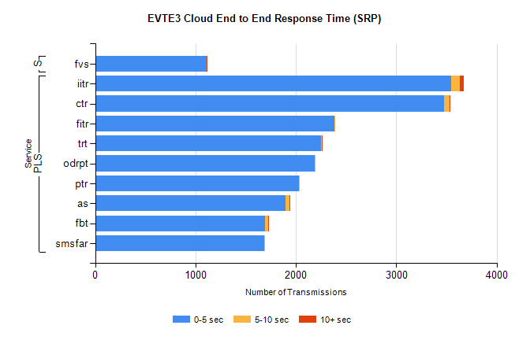
Stream | Service | 0-5 sec | 5-10 sec | >10 sec | Total | % within 5 sec timing target
PLS | iitr | 3545 | 87 | 40 | 3675 | 96.5%
PLS | ctr | 3477 | 54 | 5 | 3543 | 98.1%
PLS | fitr | 2382 | 4 | 0 | 2386 | 99.8%
PLS | trt | 2248 | 11 | 4 | 2289 | 98.2%
PLS | odrpt | 2185 | 2 | 0 | 2212 | 98.8%
PLS | ptr | 2031 | 4 | 0 | 2035 | 99.8%
PLS | as | 1898 | 38 | 4 | 2022 | 93.9%
PLS | fbt | 1691 | 33 | 2 | 1726 | 98.0%
PLS | smsfar | 1683 | 2 | 0 | 1687 | 99.8%
Super | fvs | 1108 | 1 | 2 | 1111 | 99.7%

SBR2 External Vendor Testing Environment (EVTE3)

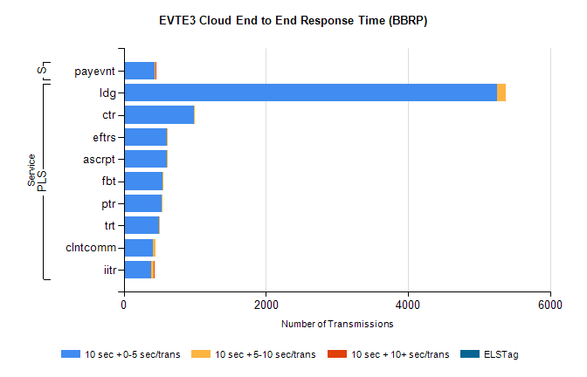
Stream | Service | 10 sec + 0-5 sec /trans | 10 sec + 5-10 sec /trans | 10 sec + >10 sec /trans | Processing Incomplete | ELStag | Total
PLS | ldg | 5249 | 125 | 0 | 74 | 0 | 5464
PLS | ctr | 986 | 9 | 0 | 0 | 0 | 998
PLS | ascrpt | 606 | 16 | 0 | 0 | 0 | 624
PLS | eftrs | 606 | 16 | 0 | 0 | 0 | 624
PLS | fbt | 550 | 5 | 0 | 0 | 0 | 558
PLS | ptr | 529 | 13 | 0 | 0 | 0 | 542
PLS | trt | 492 | 12 | 0 | 1 | 0 | 508
PLS | clntcomm | 404 | 37 | 0 | 21 | 0 | 462
PLS | iitr | 379 | 38 | 2 | 0 | 0 | 427
STP | payevnt | 428 | 14 | 1 | 36 | 0 | 479

SBR2 External Vendor Testing Environment (EVTE3)

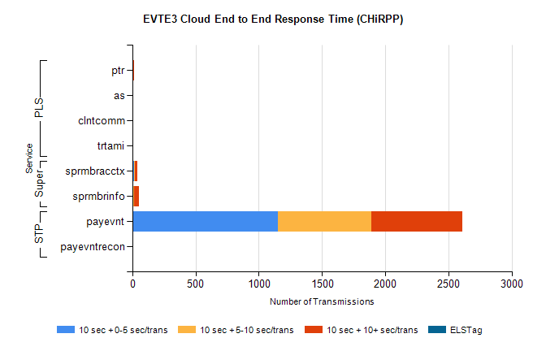
Stream | Service | 10 sec + 0-5 sec /trans | 10 sec + 5-10 sec /trans | 10 sec + >10 sec /trans | Total | % within 5 sec timing target
STP | payevnt | 1152 | 736 | 719 | 3219 | 35.8%
STP | payevntrecon | 0 | 0 | 4 | 4 | 0.0%
Super | sprmbracctx | 17 | 6 | 14 | 58 | 29.3%
Super | sprmbrinfo | 6 | 7 | 37 | 55 | 10.9%
PLS | ptr | 0 | 5 | 11 | 16 | 0.0%
PLS | as | 0 | 2 | 3 | 11 | 0.0%
PLS | trtami | 0 | 0 | 2 | 2 | 0.0%
PLS | clntcomm | 0 | 0 | 2 | 2 | 0.0%

