Transmission Timings Report Week - 29
14/07/2025 - 20/07/2025

SBR2 Cloud Production2 - Single | Bulk or Batch Requests | (SRP, BBRP & CHiRPP)

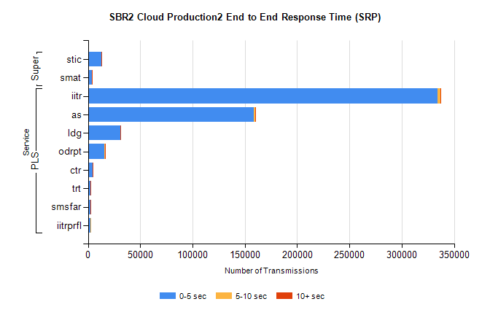
Stream | Service | 0-5 sec | 5-10 sec | >10 sec | Total | % within 5 sec timing target
PLS | iitr | 334226 | 2863 | 745 | 337834 | 98.9%
PLS | as | 158760 | 992 | 189 | 159941 | 99.3%
PLS | ldg | 30706 | 133 | 20 | 30859 | 99.5%
PLS | odrpt | 15708 | 660 | 141 | 16509 | 95.1%
PLS | ctr | 4314 | 25 | 6 | 4345 | 99.3%
PLS | trt | 2568 | 29 | 2 | 2599 | 98.8%
PLS | smsfar | 2473 | 9 | 2 | 2484 | 99.6%
PLS | iitrprfl | 2111 | 27 | 0 | 2138 | 98.7%
Super | stic | 12679 | 90 | 65 | 12834 | 98.8%
Super | smat | 3550 | 71 | 51 | 3672 | 96.7%

SBR2 Cloud Production2 - Single | Bulk or Batch Requests | (SRP, BBRP & CHiRPP)

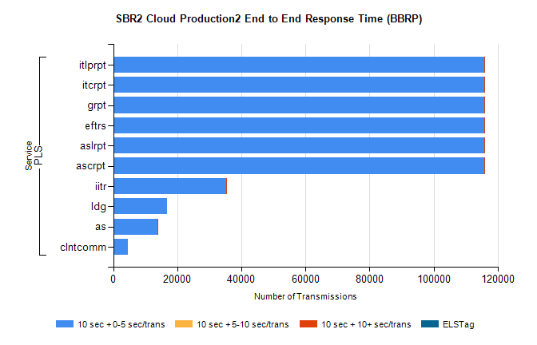
Stream | Service | 10 sec + 0-5 sec /trans | 10 sec + 5-10 sec /trans | 10 sec + >10 sec /trans | Processing Incomplete | ELStag | Total
PLS | ascrpt | 115931 | 7 | 2 | 0 | 0 | 115955
PLS | aslrpt | 115931 | 7 | 2 | 0 | 0 | 115955
PLS | eftrs | 115931 | 7 | 2 | 0 | 0 | 115955
PLS | grpt | 115931 | 7 | 2 | 0 | 0 | 115955
PLS | itcrpt | 115931 | 7 | 2 | 0 | 0 | 115955
PLS | itlprpt | 115931 | 7 | 2 | 0 | 0 | 115955
PLS | iitr | 35354 | 1 | 11 | 0 | 0 | 35367
PLS | ldg | 16762 | 0 | 0 | 0 | 0 | 16762
PLS | as | 13876 | 0 | 1 | 0 | 0 | 13878
PLS | clntcomm | 4496 | 0 | 0 | 0 | 0 | 4496

SBR2 Cloud Production2 - Single | Bulk or Batch Requests | (SRP, BBRP & CHiRPP)

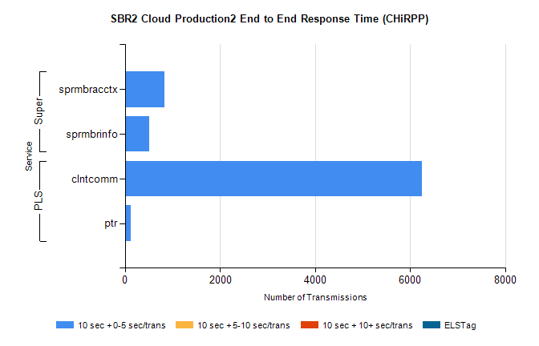
Stream | Service | 10 sec + 0-5 sec /trans | 10 sec + 5-10 sec /trans | 10 sec + >10 sec /trans | Total | % within 5 sec timing target
PLS | clntcomm | 6242 | 0 | 0 | 6242 | 100.0%
PLS | ptr | 118 | 0 | 0 | 118 | 100.0%
Super | sprmbracctx | 837 | 0 | 0 | 837 | 100.0%
Super | sprmbrinfo | 505 | 0 | 0 | 505 | 100.0%

SBR1 Production Transactions

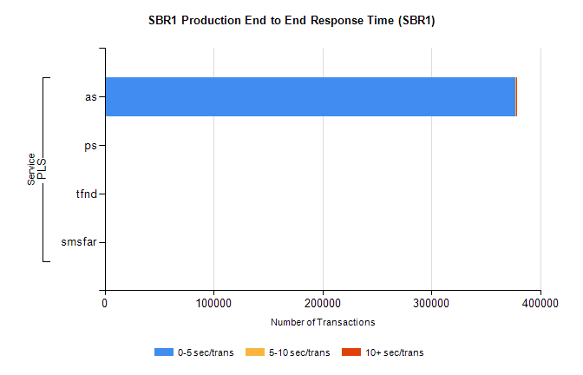
Stream | Service | 0-5 sec/trans | 5-10 sec/trans | 10+ sec/trans | Total | % within 5 sec timing target
PLS | as | 377318 | 309 | 361 | 377988 | 99.8%
PLS | ps | 309 | 195 | 346 | 850 | 36.4%
PLS | tfnd | 229 | 55 | 8 | 292 | 78.4%
PLS | smsfar | 3 | 17 | 4 | 24 | 12.5%

