Transmission Timings Report Week - 30
21/07/2025 - 27/07/2025

SBR2 External Vendor Testing Environment (EVTE3)

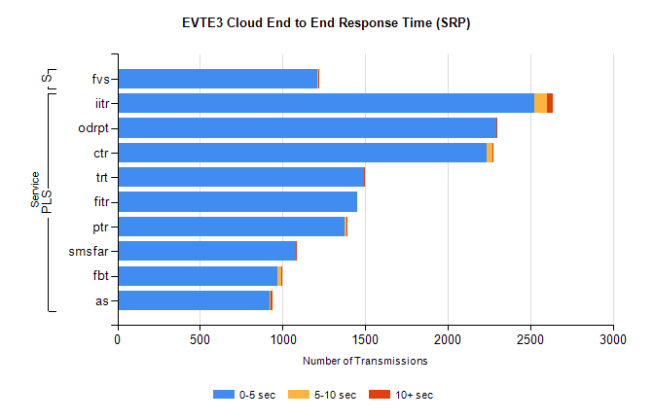
Stream | Service | 0-5 sec | 5-10 sec | >10 sec | Total | % within 5 sec timing target
PLS | iitr | 2527 | 72 | 35 | 2634 | 95.9%
PLS | odrpt | 2294 | 1 | 5 | 2301 | 99.7%
PLS | ctr | 2236 | 34 | 3 | 2278 | 98.2%
PLS | trt | 1492 | 4 | 3 | 1499 | 99.5%
PLS | fitr | 1454 | 0 | 0 | 1454 | 100.0%
PLS | ptr | 1374 | 13 | 2 | 1392 | 98.7%
PLS | smsfar | 1078 | 3 | 1 | 1082 | 99.6%
PLS | fbt | 968 | 24 | 4 | 997 | 97.1%
PLS | as | 922 | 5 | 10 | 955 | 96.5%
Super | fvs | 1213 | 2 | 2 | 1217 | 99.7%

SBR2 External Vendor Testing Environment (EVTE3)

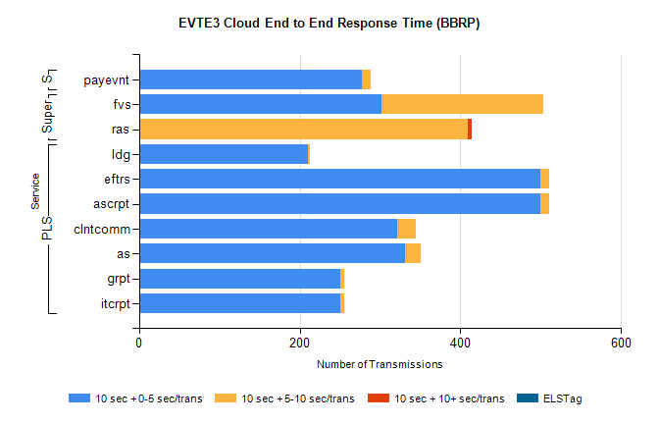
Stream | Service | 10 sec + 0-5 sec /trans | 10 sec + 5-10 sec /trans | 10 sec + >10 sec /trans | Processing Incomplete | ELStag | Total
PLS | ldg | 210 | 3 | 0 | 3893 | 0 | 4107
PLS | ascrpt | 500 | 10 | 0 | 0 | 0 | 510
PLS | eftrs | 500 | 10 | 0 | 0 | 0 | 510
PLS | clntcomm | 321 | 24 | 0 | 18 | 0 | 363
PLS | as | 331 | 20 | 0 | 0 | 0 | 351
PLS | itcrpt | 250 | 5 | 0 | 0 | 0 | 255
PLS | grpt | 250 | 5 | 0 | 0 | 0 | 255
Super | fvs | 302 | 201 | 0 | 4 | 0 | 507
Super | ras | 0 | 409 | 5 | 0 | 0 | 449
STP | payevnt | 277 | 12 | 0 | 42 | 0 | 331

SBR2 External Vendor Testing Environment (EVTE3)

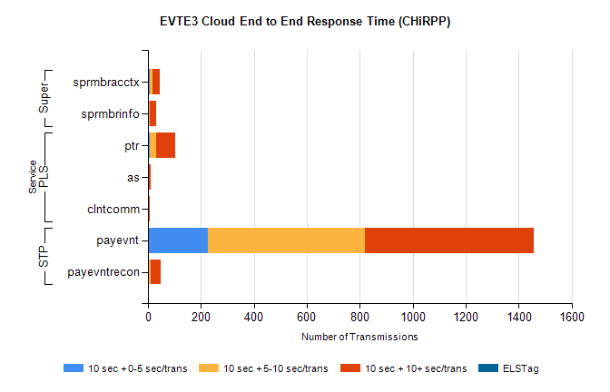
Stream | Service | 10 sec + 0-5 sec /trans | 10 sec + 5-10 sec /trans | 10 sec + >10 sec /trans | Total | % within 5 sec timing target
STP | payevnt | 226 | 594 | 637 | 1987 | 11.4%
STP | payevntrecon | 0 | 10 | 39 | 54 | 0.0%
PLS | ptr | 7 | 24 | 73 | 105 | 6.7%
PLS | as | 0 | 0 | 11 | 17 | 0.0%
PLS | clntcomm | 0 | 0 | 8 | 9 | 0.0%
Super | sprmbracctx | 9 | 8 | 29 | 69 | 13.0%
Super | sprmbrinfo | 3 | 5 | 24 | 39 | 7.7%

