Transmission Timings Report Week - 30
21/07/2025 - 27/07/2025

SBR2 Cloud Production2 - Single | Bulk or Batch Requests | (SRP, BBRP & CHiRPP)

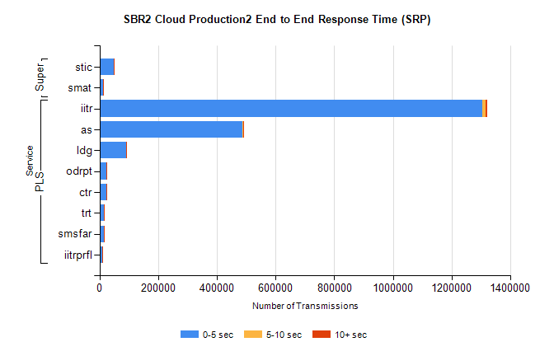
Stream | Service | 0-5 sec | 5-10 sec | >10 sec | Total | % within 5 sec timing target
PLS | iitr | 1305379 | 11277 | 3678 | 1320334 | 98.9%
PLS | as | 487354 | 1969 | 773 | 490096 | 99.4%
PLS | ldg | 92169 | 250 | 74 | 92493 | 99.6%
PLS | odrpt | 22525 | 849 | 448 | 23822 | 94.6%
PLS | ctr | 22325 | 108 | 34 | 22467 | 99.4%
PLS | trt | 14588 | 75 | 27 | 14690 | 99.3%
PLS | smsfar | 14363 | 59 | 36 | 14458 | 99.3%
PLS | iitrprfl | 8297 | 59 | 14 | 8370 | 99.1%
Super | stic | 47731 | 329 | 153 | 48213 | 99.0%
Super | smat | 11515 | 248 | 61 | 11824 | 97.4%

SBR2 Cloud Production2 - Single | Bulk or Batch Requests | (SRP, BBRP & CHiRPP)

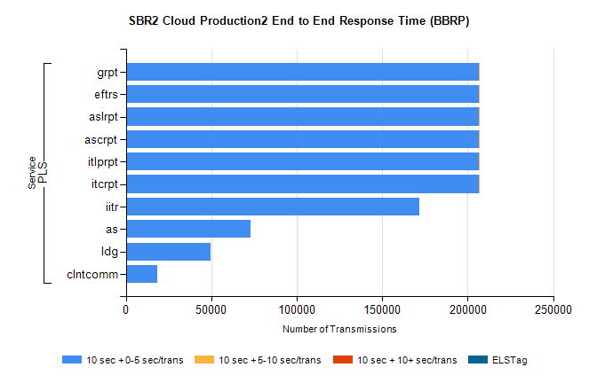
Stream | Service | 10 sec + 0-5 sec /trans | 10 sec + 5-10 sec /trans | 10 sec + >10 sec /trans | Processing Incomplete | ELStag | Total
PLS | itcrpt | 206309 | 2 | 0 | 0 | 0 | 206313
PLS | itlprpt | 206309 | 2 | 0 | 0 | 0 | 206313
PLS | ascrpt | 206309 | 2 | 0 | 0 | 0 | 206313
PLS | aslrpt | 206309 | 2 | 0 | 0 | 0 | 206313
PLS | eftrs | 206309 | 2 | 0 | 0 | 0 | 206313
PLS | grpt | 206309 | 2 | 0 | 0 | 0 | 206313
PLS | iitr | 171771 | 0 | 0 | 0 | 0 | 171771
PLS | as | 72905 | 0 | 0 | 0 | 0 | 72905
PLS | ldg | 49412 | 0 | 0 | 0 | 0 | 49412
PLS | clntcomm | 18181 | 0 | 0 | 0 | 0 | 18181

SBR2 Cloud Production2 - Single | Bulk or Batch Requests | (SRP, BBRP & CHiRPP)

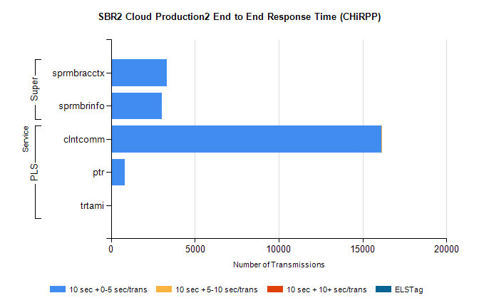
Stream | Service | 10 sec + 0-5 sec /trans | 10 sec + 5-10 sec /trans | 10 sec + >10 sec /trans | Total | % within 5 sec timing target
PLS | clntcomm | 16127 | 1 | 0 | 16128 | 100.0%
PLS | ptr | 819 | 0 | 0 | 819 | 100.0%
PLS | trtami | 3 | 0 | 0 | 3 | 100.0%
Super | sprmbracctx | 3345 | 0 | 0 | 3345 | 100.0%
Super | sprmbrinfo | 3045 | 0 | 0 | 3045 | 100.0%

SBR1 Production Transactions

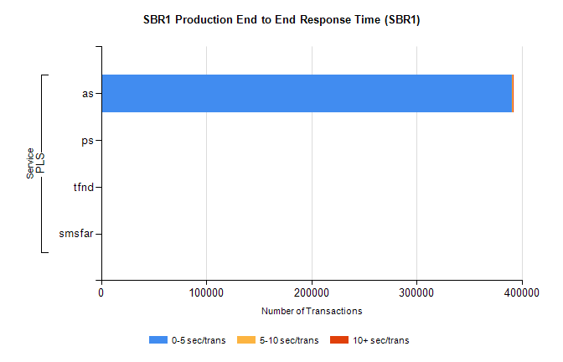
Stream | Service | 0-5 sec/trans | 5-10 sec/trans | 10+ sec/trans | Total | % within 5 sec timing target
PLS | as | 391015 | 359 | 482 | 391856 | 99.8%
PLS | ps | 118 | 150 | 294 | 562 | 21.0%
PLS | tfnd | 213 | 47 | 11 | 271 | 78.6%
PLS | smsfar |  | 9 |  | 9 | 0.0%

