Transmission Timings Report Week - 31
28/07/2025 - 3/08/2025

SBR2 External Vendor Testing Environment (EVTE3)

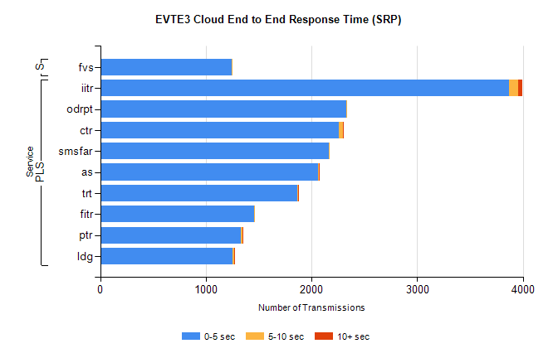
Stream | Service | 0-5 sec | 5-10 sec | >10 sec | Total | % within 5 sec timing target
PLS | iitr | 3866 | 86 | 46 | 4077 | 94.8%
PLS | odrpt | 2329 | 1 | 0 | 2330 | 100.0%
PLS | ctr | 2256 | 40 | 3 | 2324 | 97.1%
PLS | smsfar | 2162 | 2 | 0 | 2164 | 99.9%
PLS | as | 2058 | 9 | 6 | 2132 | 96.5%
PLS | trt | 1867 | 4 | 1 | 1880 | 99.3%
PLS | fitr | 1456 | 2 | 0 | 1464 | 99.5%
PLS | ptr | 1329 | 18 | 3 | 1360 | 97.7%
PLS | ldg | 1256 | 15 | 2 | 1289 | 97.4%
Super | fvs | 1242 | 4 | 0 | 1246 | 99.7%

SBR2 External Vendor Testing Environment (EVTE3)

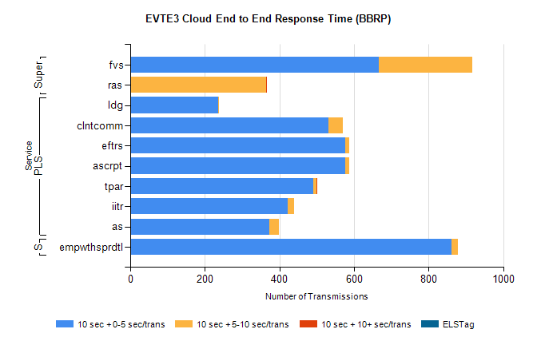
Stream | Service | 10 sec + 0-5 sec /trans | 10 sec + 5-10 sec /trans | 10 sec + >10 sec /trans | Processing Incomplete | ELStag | Total
PLS | ldg | 235 | 4 | 0 | 542 | 0 | 781
PLS | ascrpt | 576 | 12 | 0 | 0 | 0 | 592
PLS | eftrs | 576 | 12 | 0 | 0 | 0 | 592
PLS | clntcomm | 531 | 40 | 0 | 21 | 0 | 592
PLS | tpar | 491 | 9 | 2 | 0 | 0 | 512
PLS | iitr | 423 | 16 | 0 | 0 | 0 | 439
PLS | as | 373 | 26 | 0 | 0 | 0 | 399
Super | fvs | 667 | 251 | 0 | 5 | 0 | 924
Super | ras | 0 | 364 | 3 | 0 | 0 | 388
STP | empwthsprdtl | 861 | 18 | 0 | 0 | 0 | 882

SBR2 External Vendor Testing Environment (EVTE3)

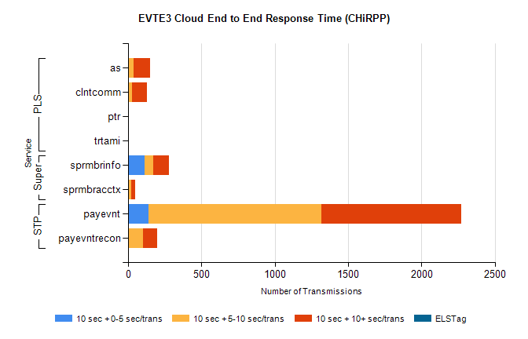
Stream | Service | 10 sec + 0-5 sec /trans | 10 sec + 5-10 sec /trans | 10 sec + >10 sec /trans | Total | % within 5 sec timing target
STP | payevnt | 139 | 1181 | 949 | 3098 | 4.5%
STP | payevntrecon | 0 | 101 | 98 | 214 | 0.0%
Super | sprmbrinfo | 113 | 57 | 110 | 339 | 33.3%
Super | sprmbracctx | 7 | 14 | 28 | 59 | 11.9%
PLS | as | 1 | 37 | 114 | 193 | 0.5%
PLS | clntcomm | 0 | 25 | 107 | 179 | 0.0%
PLS | trtami | 0 | 0 | 4 | 4 | 0.0%
PLS | ptr | 0 | 0 | 3 | 4 | 0.0%

