Transmission Timings Report Week - 31
28/07/2025 - 3/08/2025

SBR2 Cloud Production2 - Single | Bulk or Batch Requests | (SRP, BBRP & CHiRPP)

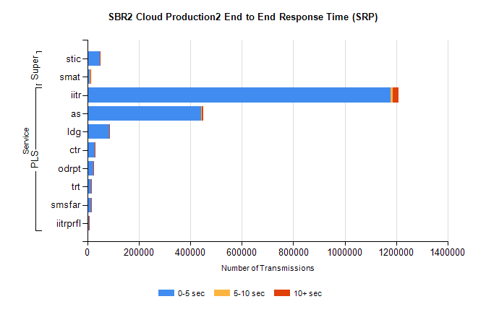
Stream | Service | 0-5 sec | 5-10 sec | >10 sec | Total | % within 5 sec timing target
PLS | iitr | 1178460 | 9031 | 20994 | 1208485 | 97.5%
PLS | as | 442391 | 1902 | 5475 | 449768 | 98.4%
PLS | ldg | 85684 | 240 | 703 | 86627 | 98.9%
PLS | ctr | 28115 | 134 | 573 | 28822 | 97.5%
PLS | odrpt | 23308 | 724 | 499 | 24531 | 95.0%
PLS | trt | 16261 | 66 | 650 | 16977 | 95.8%
PLS | smsfar | 15766 | 63 | 256 | 16085 | 98.0%
PLS | iitrprfl | 8100 | 49 | 22 | 8171 | 99.1%
Super | stic | 49232 | 592 | 399 | 50223 | 98.0%
Super | smat | 10615 | 502 | 135 | 11252 | 94.3%

SBR2 Cloud Production2 - Single | Bulk or Batch Requests | (SRP, BBRP & CHiRPP)

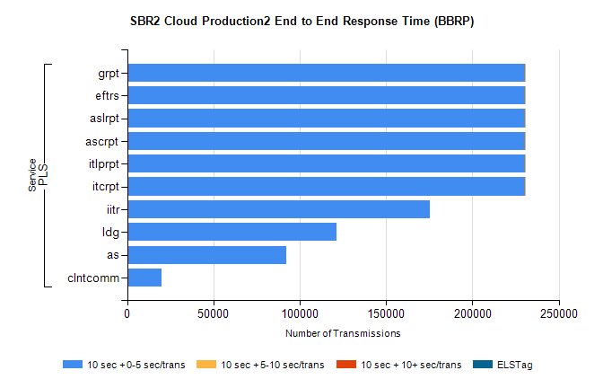
Stream | Service | 10 sec + 0-5 sec /trans | 10 sec + 5-10 sec /trans | 10 sec + >10 sec /trans | Processing Incomplete | ELStag | Total
PLS | itcrpt | 230281 | 4 | 0 | 0 | 0 | 230286
PLS | itlprpt | 230281 | 4 | 0 | 0 | 0 | 230286
PLS | ascrpt | 230281 | 4 | 0 | 0 | 0 | 230286
PLS | aslrpt | 230281 | 4 | 0 | 0 | 0 | 230286
PLS | eftrs | 230281 | 4 | 0 | 0 | 0 | 230286
PLS | grpt | 230281 | 4 | 0 | 0 | 0 | 230286
PLS | iitr | 175232 | 0 | 0 | 0 | 0 | 175232
PLS | ldg | 121510 | 0 | 0 | 0 | 0 | 121510
PLS | as | 92065 | 0 | 0 | 0 | 0 | 92065
PLS | clntcomm | 19813 | 0 | 0 | 0 | 0 | 19813

SBR2 Cloud Production2 - Single | Bulk or Batch Requests | (SRP, BBRP & CHiRPP)

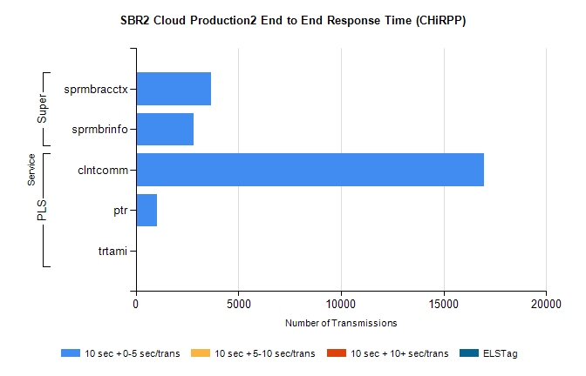
Stream | Service | 10 sec + 0-5 sec /trans | 10 sec + 5-10 sec /trans | 10 sec + >10 sec /trans | Total | % within 5 sec timing target
PLS | clntcomm | 16977 | 0 | 0 | 16977 | 100.0%
PLS | ptr | 1042 | 0 | 0 | 1042 | 100.0%
PLS | trtami | 22 | 0 | 0 | 22 | 100.0%
Super | sprmbracctx | 3653 | 0 | 0 | 3653 | 100.0%
Super | sprmbrinfo | 2805 | 0 | 0 | 2805 | 100.0%

SBR1 Production Transactions

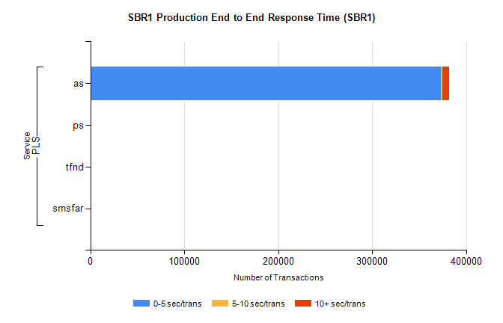
Stream | Service | 0-5 sec/trans | 5-10 sec/trans | 10+ sec/trans | Total | % within 5 sec timing target
PLS | as | 373489 | 1634 | 6756 | 381879 | 97.8%
PLS | ps | 214 | 185 | 274 | 673 | 31.8%
PLS | tfnd | 243 | 50 | 10 | 303 | 80.2%
PLS | smsfar | 1 | 11 | 4 | 16 | 6.3%

